l,'!l

VIRGINIA:

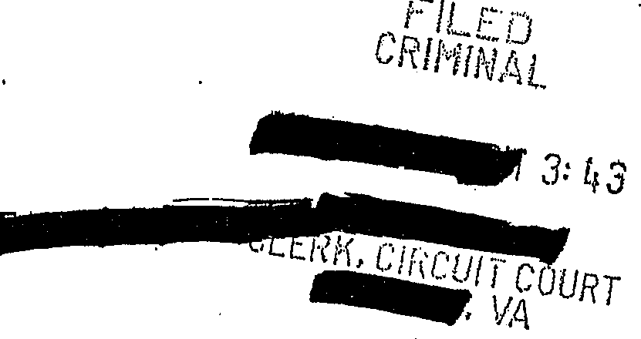
IN THE CIRCUIT COURT OF

,COMMONWEALTH OF VIRGINIA, )
)
)
)
)
)
)

Defendant. )

CRIMINAL Nos:

AFFIDAVIT FROM JN SUPPORT OF MOTION FOR AN ORDER DE IGNATING A JUDGE TO HEAR DEFENDANT'S EX PARTE REQUESTS FOR FUNDING FOR EXPERT ASSISTANCE

1. Mynameis . I am the
- In that capacity, I serve as counsel in the matter of Commonwealth v.­
. ,, am experienced in the defense of death penalty cases and the resources needed io provide constitutionally effective re.t?resentation.
2. has been charged with two counts of capital murder. The
Commonwealth has indicated that it intends to seek the death penalty agains should he be convicted of either·of these offenses.
- -hasfil d a motion seeking an order appointing

. Circuit Court judge to hear ex parte requests for expert assistance in this case. Such a motion.is expressly authorized by Va. Code Ann_. § 19.2-264.3:1.3. These requests will not be for the same experts that this Court has already considered. After the Court has assigned another judge to consider ex parte requests, the defendant will be required to

make a particularized showing f the need for the expert services in the ex parte

proceeding.

- The American Bar Association's guidelines for capital cases advise counsel.to

- · make requests for expert assistance on an -ex parte basis:

... [C]ounsel is responsible, in the exercise of sound professional judgment, for detennining what resources are needed and for demanding that the jurisdiction provide them. Because the defense should not be required to disclose privileged communications or strategy to the prosecution in order to secure these resources, counsel should insist on making such requests ex parte and in camera.

ABA Guidelines for the Appointment and Performance of Defense Counsel in Death Penalty Cases, Guideline 10.4 cmt. (2003) (footnotes omitted).

- During the course of the representation_o our defense team has. identified experts that are necessary i:o. oi:d r to ¥ffectively ass s t ... preparation of his defense in this matter. :· The defendant will be denied the effective assistance of counsel if he is not able to retain these experts. The experts will materially
- assist the defense in m tters that will be a significant factor in the defense of these charges at the guiit/innocence phase of the trial, as well as potentially at the penalty phase of the trial. The failure to appoint these experts will result in prejudice to the defendant's case and rights to a fair trial as protected by the laws and constitutions of both Virginia and the United States. Denial of these expert services will result in?, fundamentally
unfair trial.

- Making requests for these experts in ·an open court proceeding would prejudice the defendant's ability to investigate his case. The work of the experts could be thwarted or inhibited·iftheir identity and work is disclosed prematurely.

.
- Additionally, in order to make a particularized showing of the need for these

experts, counsel for the defendant will need to reveal confidential defense strategy and privilegecl information.
- · Experts are often needed in cases .in order to investigate possible defenses and •

areas of inquiry. However, sometimes these inquiries result in issues that might be detrimental to the overall strategy in a capital case. As a result, having the work of an expert be conducted in a confidential and privileged manner is crucial to an effective investigation. If defense counsel is required to demonstrate in open court the particularized need for these experts, it will result in prejudice to the defendant's case and his right to a fair trial. Accordingly, if counsel for the defendant is not allowed to seek
expert services in an ex parte fashion, the defense wHl be d.isoouraged from seeking thes\;l . . .

.....
....:; ... ··= - f,,. 1;.;-r- ,.,..-··-
,-.• ... ·· ·.· - · · · · ·
_...
. !•r,.- :.·•: ;.;: i ir .,.,-..:.:r- ;.:i.:,.·.,::·

- ·experts and ultimately may not pursue necessary defense theories for fear that r

confidential str tegy may be revealed.

- . Counsel for the defendant can demonstrate in an ex parte proceeding the
- particularized need for the experts sought in this case. However, counsel for the defendant cannot demonstrate this particularized need in open court without revealing privilege_d information and compromising the defense investigation and strategy in a manner that will prejudice the defendant's rights to effective assistance of counsel and a fair trial.
- Based on the above, I believe denying the defense team pennission to make ex parte requests for expert assistance will render lawyers ineffective and deprive him of his Sixth Amendment right to counsel. I also believe that it will result in a

\. ' .,.

.

fundamentally unfair trial and a violation of due process as protected by the Virginia and

Federal Constitutions.

  - I have read the abeve statements and swear and affinn, to the best ofmy· knowledge, that they are true.

CO:MMONWEALTH OF VIRGINIA COUNTY OF ARLINGTON

My Commission expires

..-e:,p
    - Commonwealth of Virginia My Commission ReglsttationNumbil r
es5ea

