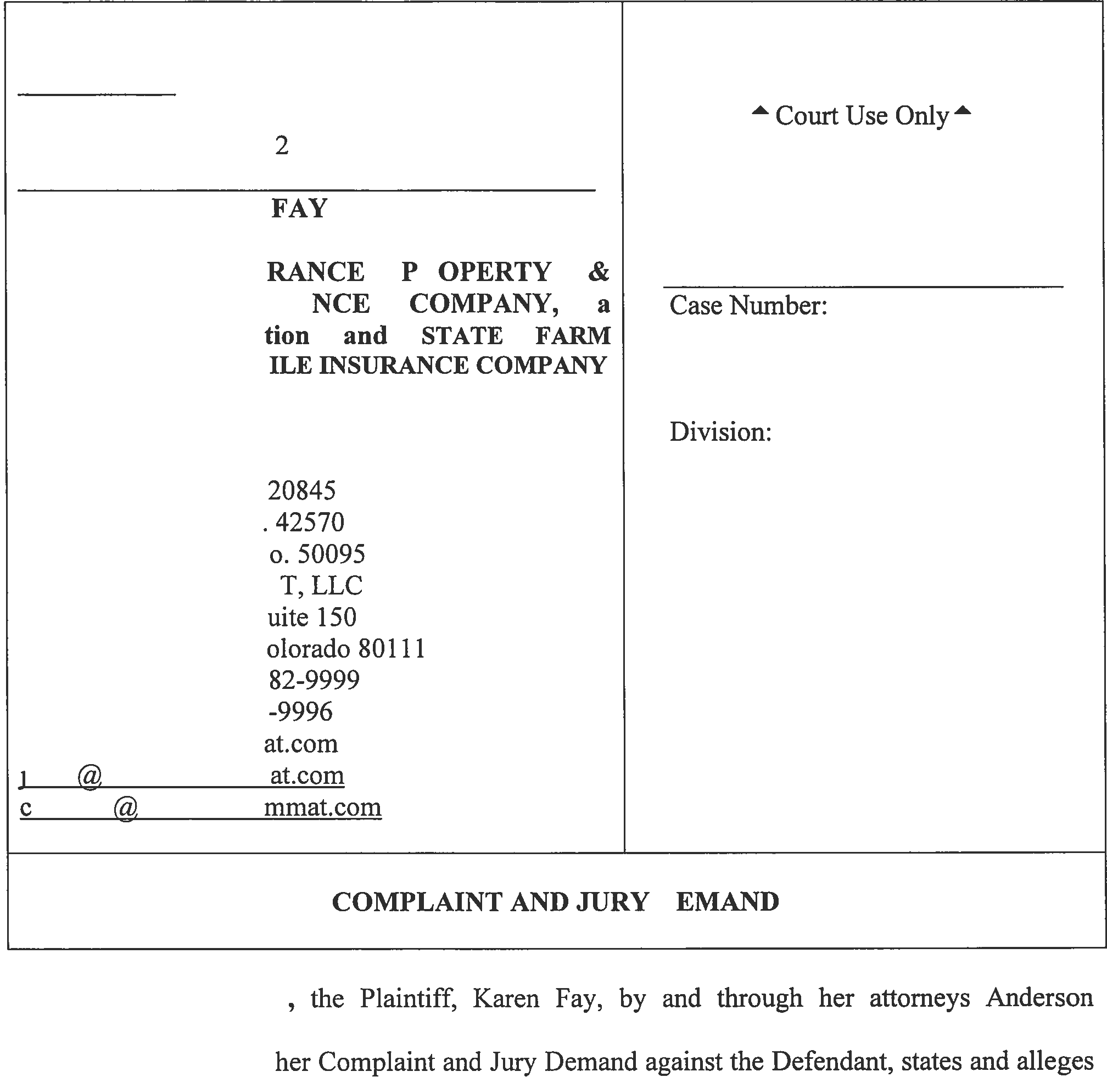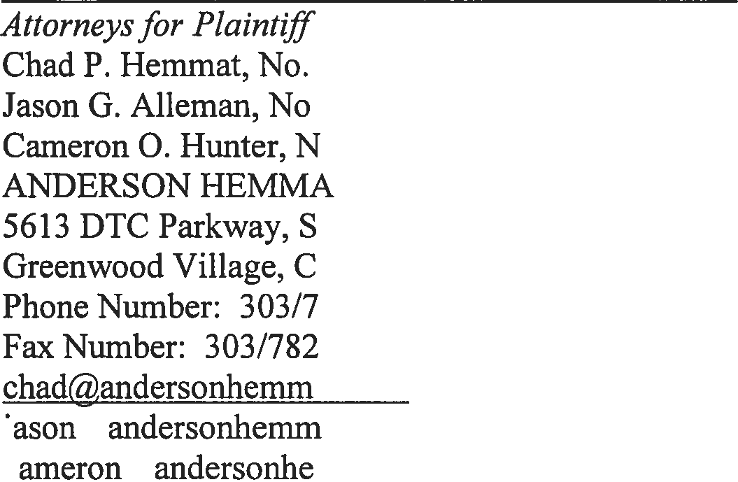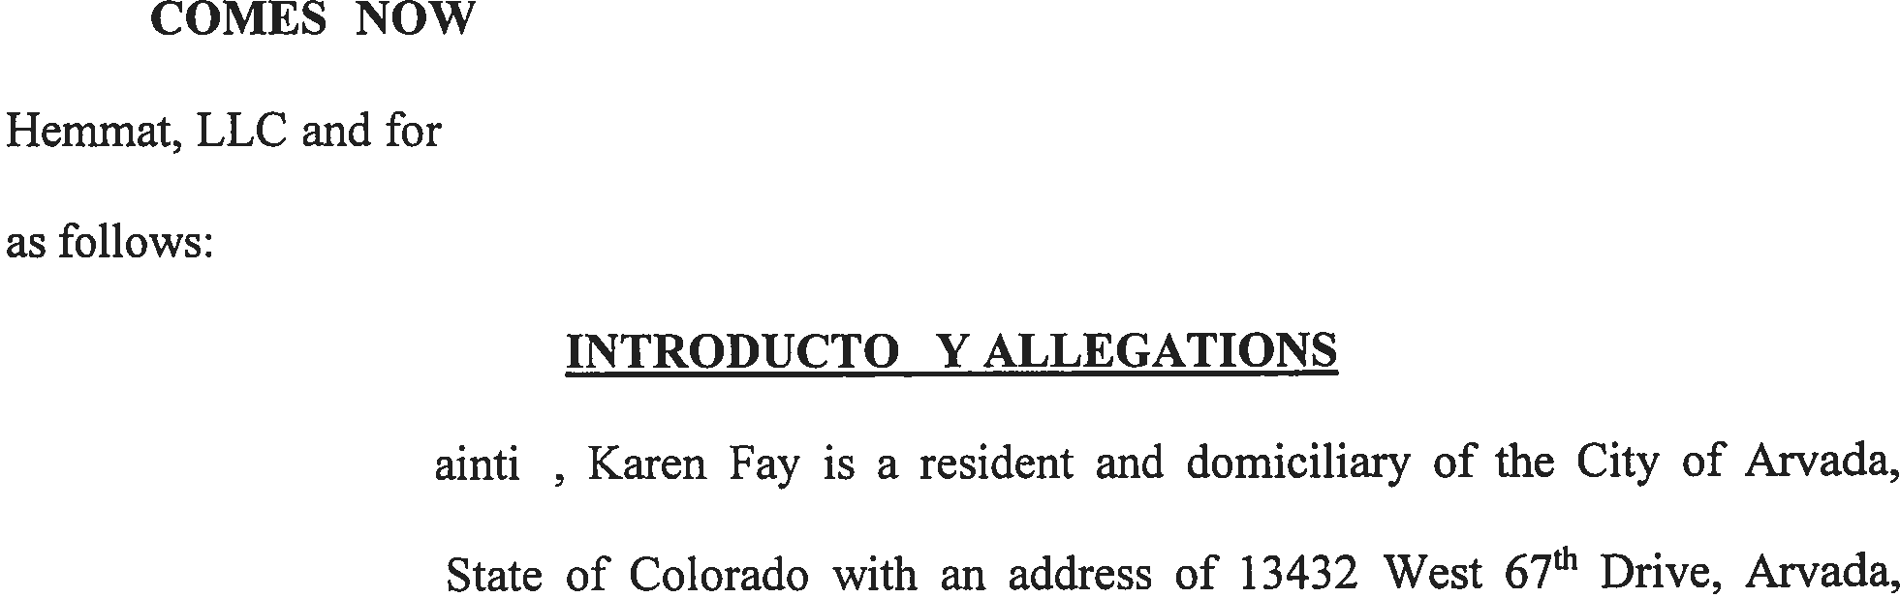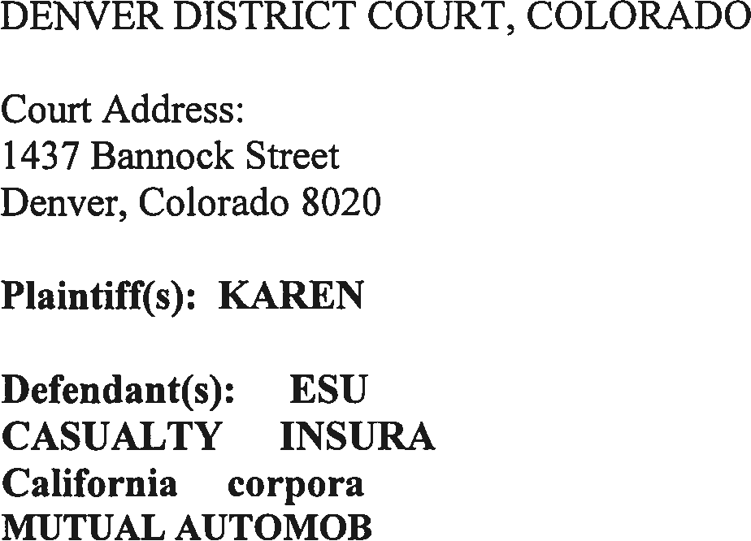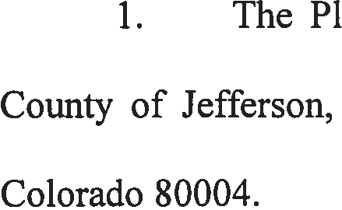

DATE FILED: March 16, 2018 11:06 AM FILING ID: C87B7A3C9AA10
CASE NUMBER: 2018CV30947

- The Defendant, Esurance Property & Casualty Insurance Company, a California corporation (hereinafter referred to hereinafter as Defendant Esurance), is a for profit company organized under the laws of the State of California and actively doing business within the County of Jefferson, State of Colorado.
- The Defendant, State Farm Mutual Automobile Insurance Company (hereinafter referred to hereinafter as Defendant State Farm), is a for profit company organized under the laws of the State of Illinois and actively doing business within the County of Jefferson, State of Colorado.
- This Court has jurisdiction over the subject matter of this action and the parties hereto and venue is proper in the County of Denver pursuant to C.R.C.P. 98(c), because Defendant is an out-of-state corporation doing business in the State of Colorado. Therefore, Plaintiff designates the City and County of Denver as the venue for this action.
- On January 17, 2016, Plaintiff was involved in a motor vehicle collision with a hit and run driver, causing Plaintiff injuries, damages and losses.
- The at-fault driver fled the scene of the accident and was never found.

- As a result of the subject motor vehicle collision, Plaintiff sustained injuries including, but not limited to her neck and shoulder.
- At the time of the April 2015 collision, Plaintiff was a passenger in Mark Smith's vehicle who was an insured under his uninsured/underinsured (UM/UIM) motorist policy with Defendant Esurance, Policy No. PAC003083045.

- Also at the time of the April 2015 collision, Plaintiff was an insured under her uninsured/underinsured (UM/UIM) motorist policy with Defendant State Farm, Policy No. 228 513-A04-06B.
- By virtue of the fact that Plaintiff was an insured under her UM/UIM motorist policy and was also a passenger in a vehicle insured under a UM/ UIM motorist policy, Defendants are contractually obligated to pay benefits, up to the contractual limits for the injuries, damages and losses that Plaintiff suffered at the hands of the negligent driver.
- Plaintiff had purchased $25,000 of UM/UIM coverage from Defendant State Farm. This coverage was in effect on the day of the subject collision.
- Mark Smith had purchased $250,000 of UM/ UIM coverage from Defendant Esurance. This coverage was in effect on the day of the subject collision.
- Colorado law requires every motor vehicle liability Policy issued in the State of Colorado to include coverage for the protection of persons insured thereunder who are legally entitled to recover damages for bodily injury, sickness, or disease resulting from owners or operators of an uninsured motorist vehicle C.R.S. §10-4-609(1)(10). Uninsured/underinsured motorist coverage must include coverage for damage for bodily injury or death that an insured is legally entitled to collect from the owner or driver of an underinsured motorist vehicle. C.R.S. § 10-4-609(C)( 4).
- The purpose of uninsured/underinsured motorist statute, C.R.S. §10-4-609, et seq., is to enable an insured to obtain compensation from his/her automobile liability or motor vehicle liability insurer for loss resulting in negligent conduct of an uninsured or underinsured

motorist that is equal to the compensation obtainable for the negligent conduct of a properly insured motorist.
- Taking into consideration the UIM policy language, Plaintiff was entitled to underinsured motorist benefits up to the total limits of the $275,000 worth of available uninsured motorist coverage.
- All damages to Plaintiff are in the past, present and future whether so specifically delineated in each paragraph or not.
- Plaintiff s medical records verify that Plaintiffs medical care was causally related to the injuries sustained in the motor vehicle collision.
FIRST CLAIM FOR RELIEF AGAINST DEFENDANTS
(Breach of Contract)

- Plaintiff incorporates herein all allegations contained in Paragraphs 1 through 17 in the Introductory Allegations.
- In consideration of payments of premiums, Defendants issued a policy of insurance to Plaintiff and Mr. Smith for UM coverage in effect at the time of the subject collision.
- The policy issued by Defendant constitutes a contract for UM/UIM coverage.

- Plaintiff has performed all obligations imposed upon her by the policy of

- By Defendants' actions, as detailed above and other misconduct to be revealed in discovery, the Defendants breached the terms of the contract of insurance by failing to fulfill its duties as set forth in the policy.

- As a direct and proximate result of the Defendants' breach of contract of insurance, Plaintiff, as a foreseeable consequence, has been substantially damaged, been forced to incur expenses, costs and attorney's fees.
- All damages to the Plaintiff are in the past, present and future whether so specifically delineated in each paragraph or not.
WHEREFORE, Plaintiff prays for relief all is as more particularly hereinafter set forth.

WHEREFORE, on account of the matters set forth in the First and Second Claims For Relief, Plaintiff, prays for a judgment in favor of the Plaintiff, and against the Defendants, for damages and other relief in such amounts as are determined herein, including:
- All UIM benefits.

- Costs and expenses in such amount as are determined herein.

- Interest on all damages at the highest legal rate.

- Such other and further relief as is just and proper under the circumstances.

PLAINTIFF DEMANDS A TRIAL BEFORE A JURY OF SIX (6) PERSONS ON ALL ISSUES.

DATED this 16th day of March, 2018.

A T, LLC
s/ C . , Es .

Plaintiff's Address:
13432 West 67th Drive
Arvada, Colorado 80004
Chad P. Hemmat, No. 20845 Jason G. Alleman, No. 42570 Cameron 0. Hunter, No. 50095 Counsel for Plaintiff

