DISTRICT COURT  JEFFERSON COUNTY, COLORADO  100 JEFFERSON COUNTY PARKWAY GOLDEN, COLORADO 80401 | DATE FILED: July 20, 2017 5:21 PM FILING ID: 5DBBF67C36E06  CASE NUMBER: 2016CR1463  ο COURT USE ONLY σ
THE PEOPLE OF THE STATE OF COLORADO
Plaintiff, v.
GARY NICKAL,
Accused.
MULLIGAN BRIET, LLC  Patrick Mulligan, #16981  1801 Broadway, Suite 1203  Denver, CO 80202  PH. 303-295-1500 FAX:  EMAIL: Patrick@MulliganBriet.com  THE LAW OFFICE OF JENNIFER E. LONGTIN, LLC  Jennifer E. Longtin, #43509 2401 S. Downing St.  Denver, CO 80201  Ph. 303.747.6898  Fax. 800.243.2691  Jen@jlongtinlaw.com | Case No. 16CR001463  Division: 12
NOTICE AND REQUEST FOR IN PERSON TESTIMONY

Gary Nickal., by and through counsel, hereby gives notice to this Honorable Court and the prosecution, pursuant to C.R.S. § 16-3-309(5), that he requests all employees and technicians of any crime laboratory whose report or findings are

sought to be received in evidence, to testify in person at the trial in the above- captioned matter.
Furthermore, pursuant to Mr. Nickal’s Constitutional guarantee of the right to confront witnesses against him, provided by Amendments 6 and 14 of the U.S. Constitution and Article II §16 of the Colorado Constitution, Mr. Nickal objects to the admission of any crime laboratory results into evidence at trial without the in- person testimony of the appropriate employees and technicians.

Dated: July 20, 2017 Respectfully Submitted,

/s/

Patrick Mulligan Reg. No. 161981

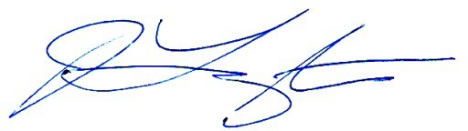

Jennifer Longtin, #43509
The Law Office of Jennifer E. Longtin, LLC

Certificate of Service

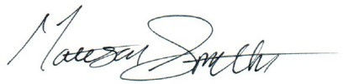
The undersigned does hereby certify that on July 20, 2017, s/he served the foregoing NOTICE AND REQUEST to all opposing counsel of record via ICCES:

DISTRICT COURT  JEFFERSON COUNTY, COLORADO  100 JEFFERSON COUNTY PARKWAY GOLDEN, COLORADO 80401 | ο COURT USE ONLY σ
THE PEOPLE OF THE STATE OF COLORADO
Plaintiff, v.
GARY NICKAL,
Accused.
Case No. 16CR001463

Division: 12
ORDER RE: NOTICE AND REQUEST FOR IN PERSON TESTIMONY
The above captioned motions is hereby:
Granted
Denies

Ordered this day of , 2017

Honorable District Court Judge

