VIRGINIA:
·, .)..

IN THE CIRCUIT COURT OF

)
FILED
C,WN!NAL.
hp
l AM :4'?9
C'LE' il ·
_iiil.f'?"J1t'•1 tr c•ouR
- VA . . r

. ,,·..

COMMONWEALTH OF VIRGINLA, )
)
- )
)
)
)
)
Defendant. )

The Honorable Hearing Date:

MOTION FOR ACCESS TO CRIME SCENE AND WITNESSES

COMES NOW, the Defendant, by his attorneys, and

, pursuant to his rights under the Fifth, Sixth, Eighth and Fourteenth Amendments to the United States Constitution and Article 1, §§ 8, 9 and 11 of the Virginia Constitution, and respectfully moves tb.is·Court·for an order compelling
and the management o- at
defense team reasonable access to examine the - crime scene and prohibiting interference with defense efforts to interview witnesses.
In making this motion, -reliesupon his right to call evidence in his favor and
to compulsory process, his right to due process, his right to a fair trial, his right to counsel, his
r,i.ght to ll!-Yestigate, prepare and present a defense, his right to equal protection;• his"right to·be . •,•,..,.. free from cruel and unusual punishment, his right to reliable sentencing determination, and other · rights safeguarded by the Fifth, Sixth, Eighth and Fourteenth Amendments to the United States Constitutipn, Article I, §§ 8, 9, and 11 of the Virginia Constitution, and the other authorities cited

herein.

fu support of this motion,

  - The defense of

by Counsel, states as follows:

Background

requires that his counsel and defense team view and

inspect the scene of the crime. The defense o also requires that his counsel and

defense team have access to witnesses who reside and work at
,_
1, I • • •
- 2. On information and belief,1 the crime scene is the located at
believed to be owned d/or managed by
apartment complex.
. . ·: . . .
apartment complex

, Virginia and

;a.

foreign limited liability company whose registered agent in Virginia is Corporation Service

Company,'

-(Seeattached)

.On
-VA
and who is represented by the

was a resident ofi ;when the police

responded to a citizens telephone call requesting a check on the well being of the decedent. The

police located the decedent's body in apartment.. A search of the area allegedly revealed
'
bloodstain evidence in the hallway and stairwell outside the decedent's apartment. Additionally,

the public areas of the complex, the business areas accessible to

''the key room"), and specific movements of the decedent and others on
(such as

were all investigated by the police. Some of the residents and employees of are believed to be witnesses to the circumstances surrounding the death of the decedent and any prior contacts between and the decedent may have had. It is believed that residences- and

1 The bases for this information and belief are the discovery materials obtained from the prosecution, a review of the pleadings and materials that have been filed in this case, and the media coverage of the case.

.. ·)

employees of-have infonnation concerning employment there and other matters related to potential mitigation in this case. The defense has been denied the ability access the property to investigate this incident and interview witness who h_ave been identified by law enforcement or attempt to identify any additional witnesses relevant to the alleged offenses and possible punishment.
- -facilitated the Commonwealth's investigation and preparation for trial by

pennitting the Police unfettered access to the apartment complex, its residents

and e ployees from through allowing more than two

doze police officers conduct investigations which include, but were not limited·to:² ,

- canvassing every apartment in the complex over a period of several days for the purpose of interviewing residents gathering infonnation, and identifying witnesses;
- searching the public areas of the entire complex, including the swim.ming pool area, .

.exercise room, and locker rooms; ·

- seizing evidence and taking numerous photographs and measurements of the complex and its features;
- permitting-employees to be interviewed; all employees were

cooperative in their interviews - none refused to talk with or mentioned that they had been

prohibited from talking to the.police by management; -himself was directed to
) ;._,,, ... ,',·'I, ! • •• :•:•1:f , ':, • • · • • •• , • I ,,

. ,• ,';;

cooperate with the police by- his supervisor and
's agent; and
'

- providing police investigators with key fob logs for the complex and information on

tenants.

2 These allegations are based on police reports and other information previously provided to the defense by the Commonwealth.

- continues to permit the police access to the-s curtilage, its residents and visitors.3
- However, - through its agents, has aggressively and affirmatively restricted the defense's access to apartment complex, its residents and employees -- forbidding its employees from speaking with the defense. s conduct is an effort to undermined the defense's investigation, thwarting s :fundamental rights to investigate and prepare
his defense. (See attached)
;
- It goes without saying that physical access of the defense team to

critically necessary to the preparation and presentation of 's defense. The taking of measurements of distances between objects, rooms, and alleged locations of persons and events, the dimensions of rooms and hallways, presence and location of doors and windows, lines of sight within the buildfug and curtilage, and views from inside to outside the residence and between wings of the complex are all necessary for defense counsel to understand witness accounts of the events in this matter, to locate and interview witnesses, to examine and cross- examine witnesses effectively, and to call for witnesses and-eviden_ce in 's behalf Furthermore, many identified witnesses who were residence of were also employed

_ there, as -was,dthese resident/employees material to both culpability and

mitigation.⁴ Unfortunately, these witnesses are solely ace:essible through entry to the apartment
·-: ..:1.· •• .:.;•·.": :: 1r••',;'i •,,,'I I

!•11... :·.

'' ·'·· .· · :..
. ..
;• ,·
complex.

- . The access to

. .
that the defense is requesting will be significantly less

3 This allegation is based on police reports and other information previously provided to the defense by the Commonwealth.
4 See, infra, Commentary to Guideline 10.7, Guidelines for the Appointment and Performance of Defense Counsel in Death Penalty Cases, ABA (2003). ·

intrusive than the investigative activities of the police/Commonwealth- which helped

facilitate.

Legal Argument

The Court has the authority and responsibility to order to provide the defense

team with reasonable access to the and to desist' in any interference with defense

interviews of its residents and employees. This authority deriv s from 's rights to effective assistance of counsel, compulsory process and due process under the Sixth and Fourteenth Amendments to the United States Constitution and Article 1, § 8 of the Constitution of Virginia. -s right to be free from cruel and unusual punishment under the Eighth Amendment to the U. S. Constitution and Article 1, § 9 of the Virginia Constitution further justifies and necessitates the Court granting the requested relief. The court should exercise its authority in the circumstances of this case for the.following reasons.
. To start, because this is a capital prosecution, exacting standards must be met to assure that it is fair. "[T]he penalty of death is qualitatively different from a sentence of imprisonment, however long. Death, in its finality, differs more from life imprisonment as than a 100-year prison term differs from one of only a year or two." Woodson v. North Carolina, 428 U.S. 280, 305 (1976). Because "death is different," the United States Constitution requires that
: .

,•,,1 •,•.
"extraordinary measures [are] to insure that"

';"
"is afforded process that will guarantee,
'. . ..·: ' .. .,'

as much as is humanly possible, that [a sentence of death not be] imposed out of whim, passion, prejudice, or mistake." Caldwell v. Mississippi, 472 U.S. 320, 329 n.2 (1985) (quoting Eddings
- Oklahoma, 455 V S.104, 118 (1981) (O'Connor, J., concurring)). The.refore, in order to

..·11
)
v

prevent a misc_arriage of justice, due process requires that the Court exercise its authority to remove any unfair and prejudicial obstructions to -•s defense.
Similarly, the barriers imposed on the defense's investigation in this case, if allowed to · persist, will render counsel constitutionally ineffective. The seriousness of a capital murder charge and the defendant's possibility of a sentence of death are circumstances that must be considered in evaluating whether.counsel provides the effective assistance required under the
Sixth Amendment. See Virginia Dept. of Corrections v. Clark, 227 Va. 525, 534 (1984).
'-

Counsel mu t conduct a reasonable pretrial investigation in a capital case. Id. A thorough defense investigation in a capital case is "vitally important," Powell v. Alabama, 287 U.S. 45, 57 (1932). As stated, "[c]ounsel at every stage have an obligation to conduct thorough and independent investigations relating to the issues of both guilt and penalty.'' Guideline·10.7, Guidelines for the Appointment and Pe,formance of Defense Counsel in Death Penalty Cases, ABA (2003) (emphasis added).5 This obligation includes the duty to find and interview:
. .
  - eyewitnesses or other witnesses having purported knowledge of events surrounding the alleged offense itself;

  - potential alibi witnesses;

  - witnesses familiar with aspects of the client's life history that might affect the lik:elihood that the client committed the charged offense(s), and the degree of culpability for the offense, including: ·

•,·. l · (a) members of the client's immediate-and extended family· •: ' , { • I ' '!" t:; •," • , t

    - neighbors, friends and acquaintances who knew the client or
his family

5 The United States Supreme Court has repeatedly endorsed the ABA Guidelines as benchmarks for assessing the constitutional effectiveness of defense counsel's representation in a capital case. See Rompilla v. Beard, 545 U.S. 374 (2005) (finding trial counsel constitutionally ineffective and vacating death sentence based upon failure to comply with ABA Guidelines); Wiggins v. Smith, 539 U.S. 510 (2003) (same).

·, · · -· ·

,....,,,
y

    - former teachers, clergy, employers, co-workers, social service providers, and doctors

Commentary to Guideline 10.7, Id (emphasis aqded).

The right to call witnesses and present evidence in your own defense is a fundamenta·l

- right of due process protected under both the United States Constitution and the Virginia Constitution. Washington v Texas, 338 U.S. 14, 19 (1967). The 6th Amendment of the U.S. Constitution proclaims that an accused is guaranteed a "compulsory process for obtaining witnesses in his favor." U.S. Const. am. Under the Virginia Constitution, an accused has the right to "call evidence in his favor." Va. Const. art. I. § 8. It is imperative that defense counsel be able to converse with willing residents so that the defendant may "investigate and evaluate the
)
evidence in preparation for trial." Gilchrist v_ Commonwealth, 227 Va. 540, 54_6 (1984).

. "Witnesses preparation is a vital part of counsel's assistance to the defendant. "[A]n accused has the unqualified right to 'call for evidence in his favor.' This includes e right to prepare for trial which, in turn, includes the right to interview material witnesses and ascertain the truth.'" Warmouth v Commonwealth, 29 Va. App. 476, 485 (1999), (quoting Bobo v Commonwealth,
187 Va. 774, 779, (1948)), Va. Const. art. I, § 8.

The effective assistance of counsel is not only thwarted through counsel's lack of effort -

it c_an also result_;g.-wn e?rt"1.r:g :f irpµ:o.J,stance. fhat prevent. c,ompetent counsel from being·•;,•. .-,·:'·. · _{:-r,-,·,}

effective. See Sheikh v. Bucki.ngham Correctional Ctr., 264 Va. 558, 564-:-65 (2002) (cifu1g with approval United States v. Cronic, 466 U.S. 648, 659-60 (1984)). I ; ; inte1ference with the defense investigation in this case is just such an external circumstance which, if not
neutralized, will result in violation of-'srights to effective assistance and due process,

,. '}) ' '

as well as bis right to compulsory process.

In a non-capital context, the Court of Appeals addressed a similar situation in Henshaw v. Commonwealth, 19 Va. App. 338 (1994). There, the offense- a shooting that resulted in a death
- occurred inside a private residence. The ovvner of the residence had refused permission to the
',
defense to view the scene of the incident. The defense, therefore, moved the trial court for an order providing access to the private residence, wbich the trial court denied. Citing the defendant's constitutional rights, the Court of Appeals found that "the trial court erred in denying the [defendant] access to the crime scene." Id at 339.
In so ruling, the Court of Appeals observed that a criminal defendant's rights to compulsory process and due process (denominated the "right to call for evidence in bis favor" under the state constitution) require that a 'trial court grant a defendant's request to compel·
defense "'access to the raw m terials integral to the building of an effective defense."' Id at 344 (quoting Ake v. Oklahoma, 470 U.S. 68, 77 (1985)). The court elaborated
"This ... includes the right to interview material witnesses and to ascertain the truth." Bobo v. Commonwealth, 187 Va. 774, 779, 48 S.E.2d 213, 215 (1948)), the right to prepare for trial, and tlte right to
present an adequate defense. Gilchrist v. Commonwealth, 227 Va. 540, 547, 317 S.E.2d 784, 787 (1984). "These rights lie at the heart of a fair
trial, and when they are abridged, an accused is denied due process."
Id
Id. (emphases added; quotations and citations in original). The court then concluded that, upon a

.. 'j• .,......•.· ,r,;.X \-:•,
·rr. ·.. , . .. f, ·: t -. / • • ..... • •• . "'•'.·: .- ,

showing of a factual basis of the need for such access, the right of a criminal defendant includes
' '

the right to compel access to a crime scene despite a third party's denial of access. Id at 345-46. ''Upon a prima facie showing of relevance, the trial judge shall order access for observation and inspection, subject to such reasonable restrictions and limitations as the court determines

key fob logs).

Thus, the foregoing facts and argument demonstrate that presentation of his defense grossly outweighs any right or interest preventing defense access to

's preparation and may have in

therefore enter an order grant the relief requested herein.

WHEREFORE, by Counsel, requests that this Court enter an order that requires (a) to provide the defense team with reasonable access to the I L apartment complex for the investigation and preparation of s defense, and (b) to cease
and desist from interfering with the defense interviews of its agents, employees and residents, including, being required to correct previous instructions that such persons should not speak to members of the defense team, and to instruct such persons that they can speak with defense counsel and their agents just as they can speak with law enforcement agents.

Respectfully submitted,

By Counsel

Co-Counsel for Defendant
. ..::::,:·. .;. \-t''••··· .., •.. ·!•';_,

was delivered
• ··•• -.·.,.
. '•.·,,. •'

"}

,VSB#­

Co-Counsel for Defendant
,VA
Phone­

Fax-

CERTIFICATE OF SERVICE

We/I hereby certify that a true copy of the foregoing Motion/Memorandum

and/or mailed, first class mail to:

, Esquire Commonwealth's Attorney

And personally served upon
.,.....

Esquire

VA..
And the original was forwarded for filing to: Hon.­
...........
Clerk
Circuit Court

.U , Virginia ·,:...: • !. ;.,:• ..,' . ·: \ •....' •• :,:..:r.c.:. •..,._..._{·1·•} ., • •:· ··•
-

On this• day of

...

VJRGINIA:
IN THE CJRCUIT COURT OF

COMM:ONWEALTH OF VIRGINIA, )

)
v. )
)
)
)
,.,, )
Defendant. )

CRIMINAL Nos:

The Honorable Hearing Date:

NOTICE OF MOTION FOR ACCESS TO CR™E SCENE AND WITNESSES

PLEASE TAKE NOTICE that on at the Defendant, - through his attorneys, and , will move this Honorable .
0
Court for the entry of an Order (I) providing the defenseteam with reasonable access to apartment complex for the investigation and preparation of s defense and
(2) to cease and desist from interfering with the defense interview ofits agents, employees and residents.
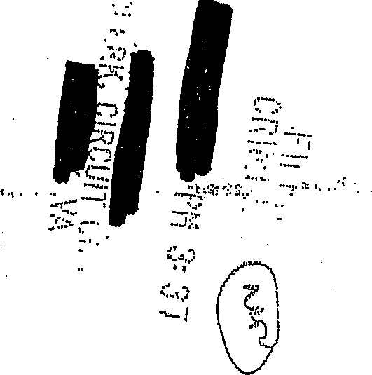
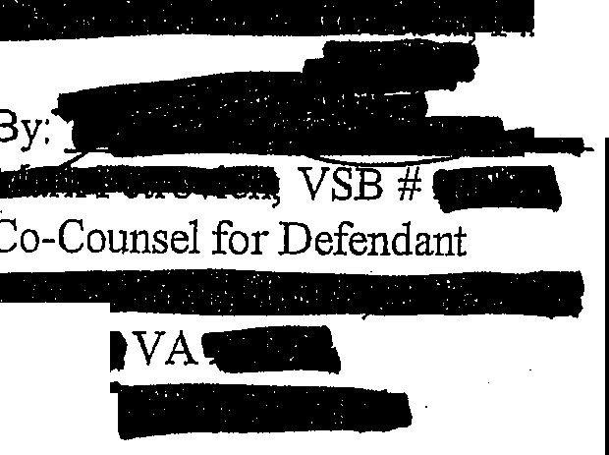Respectfully submitted,

By Counsel

a
Phone
. -.

•• ••

:.-.... :,:,1.•, • • • •

• ·.r •··

:y _

. Co-Counsel for Defendant

CERTIFICATE OF SERVICE

We/I hereby certify that a true copy of the foregoing Motion/lv.[emorandum was delivered and/or mailed, first class mail to;

Commonwealth's Attorney
£ Q Virginia£ ] And personally served upon

Counsel for
J•tI QVA
And the original was·forwarded for filing to:

·:·.·

·:• .....
Hon. Clerk

Circuit Court

. ::: .•1 \ ..

- . 1•:' ..,•.

f·1 , .

I 4 Virginia
On thlrl/l day ofNovember,...

2

