VIRGINIA:

- , . iI r:{ .
I•,. ••

Defendant.
Judge:· Hon.

Motion for Mitochondrial DNA Testing by Private Laboratory of Human Hair Fragments Recovered in Item # 25 and Item #38
,..

DEFENDANT'S MOTION FOR MITOCHONDRIAL DNA TESTING BY PRIVATE LABORATORY OF HUMAN HAIR FRAGMENTS RECOVERED IN ITEM 25 AND ITEM 38

PLEASE TAKE NOTICE that on
at 10:00 a.m., or as soon

thereafter as this Motion can be heard, the Defendant, attorneys, of
through his and

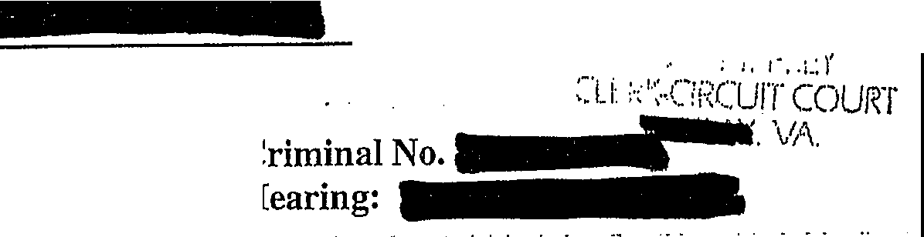of the will move this Honorable Court, pursuant to
IN THE CIRCIDT COURT OF COMMONWEALTH OF VIRGINIA
vs.
...

his rights under the Fifth, Sixth, Eighth and Fourteenth Amendments to the United States Constitution and Article 1, sections 8, 9 and 11 of the Virgin_ia Constitution, § 19.2- 264.3:1.3 & 332 of the Code of Virginia, for the entry of an Order ordering mitochondrial DNA testing of particular human hair fragments recovered in Item #25 and Item #38, based on the report in DFS's bench notes that hair fragments could be grouped out by identifying physical characteristics. Assuming that DFS does not have the capability to conduct all requested and necessary testing prior to the trial date, as has been represented,
-respectfully requests that the remainder of any such testing is conducted by a private laboratory.

In support of this Motion, through counsel, states the following:

  - On the Department of Forensic Sciences issued a Certificate of Analysis that reflected the results of microscopic analysis of Items, 1, 25, and 38 for review of evidence recovery of possible human hairs and human hair
fragments. That Certificate was attached to Defendant's Notice of Defense Counsel's

-Letter to Depa1iment of Forensic Sciences Requesting Mitochondrial

DNA Testing of Particular Human Hair Fragments Recovered in Item #25 and Item #38,

Based on Report in DPS' Bench Notes that Hair Fragments Could be Grouped Out by

Identifying Physical Characteristics ("Defendant's Notice of Defense Counsel's
-----I Letter).
  - The Certificate of Analysis (COA) reported that no hairs suitable for nuclear or mitochondrial DNA testing were recovered from Item 1 right fingernail clippings. The COA reported that no hairs·suitable for nuclear DNA testing were recovered from Item 1 left hand fingernail clippings. The COA reported that 3 human hairs that may be suitable for mitochondrial DNA analysis were recovered from Item 1 left hand fingernail clippings.
  - The COA reported that foreign material recovered from Item 25 included approximately 49 human hair fragments and ten human hairs. The COA reported that six of the ten human hairs may be suitable for nuclear DNA testing. The COA reported that the remaining four human hairs not suitable for DNA testing may be suitable for mitochondrial DNA testing.
  - . The COA reported that no hairs suitable for nuclear DNA testing were recovered from Item 38. The COA reported that foreign material recovered from Item 38

i.

included one human hair and approximately 42 human hair fragments·. The COA

repo1ted that the human hair and 42 human hair fragments may be suitable for mitochondrial DNA testing.
  - DFS indicated by letter to the Court that it could analyze up to 10 human hairs/hair fragments for mitochondrial DNA testing in time for the trial in this matter. There was no issue as to capacity to analyze those hairs suitable for nuclear DNA testing.
  - On Motions Hearing, the defense asked that all the human hairs and hair fragments be tested for nuclear DNA and/or mitochondrial DNA where appropriate. ¹ This Court denied that request and ordered the following specific DNA testing:
- nuclear DNA testing on the six (6) complete human hairs as identified in

Item #25 of the Certificate of Analysis;
- mitochondrial DNA testing of the three (3) human hairs as identified in Item #1 of the Certificate of Analysis;
- mitochondrial DNA testing of the four (4) human hairs as identified in Item #25 of the ertificate of Analysis; and
- mitochondrial DNA testing of the one (1) human hair identified in Item #38 in the Certificate of Analysis.
- In addition, as part of the same order, this Couit ordered "of the remaining human hair fragments as identified in Items #25 and #38, the Department of Forensic Science, in its expert discretion, shall randomly select a sample of these human hair

1 The defense reiterates its request that all the human hair and human hair fragments recovered in Items 1, 25, anci 38 are tested. In light of the Court's denial of that request (but without withdrawing the claim for trial or appellate purposes),
that derive from DPS' own grouping of hair fragments by microscopic visual comparison.
makes more specific requests
■- - ■

"

fragments to conduct mitochondrial testing upon. The method of selection and the number of human hair fragments selected shall be determined by the Department."
- Since the hearing, the defense obtained, pursuant to SDT with materials

returned to the Court Clerk's file, the scientific bench notes and worksheets that underpin
. ..
the Certificate of Analysis. Those materials were attached as an Exhibit

to Defendant's Notice of items is dated
Letter to DFS. The cover letter for the The defense obtained the materials after that date and

was able to review them closely, with assistance of a DNA expert, on

- and the defense thereafter sent a letter to DFS to request certain testing.

- Those bench notes and worksheets make clear that, through microscopic evaluation, DFS was able to broadly distinguish among the approximately 49 human hair fragments in Item #25 and among the 42 human hair fragments in Item #38.
- As for Item #25, the bench notes (pages 13-19) reflect that of the

approximately 49 human hair fragments,2 DFS grouped those hair fragments into three separate groups based upon visual observation of physical features under the microscope. One group contained approximately 36 human hair fragments (page 14, top); a second group contained approximately 15 human hair fragments (page 14, bottom); and then there was a single "v.v. dk. brown" hair fragment that was grouped by itself (page 16, top). Concerning the hair fragments, the notes (page 19) reflect, "Groupings of fragments would be as listed in notes, due to physical features."
- Of these groupings of the approximately 49 human hair fragments in Item #25, the defense moves that the single "v.v. dk. brown" hair fragment is tested for

2 Although the report indicated 49 human hair fragments, hash marks on the notes suggest that the number is 52.

mitochondrial DNA, at least 1 human hair fragment from the group of approximately 36 human hair fragments is tested to develop a mtDNA profile, and that at least 1 human hair fragment from the group of approximately 15 human hair fragments is tested to develop a mtDNA profile.
- As for Item #38, the bench notes (pages 6-9) reflect that of the 42 human hair fragments, DFS grouped those hair fragments into four separate groups based upon visual examination of physical features under the microscope. One group contained approximately 23 human hair fragments; a second group contained approximately 17 human hair fragments; there was a single "pigmentation more dense toward cuticle, brown (proximal) to pale (distal)" human hair fragment that was separately grouped; and there was a single "darker? Than previous hairs" human hair fragment that was separately grouped. The notes (page 9) reflect, "Groupings would be as listed in notes, due to physical features."
- Of these groupings of the 42 human hair fragments in Item #38, the defense moves that the single "darker than others" human hair fragment is tested for mitochondrial DNA; the single "brown to pale" human hair fragment is tested for mitochondrial DNA; at least 1 human hair fragment from the groul? of approximately 23 human _hair fragments is tested to develop a mtDNA profile, and that at least 1 human hair fragment from the group of approximately 17 human hair fragments is tested to develop a mtDNA profile.
- The defense moves that the above requested testing is conducted either by DFS, or, if DFS does not have the capacity to conduct the testing in a timely fashion, a contracting forensic DNA laboratory.

- DPS has advised that it has already begun the mitochondrial DNA analysis of the eight hairs ordered by the Court on (in addition to doing the nuclear DNA testing). DFS has advised that it can only do mitochondrial DNA testing of
two additional hairs/hair fragments in time to have the results in advance of the trial date.
. . .. ·-
DFS has proposed that, as for the two remaining samples it tests f9r mitochondrial DNA,

it conduct mitochondrial DNA testing of (a) single "v.v. dk. brown" hair fragment that was grouped by itself in Item 25 and (b) a single "darker? Than previous hairs" human hair fragment that was separately grouped in Item 38. 'Although reiterating its preference that a private laboratory conduct the independent DNA testing for the defense in this case, in light of the Court's prior rulings denying such requests, the defense does not object to DFS's conducting th'ose two tests.
- Assuming that DPS can conduct the two above tests, there remain at least 5 other hair fragments that need to be tested to have a representative sample from each of the groups in Items 25 and 38. The defense requests that DPS be inquired whether it can incr ase its capacity to also conduct 5 or more mitochondrial DNA tests to get samples from t e other groups. If so, the defense asks that the Comt order DFS to conduct an the tests requested in paragraphs 11 and 13 above. (The defense notes that-has advised that he expects a representative of DFS to be available by telephone call during tomorrow's hearing).
- Assuming DFS ca11not conduct the mitochondrial DNA testing of the remaining groups, the defense moves that a private laboratory conduct the testing of 5-7 hair fragments. The defense has been in contact with two separate private laboratories that have stated the ability to conduct the testing prior to the trial date.

- A representative of the defense spoke witlIM ■ iloflllf
Virginia.■ -indicated thatllllcould conduct the testing of 5-7 hair fragments for mitochondrial DNA. CC 8, ndicated that with a turnaround time of 8-10 weeks, the cost per hair fragment is $2950-3200, depending on
..... - . . . .
how the hair fragments are preserved by DFS d
time of 20 days (4 business weeks), the cost per hair fragment is $5900-6400 (expedited pricing is double regular pricing), depending on how the hair fragments are preserved by DFS. Thus, ... s estimate for testing 5 hair fragments is approximately $15,000 for turnaround in 8-10 weeks and $30,000 for turnaround in approximately four weeks. -

-can breached at

- A representative of the defense and
- ,"f- I;.
I

spoke with f 8
rndicated

could conduct the testing of 5-7 hair fragments for mitochondrial DNA.

·ndicated that the turnaround time would be approximately 4 weeks. Dr.

.. indicated that the cost per hair fragment is $2500. Thus,_s estimate

for testing 5 hair fragments is $12,500. Dr. indicated that she would have no

problem with acceptance of a subpoena and appearance in court, if necessary, and that

is within driving distance of
. Dr I a :an be reached

advised Dr.-that she should make herself

available to speak with-of DFS or Deputy Commonwealth's Attorney­

-should they call.

- Section 19.2-264.3:1.3 provides for expert assistance of indigent defendant in capital cases. Subsection B provides that the Court "shall direct requests for

7

scientific investigation to the Department of Forensic Sciences or Division of

Consolidated Laboratory Services whenever practicable." Here, it appears that the it is

not practicable for the Court to directIii testing to DFS exclusively.
114 s request for mitochondrial DNA

- The right to call witnesses and present evidence in the defendant's own defense is a fundamental right of due process protected under both the United States Constitution and the Virginia Constitution. Washington v Texas, 338 U.S. 14, 19 (1967). The 6th Amendment of the U.S. Constitution proclaims that an accused is guaranteed a "compulsory process for obtaining witnesses in his favor." U.S. Const. am. VI. Under the Virginia Constitution, an accused has the right to "call evidence in his favor." Va. Const. art. I. section 8. Defense counsel must be afforded the ability to '.'investigate and evaluate the evidence in preparation for trial." Gilchrist v Commonwealth, 227 Va. 540, 546 (1984). "[A]n accused has the unqualified right to 'call for evidence in his favor.' This includes the right to prepare for trial which, in turn, includes the right to interview material witnesses and ascertain the truth." Warmouth v Commonwealth, 29 Va. App. 476,485 (1999) (quoting Bobo v Commonwealth, 187 Va. 774, 779, (1948)), Va. Const. art. I, section 8.
- The Supreme Court of Virginia has established that a defendant is entitled to inspect potential evidence upon a plausible showing that the material might have exculpatory relevance, seeRamdass v Commonwealth, 246 Va. 413,437 (1993), and impeachment value alone may make the information exculpatory. Fitezgerald v Bass, 6 Va. App. 38, 52-53 (1988). Furthe1more, the Court of Appeals has ruled that a failure on the part of the Commonwealth to conduct a particular form of investigativ testing, which

potentially could provide exculpatory evidence, requires dismissal. Breeden v Commonwealth, 15 Va. App. 148, 150 (1992).
- Any barriers imposed on the defense's investigation of the physical

evidence in this case will render¥1 @acounsel constitutionally ineffective. The seriousness of a capital murder charge and the defendant's possibility of a sentence of death are circumstances that must be considered in evaluating whether counsel provides
the effective assistance required under the Sixth Amendment. See Virginia Dept. of Corrections v. Clark, 227 Va. 525, 534 (1984). Counsel must conduct a reasonable pretrial investigation in a capital case. Id. A thorough defense investigation in a capital case is "vitally important," Powell v. Alabama, 287 U.S. 45, 57 (1932). "Counsel at every stage have an obligation to conduct thorough and independent investigations relating to the issues of both guilt and penalty." Guideline 10.7, Guidelines for the Appointment and Peiformance of Defense Counsel in Death Penalty Cases, ABA (2003) (emphasis added).
- -hasa due process right to the assistance of experts. Ake v. Oklahoma, 470 U.S. 68 (1985), andHusske v. Commonwealth, 252 Va. 203,476 S.E.2d 920 (1996). -hasheightened due process rights, through the Eighth Amendment, because this is a capital case. See Woodson v. North Carolina, 428 U.S. 280, 305 (1976); Caldwell v. Mississippi, 472 U.S. 320, 329 n.2 (1985) (quoting Eddings
v. Oklahoma, 455 U.S. 104, 118 (1981) (O'Connor, J., concurring)); Caspari v. Bolden,

510 U.S. 383, 393 (1994); Beck v. Alabama, 447 U.S. 625, 638 (1980).

- Here, the conducting of mitochondrial DNA analysis of evidence recovered from the decedent's body is crucial to-sdefense. There is evidence

of another individual- neither-nor the decedent- on the decedent's body. Prior testing has revealed blood stains from persons other than-inthhallway
and stairwell that were swabbed and recovered as evidence by the police in this case. -
•++1as aright to this testing to develop evidence that excludes W-, s the contributor of DNA evidence on the decedent's body, in support of a defense to capital murder at the guilt phase of this trial.

WHEREFORE,_ by counsel, requests that this Court enter an order that requires the Commonwealth to order mitochondrial DNA testing and development of
mitochondrial DNA profiles for the following: (1) of these groupings of the approximately 49 human hair fragments in Item #25, the single "v.v. dk. brown" hair
:fragment, at least 1 human hair fragment from the group of approximately 36 human hair fragments, and at l ast 1 human hair :fragment from the group of approximately 15 human hair :fragments; and (2) of these groupings of the 42 human hair fragments in Item #38, the single "darker than others" human hair :fragment; the single "brown to pale" human hair :fragment; at least 1 human hair :fragment from the group of approximately 23 human hair :fragments, and that at least 1 human hair fragment from the group of approximately 17 human hair fragments.

Respectfully submitted,
By Counsel
..

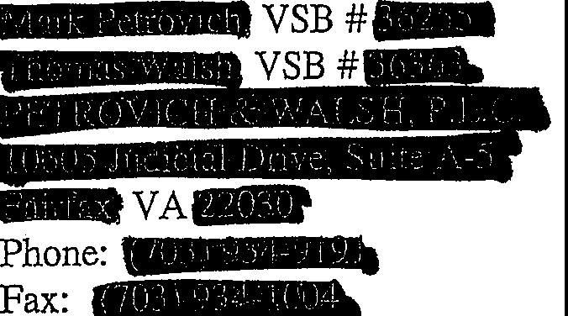

CERTIFICATE OF SERVICE

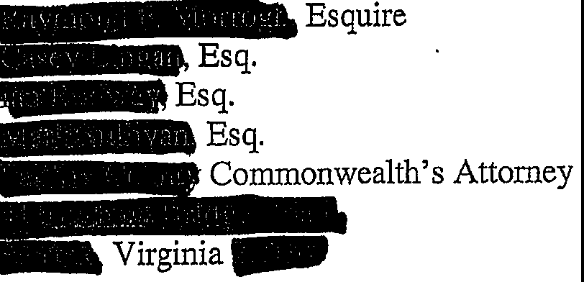
We/I hereby certify that a true copy of the foregoing Notice was delivered and/or mailed, first class mail to:

And the original was forwarded for filing to: Hon.­
Clerk
CirGuit Cou,rt
_ _ ,..,, irginia _ .
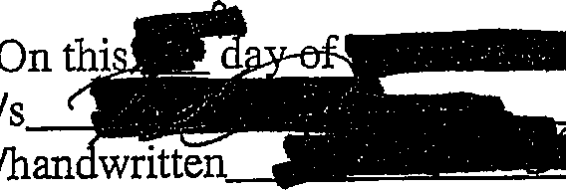

. 11

