..{

() '

·.¥JRGINIA:

JN THE CIRCUIT COURT OF COMMONWEALTH OF VIRG1NJA
vs.

,._
--,{ ,..,.I.,f;j iI/.;·
('l,.I- l · .
't l!!
'··
/J!':1 0
..1: I
=::.;_;_::.,_ ----------;.,f',.;..J I 0
• · .•r //(, l'/fi' . ()
Ml11'if,IJililt r, ..:
Criminal No_..-. ---. l1rct''1,,;:,
Hearing:_,
. . . .
Judge: lion. _.,

Motion for Further Mitochondrial DNA Testing to Corroborate Evidence of Unknown Person's DNA on the Crime Scene

MOTION FOR ADDITIONAL MITOCHONDRIAL DNA TESTING TO CORROBATE EVIDENCE OF UNKNOWN PERSON'S DNA ON THE CR™E SCENE

COMES NOW, the Defendant, by counsel, pursuant to his right to be free from cruel and unusual punishment, his right to due·process, his right to
notice, his right to a fair trial, his right to counsel, his right to present a defense, and his right to a reliable sentencing determination, guaranteed by the Fifth, Sixth, Eighth, and Fourteenth Ainendments to the United States Constitution., Article I, §§ 8, 9, and 11 of
the Coristitution of Virginia, and other authorities cited herein, respectfully moves this
-,...
Court to orde{:additional mitochondrial DNA testing, based on the fact that mitochondrial .
' . ' '..i. ;;t .
DNA testing c·6nducted thus far has identified that a human hair belonging to an

unknown person- DFS Item No. 38E,
recovered from the left hand of the decedent.¹
Item No. 3049Q6 - was

1 Dr, - of a daDNA expert consulting with the defense each compared the 1111tocho11drial DN DFS Item No. 38E to the lmown mitochondrial DNA profiles of--and the decedent. and the decedent are conclusively eliminated as po butors to that htm1an 1au- -ragment. DFS Item No. 38E was left by an unknown person.
1

,;'' !,,

The defense seeks to conduct additional. mitochondrial DNA testing to evaluate if. various samples froni the crime scene in which unknown nuclear DNA profiles were developed have the same mitochondrial DNA profile as DFS Item No. 38E and to identify other human hairs recovered from the victim's left hand in DFS Item Numbers
25 and 38 that have the same mitochondrial DNA profile as DFS Item No. 38E.

PLEASE TAKE NOTICE that on , at 9:00 a.m., or as soon thereafter as counsel may be hecird, counsel will argue this Motion to the Comi .²
In support of this Motion,-• through counsel, states the following:

- Pursuant to the Court's

request to initiate mitochondrial DNA testing,³ on
Order granting a defense

the Department of

Forensic Sciences ("DFS") issued a Ce1iificate of Analysis(' COA'') that
. ·- ' .
reflected the results of microscopic analysis ofltems, 1, 25, and 38 for review of

evidence recovery of possible human hairs and human hair fragments. The

COA reported concerning approximateiy 96 human hair/hair fragrr:ients that may be suitable for mitochondrial DNA analysis_, recovered from Item Nos. 1, 25, and 38.⁴
- At the next motions hearing, on the defense moved that
,

all the human hairs/ hair fragments that may be suitable for mitochondrial DNA analysis be tested. This Court denied the request for the testing of all 96 samples and ordered the

2 Counsel for-discussed this request for fmther mitochondrial DNA testing with the Conu11011wealth and had anticipated noticing this Motion for the hearing date;

the Court to hear the Motion sooner. Upon the Court's setting a■■- - ■
date,

however, both counsel for the Commonwealth and for the defense believe that it makes sense for
1I1earing
3 On■■-- ■•
counsel is filing this Motion to be heard that same day.
the defense filed Notice and Motion for Additional Nuclear DNA Testing of a Blood Sample, and Microscopic Hair Comparison and Mitochonchial DNA Testing of Hair Samples.
4 The COA also reported that there were 6 hairs suitable for nuclear DNA analysis.

,..

mitochondrial DNA testing of 8 specific human hairs and a random selection of the human hair fragments. ⁵
- Based upon the subsequent receipt and review of the scientific bench notes

and worksheets that underpin the COA, the defense sought additional

mitochondrial DNA testing of the human hair fragments, and the Court heard the motion

011 .6 At the hea ing and subseque tly memorialized in a...

- Order, the Comt denied the defense's request for mitochondrial DNA testing of all the human hair fragments recovered in Items 25 and 38 and granted the request for additional mitochondrial testing of two specific human hair fragments by DFS and 5
human hair fragments b :A jr echnologies.

- By its-and Orders, the Court ordered that

report its results no later than The Court did

not set a specific date for DFS .to report its results.

- DFS has not yet issued a Certificate of Analysis for the mitochondrial DNA testing of the 10 human hairs and human hair fra ents ordered by the Court, Based upon the visual inspection of those human hairs/hair fragments under a microscope, the defense has reason to believe that unknown third party mitochondrial DNA profiles will be developed from DFS testing of those samples.7

5 The Court also ordered nuclear DNA testing ₀₁₁ the six complete human hairs as identified in Item #25 of the

6 On
■--
the defense filed Defendant's Motion for Mitochondrial DNA Testing

by Piivate Laboratory ofH1m1an Hair Fragments Recovered in Item 25 anc!'Item 38. This motion followed the defense's letter to DPS, requesting additional mitochondrial DNA testing and Notice of said letter.
7 At least two of those hair fragments are described as looking very different than other recovered
hairs/hair fragments. These hair fragments are reflected in Paragraph (2)(a) of this Court's Order.

- DFS has informed both pmties that it intends to provide those results no later than

8 On
defense counsel-sent an email to

- ofDFS, asking whetherllllf knew or had reason to believe whether DFS would be providing those results prior to has not responded to that email.

6.

its testing.
On , ----epotedtresults of The defense forwarded the repo1t to the Court and to the Commonwealth on

that same day and on filed Defendant's Notice of Piling of
,

Mitochondrial DNA Test Report and Invoice fro J Technologies. As reflected in its report; :'.e-9lmologies obtained mitochond1ial DNA results for all 5 hairs it sampled. Four of those hairs had a mitochondrial DNA profile for which the decedent (and her maternal relatives) could not be excluded. Tellingly, one of those

hairs; DFS Item No. 38E, had a mitochondrial DNA profile.for which both the vic.tim and

-(and their materials relative.s) were eliminated as possible contributors.⁹ Thus, a hair.from an unknown third person wasfound and recovered in the victim 's left hand

8 On-,DFS issued a Certificate of Analysis (''-COA" for the that it conducted on 6 hairs pursuant to the Court's ,
n g
- order. By the-.,COA,_ is excluded as the contributor of the 6 the decedent is mcluded as a poss tor t 5 of the hairs, and nuclear
"DNA types ofno value were developed from hairs A, B, and F." The defense received and teviewed the scientific bench notes and worksheets underpinning the COA on Those notes reflect that there were several peaks that DFS did not use in its analysis. The defense cannot tell from the documents provided whether
those peaks might indicate the presence of an unknown person and intends to follow-up
by .._..,f.in.fo.rmation from DFS and an interview of the DFS Examiner.
9 Dr.
and a DNA expert consulting with the defense each compared
the mitochondrial DNA DFS Item No. 38E to the known mitochondrial DNA profiles of a andthe decedent. • - - and the decedent are conclusively eliminated as possible contributors to that human hair fragment. DFS Item No: 38E was left by an m1know11 person.
■■■ ■

- A number ofDNA results identify unknown nuclear DNA on the crime scene on items seized/swabbed by the police in the course of its investigation.
- Court-ordered nuclear DNA testing at the request of the defense determined that an unknown person left a blood stain in the hallway outside the victim's apartment;
- Court-ordered nuclear DNA testing at the request of the defense
determined that an unknown person left blood stains on the balusters in the back stairwell outside the decedent's apartment.
. .
- Nuclear DNA testing identified at least one genetic marker for an
unknow11 person 011 a breast swab sample of the victim.
- Nuclear DNA testing identified genetic markers for an unknown person on the kitchen implements (frying pan and cooking pot) believed to have
been used by an assailant as weapons against the decedent.

- -seeks mitochondrial DNA testing of the blood stains and other nuclear DNA samples discussed in paragraph 7, supra, that are evidence of the presence of unknown participant. If mitochondrial DNA testing of those samples matches the mitochondrial DNA profile of the hair recovered from the victim's left hand (DFS Item No. 38E), then the probative value of evidence of an unknown third party will be greatly increased. Matching mitochondrial DNA profiles between DFS Item No. 38E.and other DNA evidence will substantially undermine any argument by the Commonwealth that the

jury should disregard DNA evidence of an unknown person as a participant in the death of the decedent on the ground that the presence of such DNA is merely coincidental. ¹⁰
- -alsoseeks mitochondrial DNA testing of the remaining human hair fragments that have not been tested for mitochondrial DNA testing. If, as is currently the state of the evidence, there is just one hair that eliminates-and
points to a third person, the Commonwealth may argue - as it precisely did in seeking

death in Prieto - that the single hair's presence on the scene is coincidental and that the jwy should disregard it. However, the greater the number of unknown-contributor human hairs/hair fragments that match each other - whether 3, 5, 10, or more - the greater any argument by the Commonwealth that the jmy should disregard DNA evidence of an unknown person in the victim's hand is undermined and the stronger a defense argument to thejury ofreasonable doubt that_.was a principal in the first-degree and eligible for the death penalty.
- DFS identified approximately 96 human hairs and human hair fragments recovered from the victim's left hand in Items 25 and 38 that might be suitable for mitochondrial DNA analysis. Of those approximately 96 human hairs/hair fragments, the Court has ordered the testing of 15 (with the results of 5 having come in thus far). -
-respectfully requests that the Court order the testing of the remaining 81 human hairs/hair fragments. If the Court is not inclined at this time to order the testing of all 81 remaining human hairs/hair :fragments for financial or other reasons, the defense will note its objection and exception for the record at the hearing on this Motion and suggest an

10 The same reasoning applies to any mitochondrial DNA profiles that eliminate- and the decedent from the 10 samples awaiting results from DFS.

alternative order to protect-'s rights and to ensure that the Commonwealth does not have an unfair advantage at trial in this matter.
- Although the defense reiterates its preference that a private laboratory condu(?t the independent DNA testing for the defense in this case, in light of the Court's prior nilings denying such requests, the defense moves that the above requested testing is, pursuant to Va. Code. Sec. 19.2-264.3:1.3, conducted either by DFS, or, if it is not practicable for DFS to conduct all the testing, a contracting forensic DNA laboratory- · most likely either ₁ or-
- The right to call witnesses and present evidence in the defendant's own defense is a fundamental right of due process protected under both the United States
. -
Constitution and the Virginia Constitution. Washington v Texas, 338 U.S. 14, 19 (1967).
The.6th Amendment of the U.S. Constitution proclaims that an accused is guaranteed a "compulsory process for obtaining witnesses in his favor." U.S. Const. am. Vt Under the Virginia Constitution, an accused has the right to "call evidence in his favor." Va. Const. art. I. sec. 8. Defense counsel must be afforded the ability to ''investigate and evaluate the evidence in preparation for trial." Gilchrist v Commonwealth, 227 Va. 540, 546 (1984). "[A]n accused has the unqualified right to 'call for evidence in his favor.' This includes the right to prepare for trial which, in turn, includes the right to interview material witnesses and ascertain the truth." Warmouth v Commonwealth, 29 Va. App.
476,485 (1999) (quoting Bobo v Commonwealth, 187 Va. 774, 779, (1948), Va. Const.

art. I, sec. 8).

- The Supreme Court of Virginia has established that a defendant is entitled

.to inspect potential evidence upon a plausible showing that the material might have exculpatory relevance, see Ramdass v Commonwealth, 246 Va. 413, 437 (I 993), and impeachment value alone may make the information exculpatory. Fitzgerald v Bass, 6 Va. App. 38, 52-53 (1988). Furthermore, the Court of Appeals has ruled that a failure on the part of the Commonwealth to conduct a particular form ofinvestigative testing, which potentially could provide exculpatory evidence, requires dismissal. Breeden v Commonwealth, 15 Va. App. 148, 150 (1992).
- Any barriers imposed op the defense's investigation of the physical evidence in this case will render -•s counsel constitutiona:Uy ineffective. The seriousness of a capital murder charge and the defendant's possibility of a sentence of death are circumstances that must be considered in evaluating whether counsel provides the effective assistance required under the Sixth Amendment. See Dept; of Corrections v.
Clark, 227 Va. 525, 534 (1984). Counsel must conduct a reasonable pretrial

investigation in a capital case. Id. A thorough defense investigation in a capital case is "vitally important," Powell v. Alabama, 287 U.S. 45, 57 (1932). "Counsel at every stage have an obligation to conduct thorough and independent investigations relating to the issues of both guilt and penalty." Guideline 10.7, Guidelines/or the Appointment and_ Performance qf Defense Counsel in Death Penalty Cases, ABA (2003) (emphasis added).
- h s due process right to the assistance of experts. Ake v.

Oklahoma, 470 U.S. 68 (1985); Husske v. Commonwealth, 252 Va. 203 (1996). -

- has heightened due process rights, through the Eighth .Amendment, be ause this is a capital case. See e.g., Caspari v. Bolden, 510 U.S. 383, 393 (1994); Caldwell v.

Mississ;ppi, 472 U.S. 320,329 n.2 (1985) (quotingEdding.n. Oklahoma, 455 U.S. 104,
118 (1981) (O'Connor, J., concurring)); Beck v. Alabama, 447 U.S. 625, 638 (1980);
Woodson v. North Carolina, 428 U.S. 280, 305 (1976).

- Here, the conducting of further mitochondrial DNA analysis of evidence recovered from the decedent's body is crncial to-•s defense. There is eviderice of another individual - neither_,nor the decedent - on the decedent's body. Prior testing has revealed blood stains from persons other than-in the hallway and stairwell that were swabbed and recovered as evidence by the police in this case. Mitochondrial DNA testing has now revealed that a hair belonging to someone other than ·
-wasin the victim's hand as she lay prone on the ground in her apartment.

-hasa right to this testing to develop evidence that excludes - as the
. . .
contributor of DNA evidence on the victim's body, in support of a defense to capital

murder at the guilt phase of this trial.

WHEREFORE, - by counsel., respectfully requests that this Court enter ai1 order that requires the Cofrunonwealth to order mitochondrial DNA testing and development of mitochondrial DNA profiles for the blood stain from the hallway outside the victim's apartment that had a nuclear DNA profile of an unknown person, the blood stains from the balusters of the stairwell outside the victim's apartment that had a nuclear DNA profile of an unknown person, the swab of the victim's breast that had a nuclear DNA profile of an unknown person, the swabs of the handles of the frying pan and pot than had nuclear DNA profiles of an unknown person, and all remaining human hair

•I'

fragments that are suitable for mitochondrial DNA testing but have not yet been tested for mitochondrial DNA
Respectfully submitted,

By Counsel

CERTIFICATE OF SERVICE

We/I hereby certify that a true copy of the foregoing Notice was delivered and/or rnailed1 first class mail to:
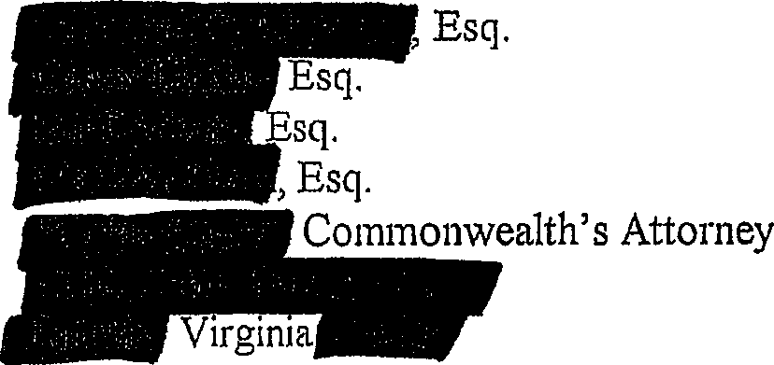
And the original was forwarded for filing to:

Hon.­
Clerk
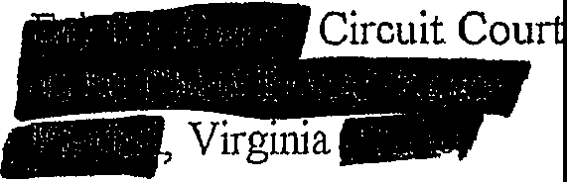

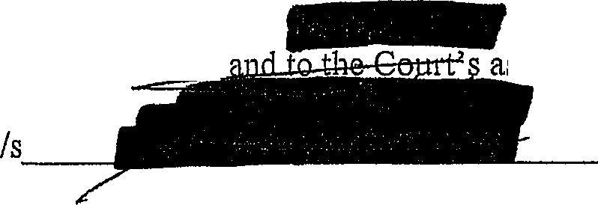
On this -day f We further certify t ailed to the

Commonwealth
assistant oJn
day o;-----

/handwritten-----------

