ADAMS COUNTY DISTRICT COURT DAT FILI  Address: 1100 Judicial Center Dr, Brighton, CO 8060C1AS | E FILED: November 10, 2017 12:02 PM  NG ID: 787A174D66AED E NUMBER: 2016CR2353  ▲ COURT USE ONLY ▲
THE PEOPLE OF THE STATE OF COLORADO

v.

Defendant(s): KALA GARCIA
Attorney for Defendant  Michael D. Evans, Atty. Reg. #39407 Megan Bibliowicz, Atty. Reg. #48671 THE EVANS FIRM, LLC  12605 East Euclid Drive, #209, Centennial, CO 80111 Mail: PO Box 371896, Denver, Colorado 80237  P: (303) 578-8550 F: (303) 708-1612  E-mail: info@theevansfirm.com | Case No.: 2016CR2353  Division: 2
MOTION FOR NOTICE OF INTRODUCTION OF EVIDENCE SIMILAR TRANSACTIONS PURSUANT TO C.R.E. 404(b)

COMES NOW, the Defendant, by and through counsel, THE EVANS FIRM, LLC, and respectfully moves for advanced notice within fifteen (15) days of this documents filing of any intent to introduce evidence of similar transactions pursuant to C.R.E. 404(b), and as grounds, the Defendant states as follows:
- Any evidence of alleged similar transactions is highly prejudicial and inadmissible absent a prosecutorial showing of all requirements under Spoto. See People v. Spoto, 795 P.2d 1314, 1318-1319 (Colo. 1990), and People v. Garner, 806 P.2d 366, 371-372 (Colo. 1991).
- The prosecution must comply with Spoto and Garner and disclose the specific evidentiary hypothesis on which a material fact can be permissibly inferred from the prior act independent of the uses forbidden by C.R.E. 404(b). These requirements will necessitate a pre-trial hearing into the admissibility of any evidence.
- Counsel also requests discovery of all alleged incidents that the prosecution seeks to elicit testimony, including the specific dates, locations, and names and addresses of all witnesses to any alleged acts.

- Absent the requested safeguards, Defendant will be deprived of constitutional rights to confront witnesses, due process, and effective assistance of counsel as guaranteed by the United States and Colorado Constitutions.
WHEREFORE, the Defendant requests that this Court ORDER that any evidence of similar transactions intended to be used by the prosecution against the Defendant pursuant to C.R.E. 404(b) at trial be disclosed to defense counsel within fifteen (15) days of the receipt of this motion.

Dated this day: November 10, 2017

Reg. #39407 ,

Attorney: Michael D. Evans, Atty.
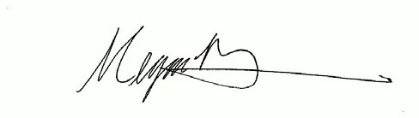

Attorney: Megan Bibliowicz, Atty. Reg. #48671

CERTIFICATE OF SERVICE Case #: 2016CR2353
Parties: People v. Garcia
I HEREBY CERTIFY that on this 10 day of November 2017, a true and correct copy of the foregoing MOTION FOR NOTICE OF INTRODUCTION OF EVIDENCE SIMILAR
TRANSACTIONS PURSUANT TO C.R.E. 404(b) was served upon all counsel of record. VIA ICCES
Adams County District Attorney

Clerk of the Adams County Court 1100 Judicial Center Dr.
Brighton, CO 80601
Division 2
Signature

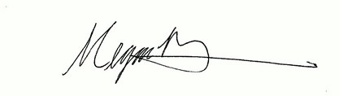

Signature

