District Court, Jefferson County, Colorado 100 Jefferson County Parkway  Golden, CO 80401 | DA FIL CA | TE FILED: July 21, 2017 3:24 PM ING ID: E627427B8678A  SE NUMBER: 2016CR1463
PEOPLE OF THE STATE OF COLORADO
v.
GARY LEE NICKAL
Defendant
Peter A. Weir, District Attorney  Eva Wilson, Senior Chief Deputy District Attorney Christian Gardner-Wood, Deputy District Attorney 500 Jefferson County Parkway  Golden, CO 80401-6002  Phone Number: (303) 271-6831  Fax Number: (303) 271-6888 E-mail: cgardner@jeffco.us Atty. Reg. #: 38889 |  | COURT USE ONLY  Case Number:  16CR1463  Div.: 12 Ctrm: 5D
MOTION FOR PRESERVATION AND DISCOVERY (P-5)

PETER A. WEIR, District Attorney in and for the First Judicial District, County of Jefferson, State of Colorado, respectfully moves this Honorable Court for an order granting preservation and discovery of the following:

PROCEDURAL BACKGROUND

- The defendant is charged with one count of Murder in the First Degree. The defendant has pled not guilty by reason of insanity and/or impaired mental condition. A jury trial is set to commence with jury selection on October 5, 2017. A motions hearing is set for August 22, 2017.

- The defendant has been evaluated at the Colorado Mental Health Institute at Pueblo. The Court and the parties are in receipt of the evaluation finding that the defendant was sane and not experiencing an impaired mental condition at the time of the murder.

- The defendant has been evaluated by two defense experts. The People are in receipt of reports from both of these experts.

FACTUAL BACKGROUND

- On April 28, 2016, the defendant ambushed his wife, Molly Nickal, while she was on the toilet and he shot her twice with a shotgun. The defendant first shot his wife from the front as she sat on the toilet and inflicted a shotgun wound to her left neck

area. The defendant then took a second shot as Molly Nickal lay face down on the bathroom floor. This second shot was a fatal gunshot wound due to the shotgun blast to the top right portion of the back of her head. This fatal shot was a contact or near-contact wound.

DISCOVERY REQUEST

- In order to prevent delay and surprise, the People request that the defendant be ordered to preserve and discover to the prosecution the following material and information in the possession, custody, or control of the defendant, or his agents:

  - Any and all reports, draft reports, or statements of experts made in connection with this case, including results of physical or mental examinations and the results of any scientific tests, experiments, or comparisons. This includes any notes taken by the expert, or recordings made of conversations with the defendant; and the underlying facts or data supporting the opinions of the experts.

  - Any communication or correspondence between the two defense experts. The defense experts both waited until the analysis was completed by the state hospital doctor and then proceeded to issue the same opinion. If the defense experts communicated in advance of issuing their opinions this information would be discoverable as the communication would be underlying facts and data relied upon by the two experts.

  - If the defendant intends on calling any additional expert witnesses that have not prepared a report, the People request the expert be ordered to prepare and provide a report or a detailed written summary of anticipated testimony, including opinions the defense intends on eliciting, and the bases and reasons therefore.

  - A curriculum vitae for each expert witness.

  - The nature of any general affirmative defense, or any defense applicable to the First Degree Murder charge in this case, which the defendant intends to use at trial other than the plea of not guilty by reason of sanity which has already entered.

  - The nature of any other defenses which the defendant intends to use at trial.

  - The names, addresses, phone numbers, and dates of birth of any and all persons the defendant intends to call as witnesses at trial or at any hearing in this case.

  - Any books, papers, notes, documents, articles, transcripts, and any other tangible objects, which the defendant intends to use or admit at trial or any

hearing in this case, except for any materials that have been discovered to the defense by the People or that contain communicative statements made by the defendant which are subject to the privilege against self-incrimination or the attorney-client privilege.

2. As authority for this request, the People cite Colorado Rule of Criminal Procedure 16, Part II, subsections (b) – (d). (2013).

Wherefore, the People request this Honorable Court order the defendant to preserve and discover to the People the aforementioned evidence.
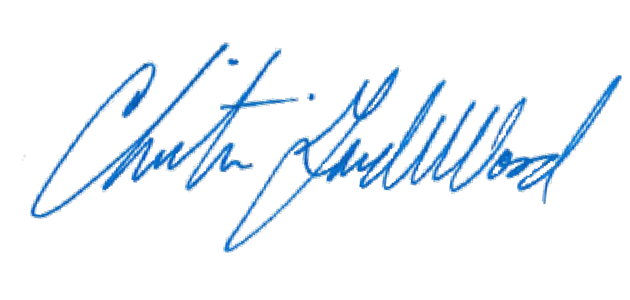
Respectfully submitted, PETER A. WEIR
District Attorney

By: Christian Gardner-Wood
Deputy District Attorney Reg. No. 38889

CERTIFICATE OF MAILING

I hereby certify that a true and correct copy of the foregoing MOTION FOR PRESERVATION AND DISCOVERY (P-5) was sent electronically via Colorado Courts E-Filing on July 21, 2017, properly addressed to the following:

Patrick J. Mulligan Mulligan Breit, LLC

Jennifer E. Longtin
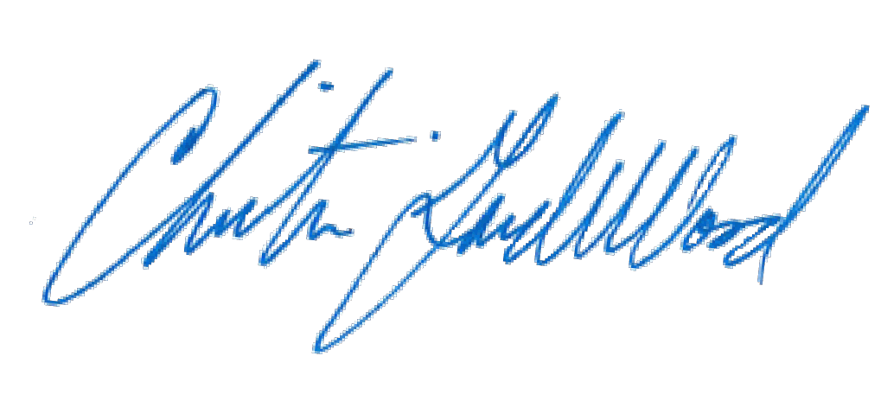The Law Office of Jennifer E. Longtin, LLC

