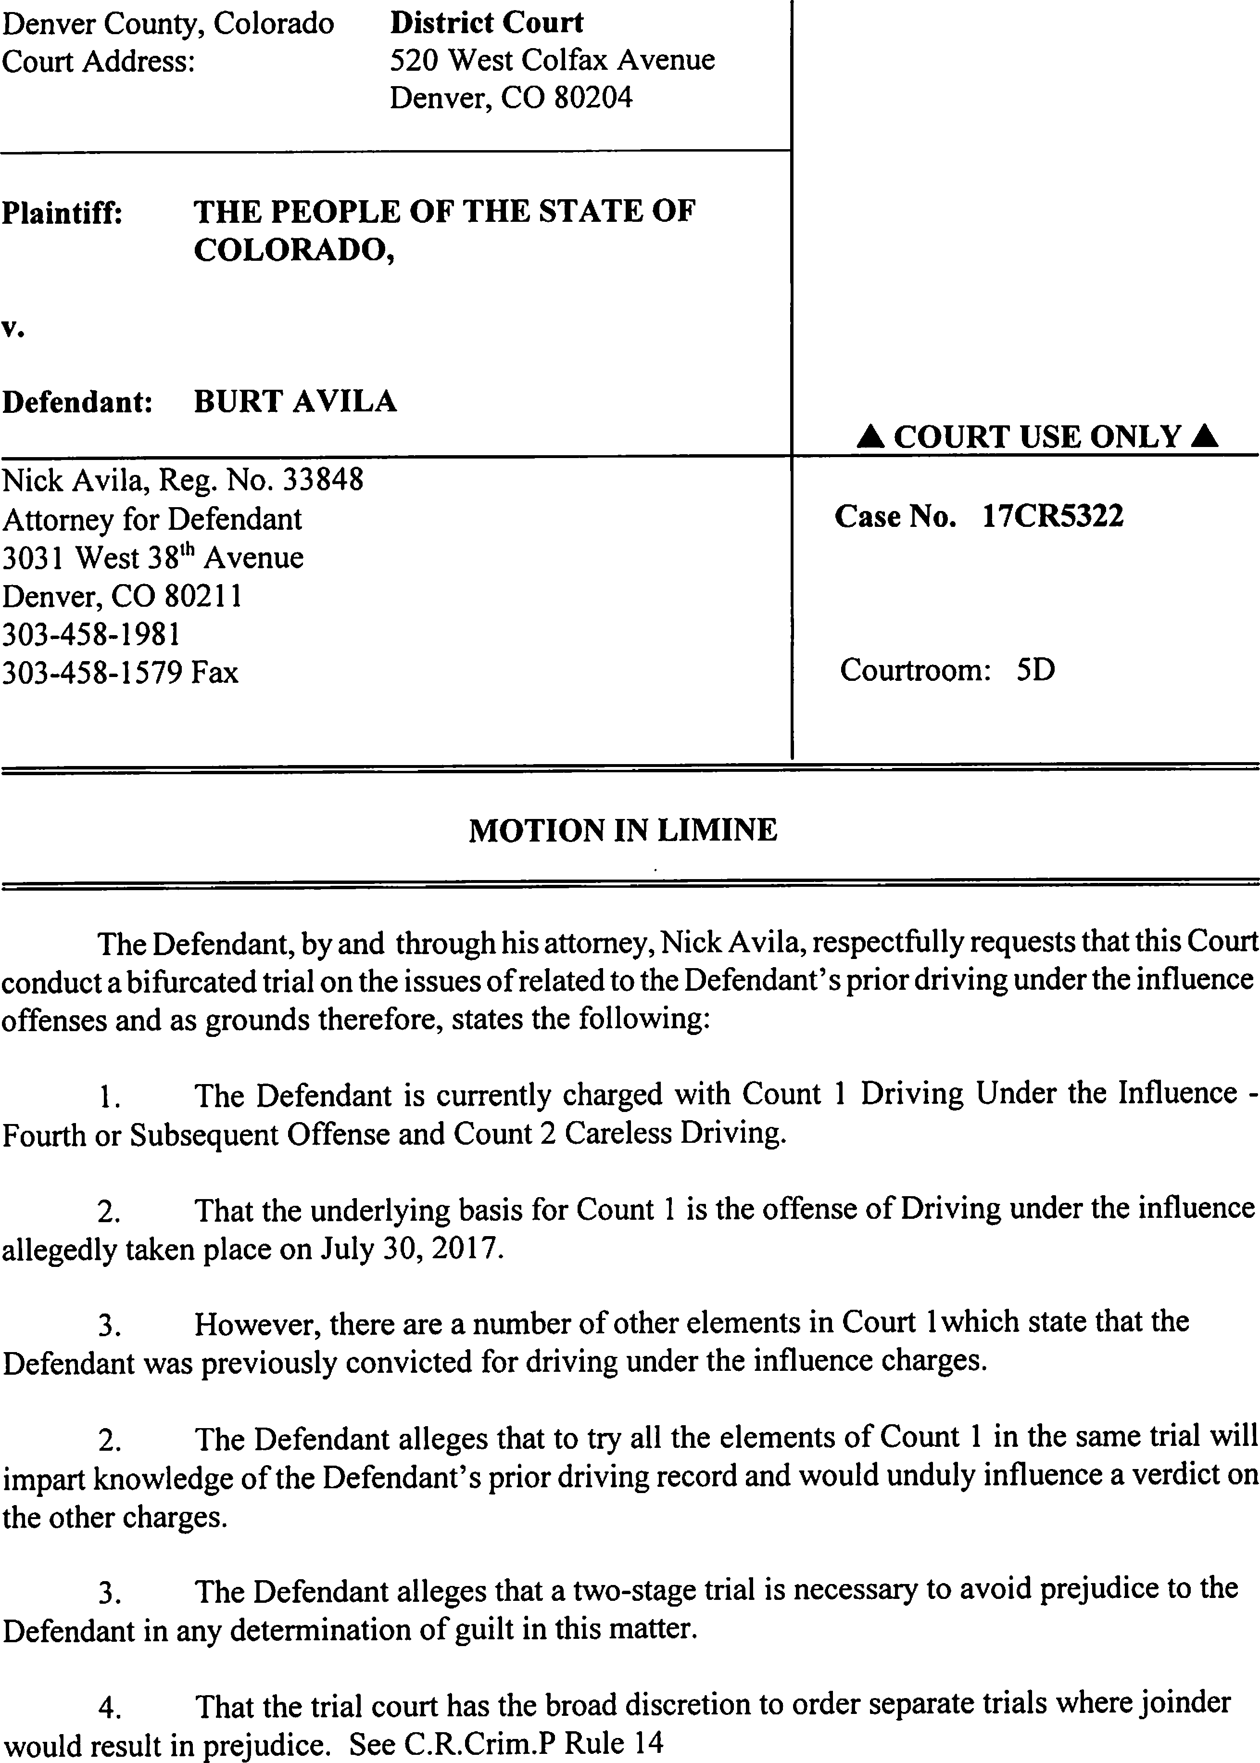

DATE FILED: January 24, 2018 5:16 PM FILING ID: B3FC55ED2BEF7
CASE NUMBER: 2017CR5322

5. That to try all the elements of Count 1 together would deny the Defendant a fair trial contrary to the U.S. and Colorado Constitutions.

WHEREFORE, the Defendant requests as stated herein above.

Respectfully submitted,

- &d
Nick Avila, #33848 Attorney for Defendant

CERTIFICATE OF SERVICE

I hereby certify that a true and correct copy of the foregoing was efiled this January 25, 2018, addressed:

Denver District Attorney's Office 201 West Colfax Avenue, Dept. 8
Denver, Colorado 80202

Attention: DDA I. L. Shamsid-Deen

