District Court, Jefferson County, Colorado 100 Jefferson County Parkway  Golden, CO 80401 | DA FIL CA | TE FILED: July 21, 2017 3:24 PM ING ID: E627427B8678A  SE NUMBER: 2016CR1463
PEOPLE OF THE STATE OF COLORADO
v.
GARY LEE NICKAL
Defendant
Peter A. Weir, District Attorney  Eva Wilson, Senior Chief Deputy District Attorney Christian Gardner-Wood, Deputy District Attorney 500 Jefferson County Parkway  Golden, CO 80401-6002  Phone Number: (303) 271-6831  Fax Number: (303) 271-6888 E-mail: cgardner@jeffco.us Atty. Reg. #: 38889 |  | COURT USE ONLY  Case Number:  16CR1463  Div.: 12 Ctrm: 5D
MOTION TO ADMIT EVIDENCE OF OTHER ACTS BY THE DEFENDANT PURSUANT TO C.R.E. 404(b) (P-9)

PETER A. WEIR, District Attorney in and for the First Judicial District, County of Jefferson, State of Colorado, respectfully requests this Court to admit evidence of other acts of the defendant pursuant to C.R.E. 404(b) at the jury trial of the above captioned matter.

INTRODUCTION

The People seek to introduce highly probative and necessary evidence of other transactions and conduct which is separate from the crime charged. The evidence is being offered to rebut the defendant’s mental condition defense.

STATEMENT OF FACTS

On April 28, 2016, the defendant ambushed his wife, Molly Nickal, while she was on the toilet and he shot her twice with a shotgun. The defendant first shot his wife from the front as she sat on the toilet and inflicted a shotgun wound to her left neck area.
The defendant then took a second shot as Molly Nickal lay face down on the bathroom floor. This second shot was a fatal gunshot wound due to the shotgun blast to the top right portion of the back of her head. This fatal shot was a contact or near-contact wound.

STATEMENT OF OTHER ACTS

- Use of Adderall/ADHD Medication

The defendant was prescribed medications for ADHD. On many occasions, the defendant was described as appearing high, jittery, paranoid, wired, and excessively skinny. This behavior and appearance was beyond the point expected from using the medications as prescribed.

Further, the defendant’s and victim’s minor daughter, Alexandra Nickal, was also on Adderall and at times she would inexplicably run out of pills early or was not being giving all of the pills prescribed when she was with the defendant. This led Alexandra’s doctor to be concerned about what was happening with the medication and to pull Molly Nickal aside after an appointment to ask what the defendant was doing with the medications. This further led Molly Nickal to believe the defendant was stealing Alexandra’s prescription.

Please see attached Motion Exhibit 1 for more information.

- March 2016 – Chad Carlberg

The Defendant and Molly Nickal visited Minnesota in March 2016 around Easter.
During this visit to Minnesota, Gary spent time with Chad Carlberg who is the ex- husband of Molly Nickal’s sister, Jolynn Kurtz, and the father of Jolynn’s daughter, Lana Carlberg. During the time spent with Chad Carlberg, the defendant and Chad talked about the defendant being on Adderall and Mr. Carlberg indicated that the defendant was a “big fan” of Adderall because it makes you “up and happy.” It is for the same reasons that Mr. Carleberg liked using Adderall recreationally. The defendant shared two of his Adderall pills with Mr. Carlberg and Mr. Carlberg shared some marijuana with the defendant.

Please see attached Motion Exhibit 2 for more information.

LEGAL BASIS

Evidence of other crimes, wrongs, or acts is not admissible to prove the character of a person to show the person acted in conformity therewith. It may, however, be admissible for other purposes and Rule 404(b) gives a non-exhaustive list of some of these other purposes for which other acts may be admissible. In order to be admissible, such evidence of prior acts must pass the following four part test:

- Is the evidence relevant to a material fact?
- Is the evidence logically relevant?
- Is the logical relevance independent of the inference that the defendant has a bad character?

- Is the probative evidence substantially outweighed by the danger of unfair prejudice?

See People v. Spoto, 795 P.2d 1314 (Colo. 1990).

Rule 404(b) is not limited in application to evidence of other crimes, but permits evidence of other wrongs or acts, provided the evidence is offered to prove a material issue and the substantive and procedural prerequisites are met. See People v. Jackson, 748 P.2d 1326 (Colo. App. 1987). The procedural safeguards referred to in Jackson include providing a cautionary instruction to the jury as to the limited purpose for which they may consider this evidence. See Stull v. People, 344 P.2d 455 (1960).

The threshold inquiry this Court must make before admitting other misconduct evidence is whether the evidence is probative of a material issue other than character. In People v. Garner, 806 P.2d 366 (1991), the Colorado Supreme Court reiterated the Spoto criteria and stated that the standard of admissibility is by a preponderance of the evidence that the other act occurred and the defendant did it.

The third prong of the Spoto test does not demand the absence of the inference of bad character. The third prong merely requires that the proffered evidence be logically relevant for a purpose independent of that inference. See People v. Snyder, 874 P.2d 1076 (Colo. 1994). In the instant matter, the logical relevance is independent of the intermediate inference, prohibited by Colorado Rule of Evidence 404(b), that the defendant has a bad character, and therefore must have committed the charged offense.

This Court may rely upon offers of proof to determine, by a preponderance of the evidence, that the other conduct occurred and that the defendant committed the other conduct. In People v. Groves, the Colorado Court of Appeals concluded it was proper to present all of the evidence in the case by offers of proof for the trial court’s determinations of the admissibility of other conduct evidence. 854 P.2d 1310 (Colo.
App. 1992).

The purpose of this evidence is to rebut the defense of impaired mental condition. Also, a limiting instruction will be given to the jury in order to avoid the problem of unfair prejudice, pursuant to Colorado Rule of Evidence 105.

“Although the prosecution must articulate a precise evidential hypothesis by which a material fact can be permissibly inferred from the prior act that is independent of the inference forbidden by 404(b), upon a showing of logical (CRE 401) and legal (CRE 403) relevance under that hypothesis, evidence of other crimes will not be excluded under the rules of relevance.” Rath at 1039.

ARGUMENT

The People assert that the defendant taking excess Adderall and treating the medication as a recreational drug that could be shared with a friend is relevant and admissible under 404(b). Specifically, the defendant taking excess ADHD medication directly explains his behavior of being paranoid, jittery, appearing “high,” and wired. Having an explanation for this behavior and appearance of the defendant will rebut the defense that this behavior shows the defendant had an impaired mental condition, specifically post-traumatic stress disorder that caused his paranoia, psychosis, and disassociation.

Further, the defendant sharing his medication with Chad Carlberg, smoking marijuana, and giving the impression that he is a “big fan” of Adderall and/or other ADHD medications as opposed to using the substance as a medication to treat a medical or mental health condition shows the defendant was voluntarily ingesting a psychoactive substance, beyond or contrary to the prescription he had obtained from a doctor. In so doing, the defendant shows that he does not have a mental disease or defect, as any behavioral abnormalities are attributable to the psychoactive substance.

In examining evidence under C.R.E. 403, the evidence should be accorded its maximum probative weight and its minimal prejudicial effect. See People v. Quintana, 882 P.2d 1366, 1374 (Colo. 1994). “Because the balance required by C.R.E. 403 favors admission, a reviewing court must afford the evidence the maximum probative value attributable by a reasonable fact finder and the minimum unfair prejudice to be reasonably expected.” People v. Rath, 44 P.3d 1033, 1043 (Colo. App. 2002). Unfair prejudice is that which introduces into trial considerations extraneous to the merits, such as bias, sympathy, anger, or shock. People v. District Court of El Paso County, 869 P.2d 1281, 1286 (Colo. 1994).

Finally, the People aver that the other act evidence is not offered to prove the defendant's bad character or propensity to commit the crime charged. In fact, the defendant is charged Murder in the First Degree and the other acts are very minor in comparison to the charged offense. Nothing about the substance abuse alleged would suggest a propensity to commit murder. Simply, the other act evidence is being offered in direct contradiction to the defendant’s plea of not guilty by reason of insanity and impaired mental condition. The offered evidence is not intended to provoke or inflame the jury; rather it is offered for legitimate purposes under C.R.E. 404(b), and the evidence has substantial probative value and therefore the probative value outweighs the danger of unfair prejudice, specifically considering the giving of limiting instructions to the jury.

WHEREFORE, the People respectfully request this Court admit evidence of other acts by the Defendant.

Respectfully submitted,

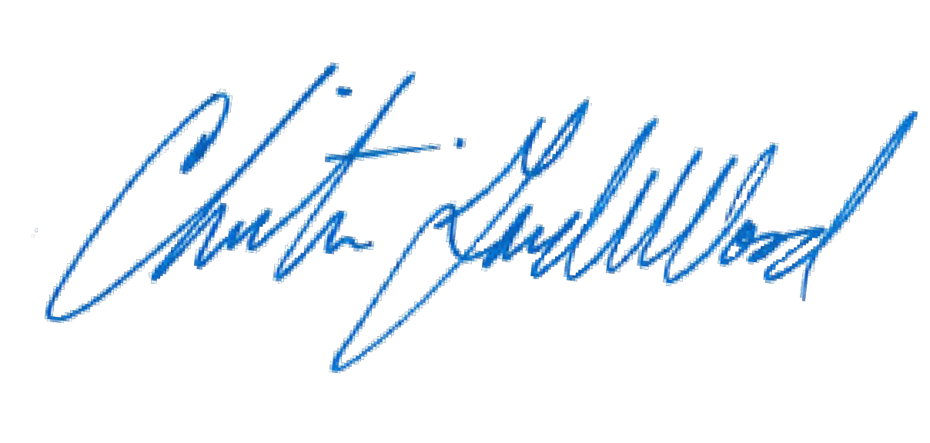
PETER A. WEIR
District Attorney

By: Christian Gardner-Wood
Deputy District Attorney Reg. No. 38889

CERTIFICATE OF MAILING

I hereby certify that a true and correct copy of the foregoing MOTION TO ADMIT EVIDENCE OF OTHER ACTS BY THE DEFENDANT PURSUANT TO C.R.E. 404(b)
(P-9) was electronically served through Colorado Courts E-Filing on July 21, 2017, properly addressed to the following:

Patrick J. Mulligan Mulligan Breit, LLC

Jennifer E. Longtin
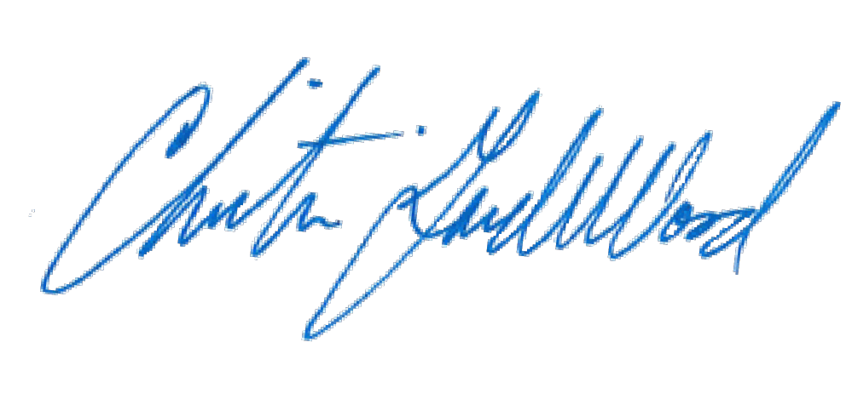The Law Office of Jennifer E. Longtin, LLC

