District Court, Jefferson County, Colorado 100 Jefferson County Parkway  Golden, CO 80401 | DA FIL CA | TE FILED: July 21, 2017 3:24 PM ING ID: E627427B8678A  SE NUMBER: 2016CR1463
PEOPLE OF THE STATE OF COLORADO
v.
GARY LEE NICKAL
Defendant
Peter A. Weir, District Attorney  Eva Wilson, Senior Chief Deputy District Attorney Christian Gardner-Wood, Deputy District Attorney 500 Jefferson County Parkway  Golden, CO 80401-6002  Phone Number: (303) 271-6831  Fax Number: (303) 271-6888 E-mail: cgardner@jeffco.us Atty. Reg. #: 38889 |  | COURT USE ONLY  Case Number:  16CR1463  Div.: 12 Ctrm: 5D
MOTION TO DETERMINE COMPETENCY OF CHILD WITNESS (P-4)

PETER A. WEIR, District Attorney in and for the First Judicial District, State of Colorado, respectfully requests this Honorable Court to determine the competency of the child witness who will be under ten years of age at the time of trial. As grounds, the People state:

- The defendant is charged in this criminal prosecution with one count of First Degree Murder. On April 28, 2016, the defendant ambushed his wife, Molly Nickal, while she was on the toilet and he shot her twice with a shotgun. The defendant first shot his wife from the front as she sat on the toilet and inflicted a shotgun wound to her left neck area. The defendant then took a second shot as Molly Nickal lay face down on the bathroom floor. This second shot was a fatal gunshot wound due to the shotgun blast to the top right portion of the back of her head. This fatal shot was a contact or near-contact wound. To compound the tragedy of this intentional murder and the egregiousness of the defendant’s actions, all three of the defendant’s and Molly Nickal’s minor children were in the home at the time of the murder.

- The People intend to call the two minor daughters of the defendant and Molly Nickal, Alexandra Nickal and Kameryn Nickal at the trial currently set to commence with jury selection on October 5, 2017.

- Alexandra Nickal will be ten years old at the time of trial. She was born on August 31, 2007. As she will be ten years old at the time of trial, she is

presumed competent and the Court need not make a determination as to her competency to testify due to the presumption of competency.

  - A witness (who is at least ten years old) is generally presumed competent to testify, and the defendant carries the burden to prove otherwise. People
v. Gillispie, 767 P.2d 778 (Colo. App. 1988), citing People v. Galloway, 677 P.2d 1380 (Colo.App.1983).

- Kameryn Nickal, however, is under the age of ten. She was born on August 28, 2008 and will be nine years old at the time of trial.

- Pursuant to §13-90-106(1)(b)(I), C.R.S., children under ten years of age are incompetent to testify in a criminal proceeding if they are incapable of receiving just impressions of facts or of relating those facts truly. Thus, if a child, even under ten years of age, is capable of receiving just impressions of facts and is able to relay those facts truly, the child is competent to testify.

- It is the People’s belief that Kameryn Nickal is capable of receiving just impressions of facts and capable of thereafter relaying those facts truly. Therefore, the People assert, and ask this Honorable Court find, that Kameryn Nickal is competent to testify.

- The competency of a child under ten years of age is addressed to the trial court’s discretion. People v. District Court, 791 P.2d 862 (Colo. 1990); People v. Hise, 738 P.2d 13 (Colo. App. 1986).

Wherefore, the People request this Honorable Court determine the competency of the child witness, Kameryn Nickal.

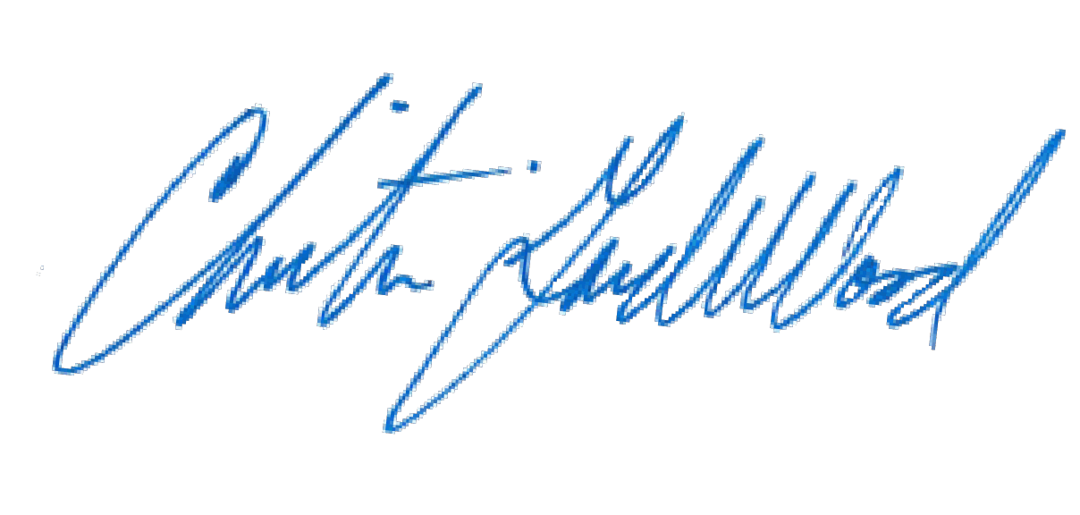
Respectfully submitted, PETER A. WEIR
District Attorney

By: Christian Gardner-Wood
Deputy District Attorney Reg. No. 38889

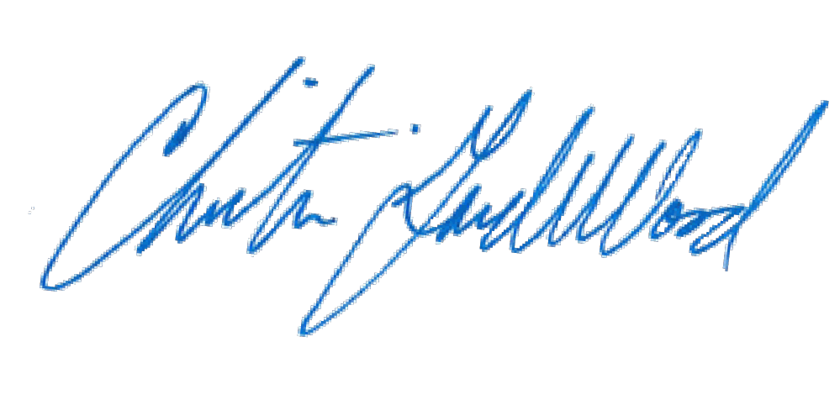
CERTIFICATE OF MAILING

I hereby certify that a true and correct copy of the foregoing MOTION TO DETERMINE COMPETENCY OF CHILD WITNESS (P-4) was electronically served through Colorado Courts E-Filing on July 21, 2017, properly addressed to the following:

Patrick J. Mulligan Mulligan Breit, LLC

Jennifer E. Longtin
The Law Office of Jennifer E. Longtin, LLC

