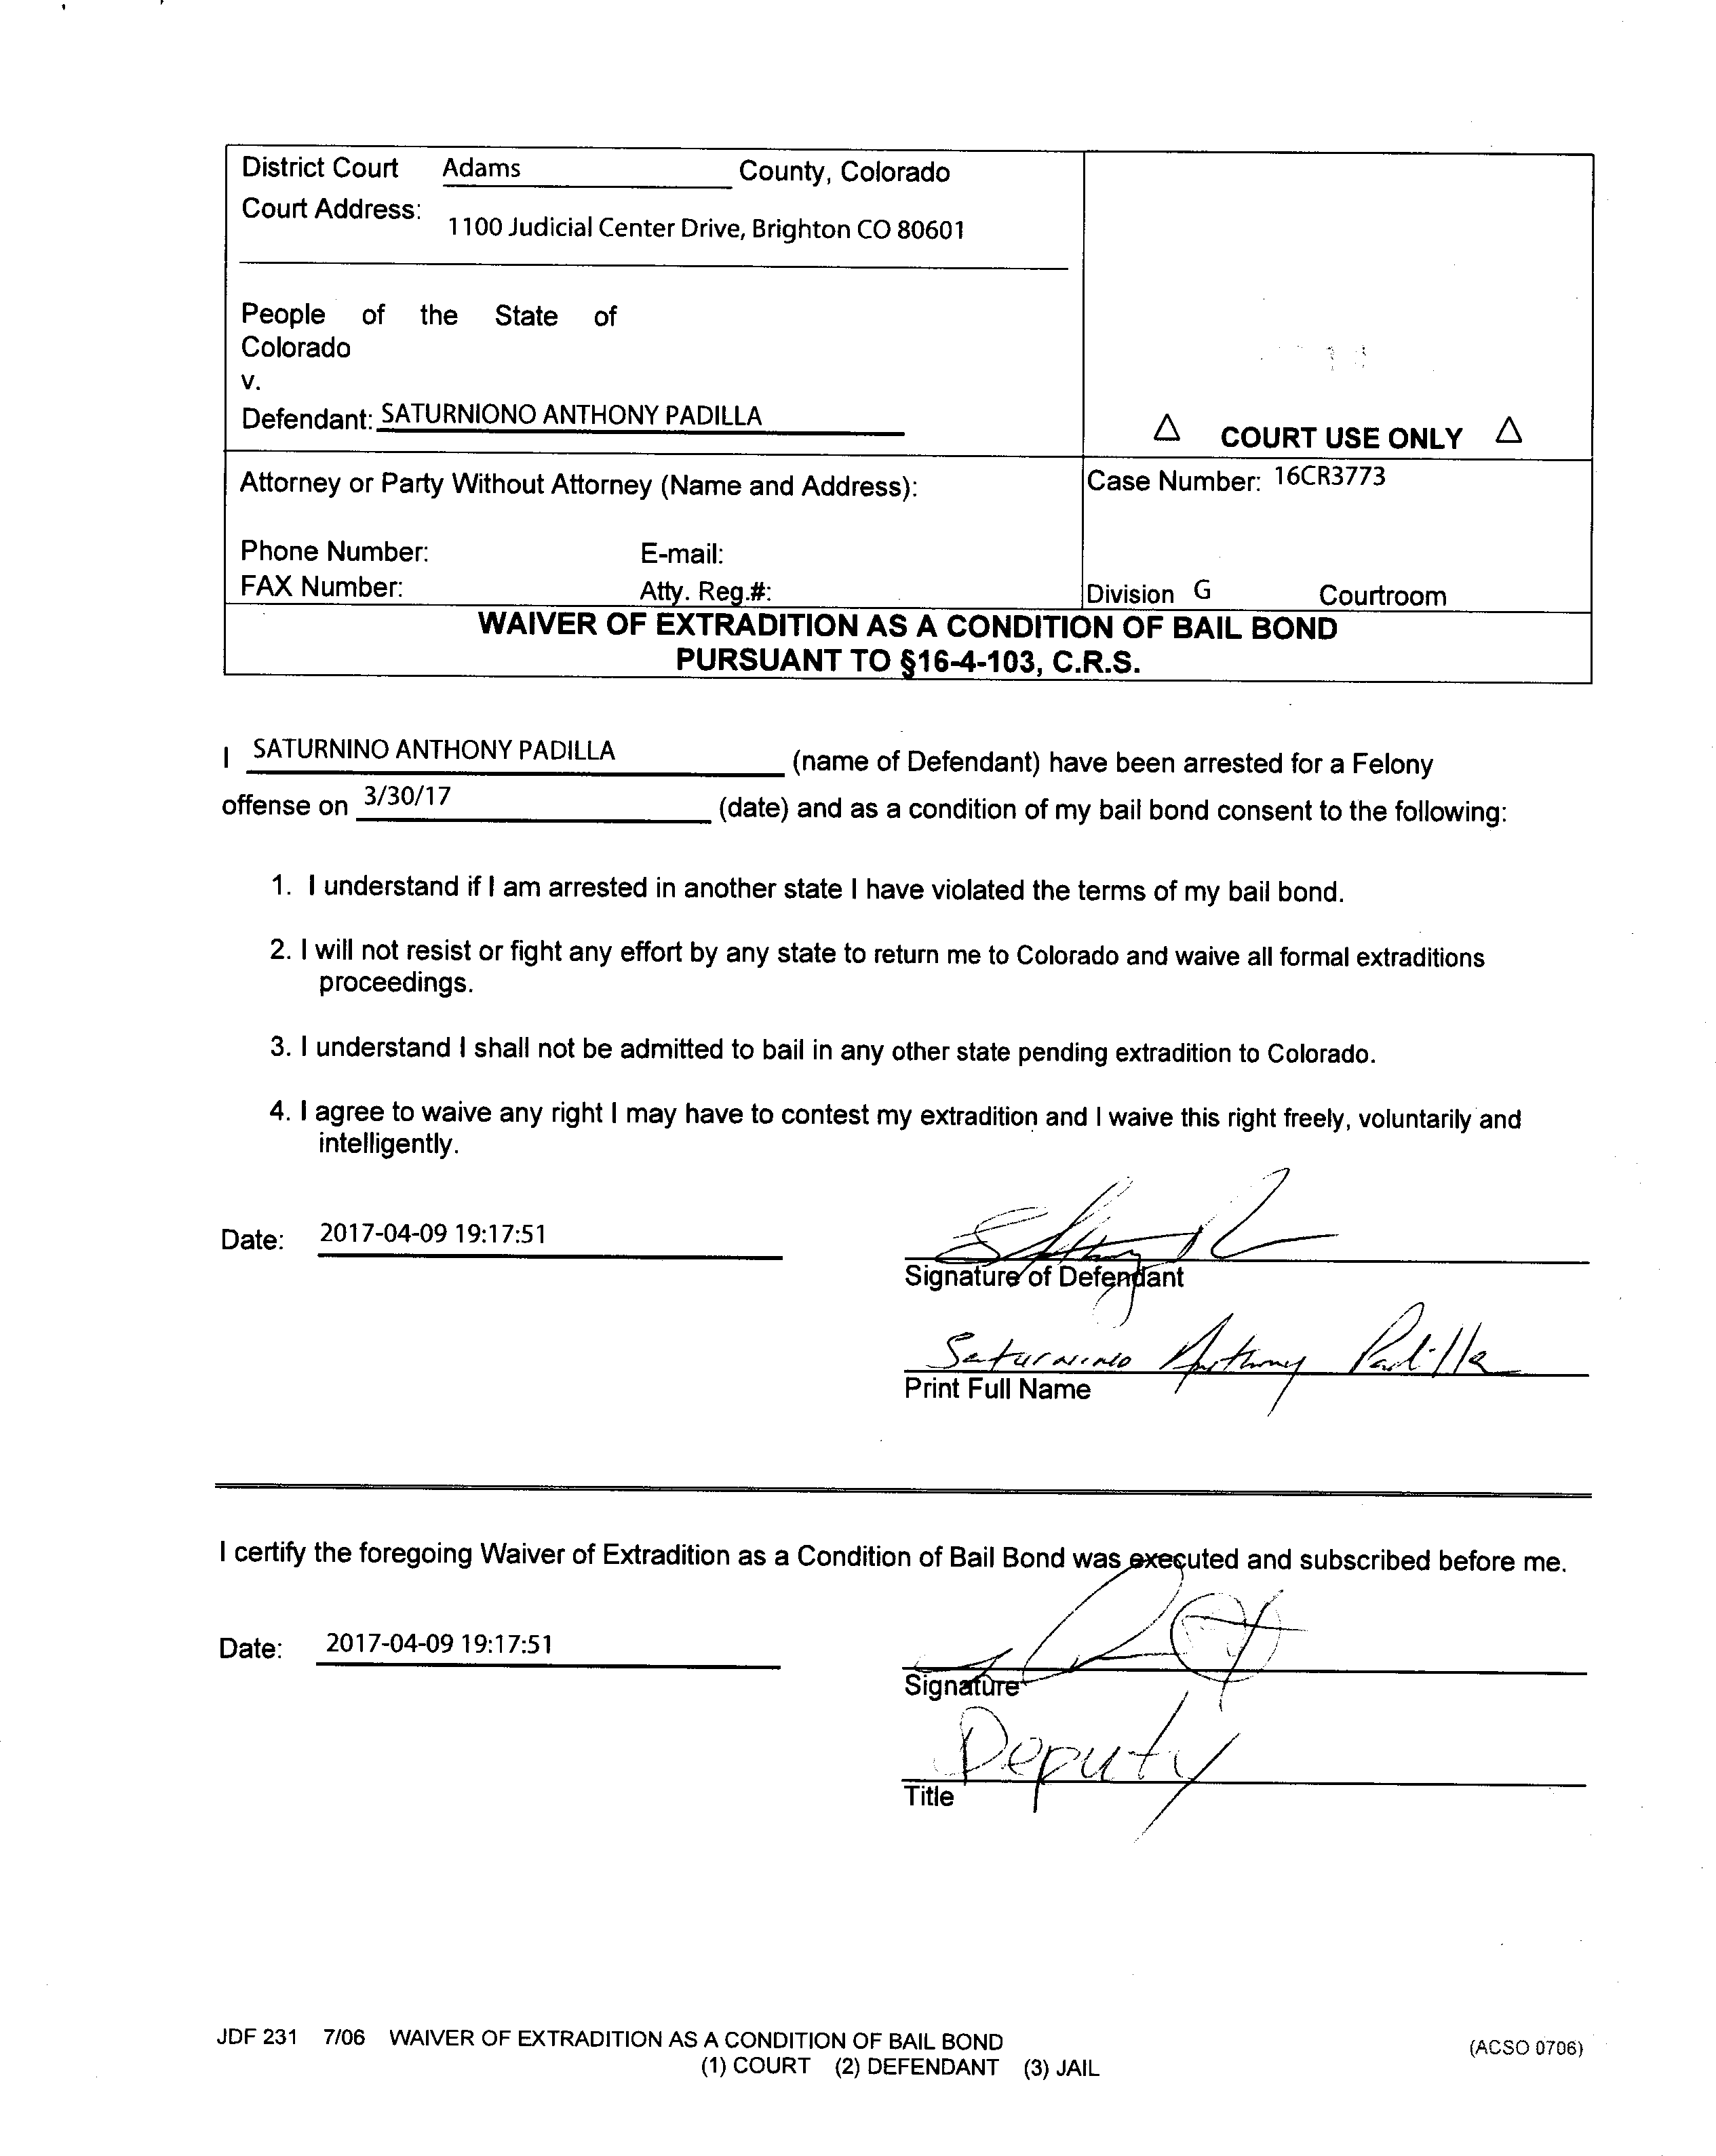

DATE FILED: April 10, 2017 CASE NUMBER: 2016CR3773

