.., . ·· ,n:i _

YAVAPAI COUNTY A'ITORNEY'S OFFICE JOSEPH C. BUTNER SBN 005229
- DEPUTY COUNTY A'ITORNEY 255 East Gurley Street
- Prescott, AZ 86301
4 Telephone: 928-771-3344 ycao@co.yavapai.az.us
' I ,-,..
' - . - •·-· _•_J Li I ' S
-t . .d_ i . - \ •
'.
.· ,::N '.5'!i t.!!:_

epu '

5

IN THE SUPERIOR COURT OF STATE OF ARIZONA
- IN AND FOR THE COUNTY OF YAVAPAI
8

9 STATE OF ARIZONA,

10 Plaintiff,

v.
12

STEVEN CARROLL DEMOCKER,

13
Defendant.
14

Cause No. P1300CR20081339

Division 6

STATE'S RESPONSE TO DEFENDANT'S MOTION TO COMPEL INTERVIEW WITH A VICTIM, RUTH KENNEDY

15 Toe State of Arizona, by and through Sheila Sullivan Polk, Yavapai County Attorney, and her deputy undersigned, hereby submits its Response to Defendant's Motion to Compel
Interview and respectfully requests that the Motion be denied .

18
- As the Court is aware, Ms. Kennedy is the elderly mother of Carol Kennedy. AR.S. §
- 13-4401(19) provides that when the "person against whom the criminal offense has been

- committed ... is killed .. . the person's spouse, parent, child, grandparent, or sibling" is then
- identified as a victim. Accordingly, Ms. Kennedy, Carol's brother John, and Carol's

23
daughters, Katherine and Charlotte DeMocker, are victims in this case. A.R.S. § 13-4433(A)
24

provides that:

25
26

[u]nless the victim consents, the victim shall not be compelled to submit to an interview on any matter, including any charged criminal offense witnessed by the victim and that occurred on

- the same occasion as the offense against the victim ... that is
conducted by the defendant, the defendant's attorney or agent of
- the defendant.
- (emphasis added.)
- Both John and Ruth Kennedy have asserted their right to refuse a pre-trial interview.
5
Defendant's allegation that Ms. Kennedy has been "interviewed" by the prosecution is simply
6
not true. As with any victim case and as required by Arizona law, Victim Services and the
7
- assigned prosecutor have had numerous conversations with the Kennedys including one where
- both asked that the Chapman letters, which requested contact, be read to them over the

- telephone. After considering Ms. Chapman's request, both John and Ruth asked the prosecutor
- to convey to the defense team that they chose to continue to assert their right to refuse a pre­ 12
trial interview. The prosecutor complied.
13
Relying on Champlin v. Sargeant, In and For the County of Maricopa, 192 Ariz. 371,
14
- 965 P.2d 763 (1998), Defendant claims Ms. Kennedy is not a victim of the burglary; therefore,
- she is not entitled to refuse an interview on that charge. First, this position is unsustainable

- under State v. Sarullo, 219 Ariz. 431, 436, 199 P.3d 686, 691 (App.2008) (occupants of a
- burglarized home may be fairly characterized as "victims" for the burglary for purposes of
- the statute that a victim of a crime may refuse an interview) and A.RS. § 13-4401 (19). The 20
members of Carol's immediate family are victims of both the burglary and the homicide.
21
Second, even if Ms. Kennedy were not a victim of the burglary, she would still have protection
22
- under the plain and unambiguous language of A.R.S. § l 3-4433(A) iD4 the Champlin decision.
- In Champlin, the Arizona Supreme Court unequivocally detennined ..the logical interpretation

- of section 13-4433(A) is that a person who witnesses a crime against others and is also
- victimized by the same defendant on the same occasion gains protected 1 victim' status and

may not be compelled to grant a pretrial interview as to the offense in question." Champlin at

2 375, 965 P.2d at 767 (emphasis added.) Toe Court added: "We believe that today's

:>.
e

0........ I:-.

interpretation of section l 3-4433(A) strikes a proper balance between the victim's right to be
- free from retraumatization during the pretrial process and preserving the defendant's ability to
5
discover and present evidence in his or her defense." Id.
6
- Defendant also claims his rights under the Confrontation Clause should trump the rights
- of the victims and cites case law which on the surface seems to support his claim; however, a
- closer look reveals many of the cases cited either pre-date the enactment of the Victims' Bill of
IO Rights (VBR), which became effective November 26, 1990, or are actually contradictory to

G> '.?...
00
0 I:-.

:t:
N
.e-!!
<8 11
('t') 0\
s;::s: ·:-:t...:.;::Q:I 12
uoUl E
.... -t' 00 ·0 13
N _{Ill}
<
Ill ...., S:..
Ill>l ,,

Defendant's position. For example, both State v. Radjenovich, 138 Ariz. 270, 674 P.2d 333 (1983), and State v. Schultz, 140 Ariz. 222, 681 P.2d 374 (1984) (both promoting that defense

counsel should interview all state witnesses), pre-date the enactment of VBR. In State v.

]] 14

Cl e!";l
15
.<.sI':::• P-, _{rl}
Superior Court In and For the County of Maricopa (Coronado), 186 Ariz. 363, 366, 922 P.2d

..,. an
I:'-.
i:-...

- an 16
ON 00
--
..uQ..I
0
N

iii
C:
17

927, 930 (App.1996), the issue was whether the parents of a victim who committed suicide
after the crime would qualify as victims. There, the Court determined that where there was a

f 18

19
20
21
22
23
24

25
26
showing that the accused caused the death of the victim, the victim's survivors would be shielded from pre-trial interviews. In another case Defendant relies upon, State ex rel. Romley (Roper}, 172 Ariz. 232, 836 P.2d 445 (App.1992), the issue was disclosure of the victim's
medical records, not a pre-trial interview, and even then both the trial court and the Court of Appeal agreed that the victim should be afforded protection by ordering that the records be reviewed in camera rather than delivered directly to defendant.
More importantly, the question of whether a victim's right to refuse a pre-trial interview violates the Confrontation Clause was decided in State ex rel. Romley v. Hutt

- (I'reen), 195 Ariz. 256, 987 P.2d 218 (App.1999). There, a tennination of an attorney-client

- relationship ended in criminal charges when the defendant and her husband failed to return a
- vehicle the attorney allowed them to use. When the vehicle was finally located, the police

4
discovered the defendant's husband fraudulently obtained an Arizona title and registration
5
which transferred ownership of the vehicle to him. Both the defendant and her husband were

6
charged with theft of the vehicle. The defendant asked to interview the victim but the victim
7
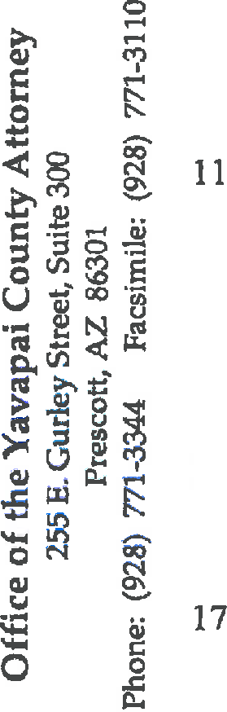8 refused. The defendant then filed a motion for a pre-trial hearing to detennine whether the refusal was based on ''bias, interest, or hostility." Id. at 258, 987 P.2d at 220. The trial court
9

10
12

13

14

15

16
18
ordered the victim to submit to a pre-trial interview finding "[w]here the two rights are in conflict the defendant's right to due process must be paramount." Id The state filed a petition for special action. The Court of Appeals held the:
[C]onfrontation rights under the Sixth Amendment do not normally afford criminal defendants a right to pretrial discovery. See Pennsylvania v. Ritchie, 480 U.S. 39, 52-S3, 107 S.Ct. 989, 94 L.Ed.2d 40 (1987) (plurality decision). The right to confront witnesses at trial "does not include the power to require the pretrial disclosure of any and all infonnation that might be useful in contradicting unfavorable testimony." Id. at 53, 107 S.Ct. 989.

- State ex rel. Romley v. Hutt (I'reen), at 260, 987 P.2d at 222.
- The Court acknowledged that "it would he useful to defendant to talk to {victim]

- before trial, but our constitution precludes this, and no superior constitutional right of
2 2 defendant's compels it." Id. at 261, 987 P.2d at 223 (emphasis added).
- Victims are often important, crucial, even critical
- witnesses. It is no doubt a sound practice for lawyers to interview witnesses before trial. But to compel victim
- interviews based on the kind of generic considerations presented here would nullify a significant constitutional protection
- afforded crime victims. The victim's right to refuse a defense

2
Id.
3
interview protects the victim's privacy and allows him to
minimize contact with the defendant. ifhe so chooses.

  - CONCLUSION:

Arizona law is clear, under circumstances as are present here, a victim's right to refuse

....
::t 0

a "pre-trial interview" is absolute. Defendant's motion to compel Ms. Kennedy to submit to a
  - pre-trial interview is legally unsupported, without merit and must be denied
  - RESPECTFULLY SUBMITTED thi1s ie.. day of March, 2010.
9

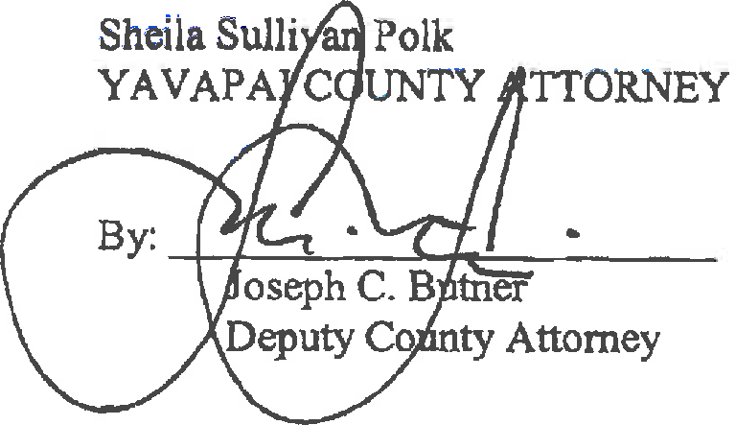
10
11
12
13
14
15
- Ill
- Ill
- Ill
- Ill
- Ill
21
Ill
22

Ill
23
  - Ill
  - Ill
  - Ill

- s -

I CO?J'fi of the foregoing delivered this
2
3
4
5
_il.. oay of March, 2010 to:
Honorable Thomas J. Lindberg Division 6
Yavapai County Superior Court (via email)
6
7
8
9
John Sears
107 North Cortez Street, Suite 104
Prescott, AZ 86301 Attorney for Defendant (via email)
10
11
12
Larry Hammond
Anne Chapman Osborn Maledon, P.A.
2929 North Central Ave, 21st Floor Phoenix, AZ
Attorney for Defendant
·1)
13
14
By: -4-
"'-AJl..-=:.._}.;z::!.. UA,lr.t---
15
16
17
18
19
20
21
22
23
24
25
26

- 6 -

