Alamosa District Court
702 4th St.
Alamosa, CO 81101 | D | TE FILED: January 25, 2018 2:29 PM
 | FI | LING ID: D7D39A0D859F3
 | C | SE NUMBER: 2016CR361
Plaintiff: State of Colorado
v.

Defendant: RICKY MANZANARES
Beale C. Tejada #44851 CRANE & TEJADA, P.C.  1801 California St.  Suite 2400  Denver, CO 80202 |  | Δ COURT USE ONLY Δ  Case Number: 16CR361
Phone Number: 970.749.1066  Fax Number: 970.247.1538  Email: btejada@craneandtejada.com |  | Div.: 2
DEFENDANT’S MOTION FOR A FURLOUGH TO ATTEND BROTHER’S FUNERAL

A A

Mr. Manzanares, by and through counsel, requests this Court to permit him a brief furlough so that he may attend the funeral of his brother, Chris Manzanares. In support, he states:

- Mr. Manzanares is set for a jury trial on January 29, 2018.

- Mr. Manzanares’ brother, Christ Manzanares, passed away on January 2, 2018.

- After passing away, Chris Manzanares’ body was transported to a medical facility in Aurora, CO because he had elected to permit his body to be used for research and scientific purposes. His body has recently been sent back to Alamosa, where the family expects to cremate him and have a service.

- The family will hold a rosary on the evening of Friday, January 26, 2018. Services will be held Saturday night, and the family will be together Saturday night and Sunday morning.

- Mr. Manzanares requests this Court to permit him to have a furlough from Friday at noon till Sunday at noon. Mr. Manzanares is currently being held on a $50,000 bond in 16CR261 and has posted a personal recognizance bond in his 16CR268, his drug distribution case.

- While defense counsel does not have a death certificate, the Valley Courier covered his passing1 in an obituary as well as a person who passed away and was remembered at a

1 Last visited January 25, 2018: https://alamosanews.com/article/chris-d-manzanares-55.

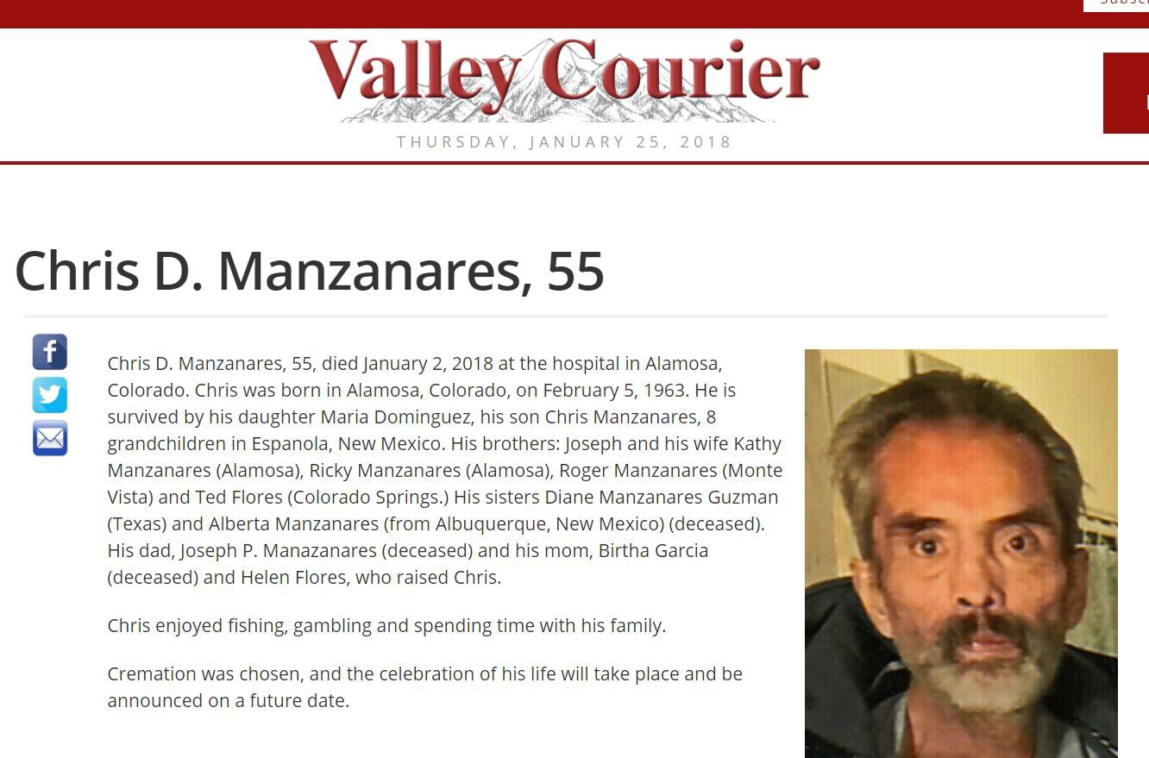local vigil at La Puente:

- While the La Puente community and Mr. Manzanares’ other family members have had an opportunity to grieve together, Mr. Manzanares has not.

- Both of Mr. Manzanares’ brothers live in Alamosa, CO, as does Mr. Manzanares. Obviously, Mr. Manzanares has maintained his innocence the entire time he has been incarcerated on this Attempted Murder charge, and is looking forward to going to trial to finally resolve this case and be set free. Mr. Manzanares has no intention of running or otherwise not turning himself back into jail on Sunday afternoon.

- Mr. Manzanares respectfully requests an expedited hearing on this matter.

Respectfully submitted on January 25, 2018,

/s/ Beale C. Tejada Beale C. Tejada

CERTIFICATE OF SERVICE

I hereby certify that on January 25, 2018, I electronically filed a copy of this document, via ICCES, with the Clerk of the Court. All parties of record were also served.

/s/ Beale C. Tejada Beale C. Tejada

