DISTRICT COURT  JEFFERSON COUNTY, COLORADO 100 JEFFERSON COUNTY PARKWAY GOLDEN, COLORADO 80401 | DATE FILED: July 20, 2017 5:21 PM FILING ID: 5DBBF67C36E06  CASE NUMBER: 2016CR1463  ο COURT USE ONLY σ
THE PEOPLE OF THE STATE OF COLORADO
Plaintiff, v.
GARY NICKAL,
Accused.
MULLIGAN BRIET, LLC  Patrick Mulligan, #16981  1801 Broadway, Suite 1203  Denver, CO 80202  PH. 303-295-1500 FAX:  EMAIL: Patrick@MulliganBriet.com  THE LAW OFFICE OF JENNIFER E. LONGTIN, LLC  Jennifer E. Longtin, #43509 2401 S. Downing St.  Denver, CO 80201  Ph. 303.747.6898  Fax. 800.243.2691  Jen@jlongtinlaw.com | Case No. 16CR001463  Division: 12
MOTION TO HAVE MR. NICKAL APPEAR IN CIVILIAN CLOTHES
AT TRIAL AND OUT OF SCHACKLES

Mr. Gary Nickal, though counsel, requests this Court allow Mr. Nickal to appear in civilian clothes at a trial on this matter. In support of this motion, Mr. Nickal states the following:

- Mr. Nickal is charged with killing his wife with a shotgun. If convicted, Mr. Nickal could spend the rest of his life in prison.
- The United States Supreme Court has explicitly held that "the State cannot, consistently with the Fourteenth Amendment, compel an accused to stand trial before a jury while dressed in identifiable prison clothes . . . ." Estelle v. Williams, 425
U.S. 501, 512, (1976). In so holding, the Court noted that the rule against forcing defendants to wear prison garb, "is a recognition that the constant reminder of the accused's condition implicit in such distinctive, identifiable attire may affect a juror's judgment." Id. at 504-05.
- Moreover, the Court stated that, "compelling an accused to wear jail clothing furthers no essential state policy," and specifically rejected the convenience of jail administrators as a possible justification for this practice. Id. at 505.
- Making a defendant, supposedly clothed with the presumption of innocence, appear in a jumpsuit and shackles is against the very principles of the American justice system. Accordingly, requiring Mr. Nickal to appear at trial in prisoner's clothing will violate his right to a fair trial, a fair and impartial jury, and a fair, reliable, and objective determination of punishment, without furthering any permissible state interest.
- Further, even in civilian clothes, if Mr. Nickal is kept in shackles, he will be burdened with the same prejudicial presumptions that would plague Mr. Nickal’s trial if he were to appear in prison orange.

WHEREFORE, Mr. Nickal asks this Court to direct the sheriff to allow him to wear the civilian clothing provided to him by counsel during trial.

Respectfully Submitted,

/s/

Patrick Mulligan, Reg. No. 161981

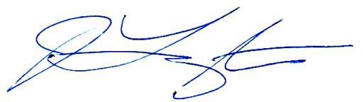Jennifer Longtin, #43509
The Law Office of Jennifer E. Longtin, LLC
Dated July 20, 2017

Certificate of Service

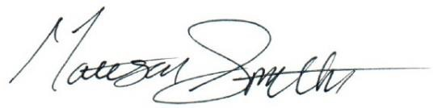The undersigned does hereby certify that on July 20, 2017, s/he did serve the foregoing MOTION via ICCES to all counsel of record.

DISTRICT COURT  JEFFERSON COUNTY, COLORADO 100 JEFFERSON COUNTY PARKWAY GOLDEN, COLORADO 80401 | ο COURT USE ONLY σ
THE PEOPLE OF THE STATE OF COLORADO
Plaintiff, v.
GARY NICKAL,
Accused.
Case No. 16CR001463

Division: 12
MOTION TO HAVE MR. NICKAL APPEAR IN CIVILIAN CLOTHES
AT TRIAL

The above captioned motion is hereby:
Granted
Denied

Ordered this day of , 2017.

Honorable District Court Judge

