VIRGJNIA:
FILED
t :/ .!·:· : , /":. f_

IN THE CIRCUIT COURT OF COMMONWEALTH OF VIRGINIA
vs. CaseNo.

NOTICE AND MOTION IN LIMINE TO EXCLUDE OR LIMIT THE OPJNION TES IMONY OF-
by counsel, moves this Court for an order in limine excluding, or in the alternative, limiting the opinion testimony of--on the ground that it is
. impermissible and scientifically unreliable in violation f Virginia evidence law, the Due Process Clause of the Fifth and Fourteenth Amendments, and Article I Section 8 of the Virginia Constitution.
PLEASE TAKE NOTICE that this on , at 10:00 am, or as soon
thereafter as possible, counsel for--will move this Court for entry of an·order.

MEMORANDUM OF LAW

According to the Notice of Commonwealth's Intent to Introduce Expert Testimony, as well as defense interviews with the witness, it is believed that_ a.police detective, will_ testify to - among other things - the following opinions:
- that the victitn was first attacked¹ while on the sofa and was then
moved from the sofa to the floor;

1Upon being interviewed by defense counsel, Detective-further indicated that his. opinion was that the "attack" on the sofa consisted of an attempt to rape -
while she was on the sofa.

- that the victim was alive when she was transferred from the sofa to the floor; and

- that the transfer pattern of blood ort the carpet, under the torso of the victim would be consistent with repeated movement back and forth, as if the perpetrator were attempting to have sexual relations with her.

This. opinion testimony. is speculative, has no.foundation in scien.ce or medicine, and is impermissibly unreliable. Further, from a relevance standpoint, the prejudicial
nature of this speculative opinion far outweighs any probative value that it offers. Finally, the above testimony is inadmissible as it is testimony as to the ultimate issue in violation of Virginia law.
- -s Opinions Cannot Be Shown To Be Based On Reliable Scientific Methods And Are Not Based On Adequate Foundation

In Virginia, "When scientific evidence is offered, the court must make a threshold finding of fact with respect to the 1:eliability of the scientific method offe1:ed, unless "it s of a kind so familiar and accepted as to requir.e no foundation to establish the fundamental reliability of the system, such as fingerprint analysis, or unless it is so unreliable that the considerations requiring its exclusion have ripened into rules of law, such as 'lie-detector' tests, or unless its admission is regulated by statute, such as blood­ alcohol test results." Spencer v. Commonwealth, 240 Va. 78, 97, 393 S.E.2d 609, 621 (1990) (citations omitted). "In making the tlu·eshold finding of fact, the court must usually rely on expert testimony." Id. Here, -•s proffered training and experience concerns the "how to" of bloodstain pattern analysis. This, however, does not in any way
qualify him under Spencer to testify regarding reliability of the methods themselves, and therefore his testimony should be excluded.
Additionally, although no majority of a Virginia appellate court has addressed the

issue, the Virginia reliability standard precisely tracks the federal standard for admission

of expert evidence set forth in Daubert v. Merrell Dow Pharmaceuticals, Inc, 509 U.S. 579 (1993). ² See Cotton v. Commonwealth, 19 Va. App. 306, 321-22, 451 S.E.Zd 673 (I994) (Benton, J., concurring in patt, dissenting in part, and concurring in the judgment).
Under Daubert, "the trial judge must ensure that any and all scientific testimony or

evidence admitted is not only relevant, but reliable." Daubert, 509 U.S. at 589.

Like Spencer, Daubert analysis "entails a preliminary assessment of whether the

reasoning or methodology underlying the testimony is scientifically valid." Id. at 592.
1
The Supreme Court outlined four non-exclusive factors worthy of consideration in determining the reliability of expert testimony:
  - whether a theory or technique can be and has been tested;

  - whether it has been subjected to peer review and publicat1on;

  - whether., in respect to a particular teclmique, there is a high known or potential rate of error and whether there are standards controlling the technique's operation; and

  - whether the theory or teclmique enjoys general acceptance within a relevant scientific community.

See Kumho Tire Co. v. Carmichael, 526 U.S. 137; 149-50 (1999) (citing Daubett v.

Merrell Dow Pharmaceuticals, Inc., 509 U.S. 579, 592-94 (1993)).

Here, the opinion testimony of-n bloodstain pattern analysis does not meet that threshold requirement of reliability as is required by Virginia law. It is not
2 Many other states have adopted the Daubert framework. See, e.g., State v. Porter, 698
- A.2d 739, 746 (Conn. 1997); Mitchell v. Commonwealth, 908 S.W.2d 100, 101 (Ky.
1995); State v. Foret_, 628 So. 2d 1116 (La. 1993); State v. Moore, 885 P.2d 457 (Mont.
1994).; Taylor v. State, 889 P.2d 319, 328 (Okla. Ct.. Crim. App. 1995); State v. O'Key, 899 P.2d 663, 6.80 (Or. 1995); E.I. du Pont de Nemours & Co., Inc. v. Robinson, 923 S.W.2d 549, 556 (Tex. 1995); Wilt v. Buracker, 443 S.E.2d 196, 203 (W. Va. 1993).

3 .

supported by scientific or medical theory. No peer-reviewed or otherwise valid scientific or medical publication has endorsed the theory. There is no quantification of the error rate of the theory, and certainly no general acceptance by the scientific or medical c01mnunity. In fact, as is shown below, the scientific community - at the direction of the United States Congress - has recently spoken loudly and clearly on the issue of bloodstain analysis and the qualifications of investigators as experts in the field.
Recognizing "that significant improvements are needed in forensi science," (See National Academy of Science Report attached as Exhibit I, at I), Congress directed the National Academy of Science (herinafter NAS) "to conduct a study on forensic science."
Id. at S-1; P.L. No. 109-108, 119 Stat. 2290 (2005); R.R. Rep. No. 109-272 at 121

(2005). Accordingly, in the fall of 2006., the NAS established a committee to implement Congress' charge. The com1nittee· included members of the forensic scienc"e community, the legal community and a diverse group of scientists (it is noted Virginia DFS Director Peter Marone was a contributing member of this committee). The committee heard expert testimony on several issues relating to the practice of forensic science. Cmmnittee members reviewed "numerous published materials, studies, and reports related to the forensic science disciplin s, engaged in independent research on the subject, and worked
on drafts of the final report." Id. at S-2. The final report, entitled Strengthening Forensic

Science in the [h1.ited States: A Path Forward, [hereinafter ''NAS Report"] was issued on February 18, 2009.
According to the findings of the NAS Report, the field of bloodstain pattern analysis suffers from some of the worst deficiencies that impair the reliable determination of scientific truth. The report notes that "[t]he uncertainties associated with bloodstain

pattern analysis are enonnous." Id. at 5-39, and that "many sources of variability arise
with the production of bloodstain patterns, and their interpretation is not nearly as straightfo1ward as the process implies." Jd. at 5-38. "Bloodstain patterns found at scenes can be complex, because although overlapping patterns may appear simple, m many cases their interpretations are difficult or impossible."3

According to the NAS Report., "scientific investigations... must be as free from bias as possible1' and "practices [must be] put in place to detect biases (such as those :from measurements, human interpretation, etc.) and to minimize their effects on conclusions." NAS Report, at 4-2. Consequently, a "body of research is required to establish the limits and measures of performance and to address the impact of sources of variability and
potential bias. Id. at 4-9. Addressing bloodstain pattern analysis, the NAS report cautions: "many bloodstain pattern analysis· cases are· pros·ecutiori driven or defense driven, with
targeted requests that can lead to context bias." Id. at 5-39.

This is unsurprising given that publicly-funded crime labs are annexed to the very law enforcement or prosecutorial agencies to which they provide assistance, and of course, the primary objective of these agencies is to prosecute. See NAS Report at 6-2: "Forensic scientists who sit administratively in law enforcement agencies or prosecutors" offices, or who are hired by those units, are subject tci a general risk of bias." As the NAS

3 The Report cites the following in support: H.L. MacDonell.1997. Bloodstain Patterns. Corning NY: Laboratory of Forensic Science; S. James. 1998; Scientific and Legal Applications qf Bloodstain Pattern Inte1pretation. Boca Raton, FL: CRC Press; P. Pizzola, S.; Roth and P. DeForest. 1986. Blood drop dynamics-II. Journal of Forensic Sciences 31(1) 36-49; R.M. Bardner. 2004. Practical Crime Scene Processing cr.nd Investigation. Boca Raton, FL: CRC Press; H.C. Lee; T. Palmbach and M.T. Miller. 2005. HemJ1 Lee's Crime Scene Handbook. Burlington, MA: Elsevjer Academic Press, pp. 281-298.

Report stressed, the "traps created by such biases can be very subtle, typically one is not aware that his or her judgment is being affected." Id. The NAS urged forensic fields to develop "rigorous protocols to guide these subjective interpretations," and to. take advantage of research from other areas regarding "the potential for bias and error in
human observers." Id. at S-6. Of course, no such safety nets were in place in the instant case.
Smtiny of bloodstain pattern analysis in Virginia has been wholly inadequate. Bloodstain pattern testimony has largely been admitted, unchallenged, as a matter of course: As such, it appears that few courts have recognized the systemic scientific problems with the field. To date., there has been no calculation of error rates in the field, there has been little or no proficiency testing, and no standards for specific applications of the teclu1ique to anything but the most basic bloodstaii1 patterns. No doubt,· this
wholesale lack of a Daubert-type scmtiny is in large part a direct consequence of defense attorneys, and a lack of understanding by attorneys of scientific method and scientific
inquiry, as well as, in sorne instances, a lack of funds to retain defense experts to
(

critically evaluate the government's claims.

From·_,s perspective, to say that the stakes in this case are high would be an understatement. - is facing the possibility of a death sentence that, if applied·,
would be based largely on unreliable and potentially erroneous bloodstain pattern at alysis. -•s testimony should be exclud d because the field of bloodstain pattern analysis currently lacks the development and implementation of adequate statistical empirical foundations and a rigorous regime of blind proficiency testing. Further, even if such requirements exist_ed, - would nonetheless still lack sufficient qualifications in

the field because he lacks the ·scientific background to testify regarding these_ impmtant issues.
Here, -is not a scientist or mathematician. There is no evidence that he has run scientific tests or looked at the en-or rates involved in bloodstain pattern analysis. Rather, the extent of his knowledge in the field was derived from attendance at two workshops on the topic of bloodstain pattern analysis. The NAS Report shows that the scientific community has rejected the reliability of Tuller's conclusions and a·ssumptions. Particularly, the scientific community recently rejected the notion that a person is an expert in this field simply based on participation in these workshops and subsequent :field experience. The NAS concluded that "[s]uch workshops are more aptly applicable for the investigator who needs to recognize the importance of these patterns so that he or she
may enlist the services of a qualifi.ed expert." NAS Report 5-38. (emphasis added). The

NAS Report makes clear that such an overview course is worth little more than·putting the student in the position of an issue spotter - one who can only be trusted to see that a true scientist and expert should be called in.⁴
Despite the fact that courts have historically allowed bloodstain pattern evidence under certain circumstances, evidence reflects a major change in the attitude of the scientific community. Most respected experts in the field, each of whom has a degree

4 While Virginia case law exists to suppo1t the proposition that blood spatter analysis is a reliable field containing evidence that can be admissible upon an appropriate foundation (see, e.g., Smith v. Commonweath, 265 Va. 250 (2003)), science is always evolving and the impartial studies and conclusions of the NAS Report post-date any case that recognizes the reliability of this science. Further, the mere fact that Virginia has said that the science can be admitted, does not in anyway preclude this Court from exercising its discretio11 in excluding such testimony in this case for the valid reasons stated in this pleading.

from an academic institution in a relevant scientific field, have now decried the lack of qualifications of too many bloodstain pattern analysts. "Numbers of individuals without scientific backgrounds have been trained [in BPA]....these individuals have stepped beyond this important investigative role to offer scientific evidence as expert witnesses. The danger inherent in this development cannot be overemphasized. No amount of experience can supplement scientific knowledge and a thought process based on careful adherertce to the scientific method." A Review of Bloodstain Evidence at Crime Scenes,
J.Forens.Sci. 35: 1491-1495, Nov. 1990; quoted in Forensic Sciences, ed. Cecil Wecht,

Bloodstain Patt.em Jnte;pretation, Herb MacDonell and Catherine Panchou, Chapter 37, Sec. 37.12[b], p. 37-68, Matthew Bender, 1992. When a complex and changing scientific field such as this involved, the last thing the court should do is simply to allow such evidence si.Jhply because of its historic admissibility.
-s conclusion that as alive when she was fast moved from the sofa to the floor, that a rape was attempted on the sofa, and that she was subject to repeated movement back and forth⁵, it is at best, speaking to the "possibility" that things occurred a certain fashion. Virginia law is clear that an "opinion based on a 'possibility'
is irrelevant_, purely speculative and, hence, inadmissible." Spruill v. Commonwealth, 221 Va. 475, 479 (1980). In Thorpe v. Commonwealth, 223 Va. 609 (1982), a Fairfax County conviction was reversed - notwithstanding the fact that the expert was qualified and that his conclusions were made "to a reasonable degree of scientific certainty" - because the Virginia Supreme Court was unwilling to allow a criminal conviction to be
5 Upon being interviewed regarding his opinions by defense counsel, Detective­ expanded upon this opinion, and stated that the "back and forth" movement was consistent with sexual behavior on the part of the perpetrator.

based on an expert's conclusion that was unable to account for other variables. See also, Grasty v. Tanner, 206 Va. 723 (1966).⁶
Similarly, here, - (who is not a scientist or expert in physics, mathematics,

inertia, gravity or viscosity) reaches his conclusions by speculating, and does so without being able to account foi· variables such as; number of patties involved, time the incident occurre9 or other influences. For instance, -s _conclusion thatlllllJwas alive
while on the floor because there was blood under her elbow ignores the possibility that the soaking stain under the elbow was caused by other means, and presumes medical conclusions which he is not qualified to testify about.
- Tuller's Proffered Testimony Is Inadmissible As It Includes An Opinion On
Ultimate Issues Of Fact

It is well-settled in· Virginia, that an expe1t may not express an opinion on the
i .. . .

ultimate issue of fact. See, M-, Zelenak v. Com., 25 Va. App. 295 (1997). In order to prove capital murder in Count I of the indictment, the Commonwealth must prove that the murder occurred in the commission o±: or subsequent to, a rape or attempted rape. Similarly, in order to prove Count II the Commonwealth must prove that -
abducted In order to prove these two ultimate issues in the case, the
.

Commonwealth now seeks to admit opinion testimony that there was an attempt to rape
while she was on the sofa, and that sh was subsequently "moved from the sofa to the floor ... while the victim was still alive" (i.e. that she was abducted) (because, according to., t perpetrator did not have enough room to rape her while on the

6 Thorge and Gratsy, while both preceding Daube1t, both further suggest that the Daubert factors are appropriate to be considered and applied in evaluating potential expert testimony in Virginia.

couch), and that-was subsequently alive and subject to "repeated movement back and fo1th" (i.e. that there_ was a rape or attempted rape while- was on the floor). These opinions are inadmissible under Virginia law, as they are opinions based on
speculation bases, and they directly address the ultimate issues of fact in this case (i.e.
. .
whether there was an abduction and a rape or attempted rape) that invade the province of the jury. See, M,, Fitzgerald v. Commonwealth. 223 Va. 615, 630 (1982); Pritchett v.
Commonwealth, 263 Va. 182, 187 (2002).

WHEREFORE - requests that this Court enter an order preventing

- from testifying as a blood stain expert or, alternatively, suggests the court take evidence concerning-'s proposed expert testimony outside the presence of the jwy and prior to his testimony in court, and order the opinions to be excluded on the basis that they are scientifically unreliable in violation of Virginia evidence case law, the Due Process Clause of.the Fifth and Fourteenth Amendments, and Article I Section 8 of the Virginia Constitution. However, should the Court allow-to testify regarding
his opinions, it is requested that the Court limit such testimony._
-
RespectfuUy submitted,
BY COUNSEL

CERTIFICATE OF SE- RVICE--
We/I hereby certify that a true copy of the foregoing Motion was delivered and/or

mailed, first class mail to:
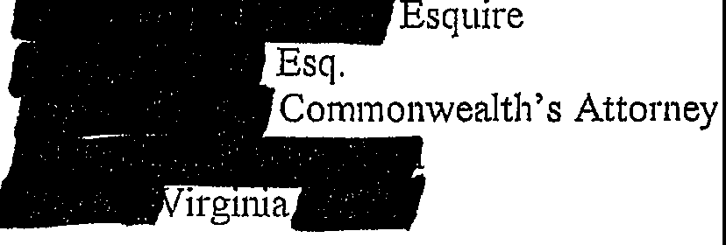

And the original was forwarded for filing to:
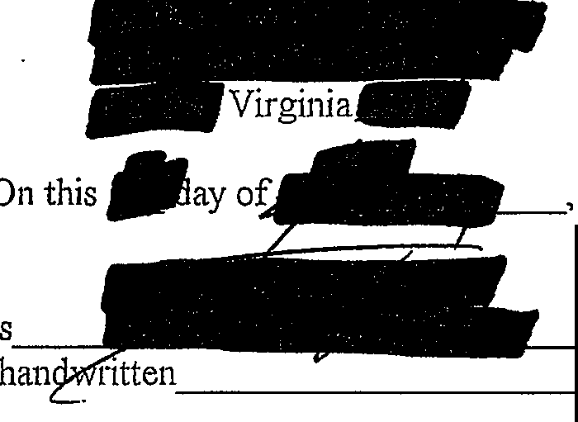
Hon. Clerk

, 2011.

