' \

VIRGINIA:

IN THE cmCUIT COURT OF

COMMONWEALTH OF VIRGJNIA, )
)
- )·
)
)
)
)
Defendant. )

CR1MINAL Nos:.....

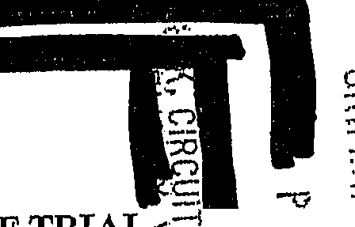The·Honorable Hearing Date:
.c

0
:::.J-.":1,
i :t!l

NOTICE AND MOTION FOR CONTINUANCE OF TRIAL:::=i -- -
  - UJ: t
, :•· . • :o.
COMES NOW Defendant,-by counsel, and will move this Hq:11,orabl at 10:00 a.m., or as soon thereafter as counsel may be heard, to continue the above styled case scheduled for trial o o a fuµire date. In making the Motion to Continue,. . relies on his right to be free fr m cruel and u u.sual punishment, his right to due process oflaw, his right to a fair triai, his right to the effective assistan e of counsel, his right to present a defense, his right to ;:i. reliable sentencing determination and the safeguards of the Fifth, Sixth, Eighth and Fourteenth Amendments to the United States Constitution, Article I, §§ 8, 9 and 11 of the Constitution of Virginia and the authority cited herein; and in supports states the following:
- On ancl efense Counsel)

were appointed to represent- along with from {he

An initial trial date of wa set.

- On
withdrew from ........epresentation due

1

to a conflict of interest with the

- On -theCourt granted 's three discovery motions [Discoveiy and Inspection Motion, Discoveiy and Inspection Motion (Supplemental) and a Discovery and Inspec ion Motion (Second Supplemental)] and ordered that-was the date th requested discovery was due·..
- On-the Commonwealth presented signifi ant amount of discovery to Defense Counsel.
- On the Commonwealth presented additional discovery to D fense Counsel, including many hours of jail call ecordings, photographs, crime scene reports, and replacement photographs from the iscovery disk which turned out to be corrupted.
- On this Court granted Defense Counsel's Motion for a

Continuance from the . Defense Counsel requested the case be set no earlier the however, the Court denied the request and ordered the case be set in At calender control with the Commonwealth and Defense Counsel, the Court determined the trial date and set the case for
... despite Defense Counsel's request for a later date.

- On after consultation with its court appointed expert, and a careful review of the discoveiy materials produced by the_,Defense Counsel issued a Subpoena Duces Tecum to the Department of Forensic Science (DFS) for the "raw data" (electropherograins, quantitation records, notes, etc.) from the DNA testing on
2

...---····-·----·-------------------------

- On. efense Counsel received additional discovery from the Commonwealth, including but not limited to, a Police Report from the a
Police Department, a CD of pictures of the deceased, and a "Secured View for Forensics" report of the de_ceased's cell phone with all contact numbers redacted.
- On the Commonwealth filed a notice of intent to seek the

penalty of death based on the "vileness" and "future dangerousness" elements.

On registered agent o
efense Counsel tssued a Subpoena Duces Tecum to the

).

However, the Subpoena went unserved, as the registered agent could not be located by the Sheriff. The subpoena requested documents were relevant to the death of the deceased and employment at
counsel,
. Up to that point
despite extensive efforts to do so, Defense Counsel and their investigator had been

denied access to the crime scene and, more important, access to any of the
3
- On---efense Counsel received additional discovery from the Commonwealth, including but not limited to·, -crime scene field notes, items seized from-work desk and correspondence between the deceased and a person located in
- On the Court granted Defense Counsel's Motion for Access to

Crime Scene and Witnesses (at ) over the objection

importance considering- is charged with premeditated murder in the

course of a rape or attempted rape.
14. On
Defense Counsel issued a second Subpoena Duces Tecum
to
) requesting the same
documents as requested back in
This time the subpoena was
sertred on
, with a return date vi
- · a
15. L D fense Counsel issued a second Subpoena Duces Tecum to the DFS for the "raw data" (electropherograms, quantitation records, notes, etc.)
from the DNA testing received by Defense Counsel on

return date on the subpoena was set for
4

witnesses, including employees, concerning guilt and/or mitigation. Defense Counsel was provided an opportunity to meet with mployees for the first time on Vital information was obtained that is required for
Doctors-and o consider in completing their evaluations.
- On • • • ■- Defense Counsel (now including from the Capital Defender's Office) received additional discovery from the Commonwealth,
including but not limited to, copies of the deceased' diaries, copies of photographs from the deceased's cell phone, a Detective's report as to the photographs and a
certificate of analysis from DFS dated egarding new
DNA testing of the combing of the pubi_c hair of the deceased. The combing was collected as part of the PERK test back in , but, was not tested and turned over until This additional discovery is of exceptional

-----·---··--··----..-- .. ----···----·.. -·--·-·-··------·--·--·---------

- On the Court took under advisement Defense Counsel's Motion for Funds to Retain Assistance of Clinical Psychologist Specializing in Childhood Abuse and Trauma.
- On two days before the documents were due from the-

responded to the Subpoena Duces Tecum by filing a Notice and Motion to Qua1;h and/or Protective Order and set the hearing for
- On Defense Counsel's Motion for Testing of Recovered Evidence
collected from the crime scene was granted.. Defense Counsel had recently gained access, through this Court's Order, to the crime scene and determined that suspected blood samples collected by the :which were sent to the
DFS lab but not tested, were material and relevant to■ s defense. The Court ordered that the testing be completed by
19.. On - ■I based on a phone consultation with Defense Counsel's court appointed DNA expert, Defense Counsel filed another Subpoena Duces Tecum .
seeking information relating to the YSTR DNA testing in this case. The Commonwealth has given notice that it intends to rely on such testing. YSTR DNA testing is a particular form of DNA evaluation, which results are not as exclusive as
ordinary testing, and the procedures involved in such testing are particular! important. The return date for the materials was - ■■however,the
  - materials are still outstanding. Defense Counsel has attempted to follow-up on the filing of the materials and will hopefully have more information soon.
5

- On the Court issued its order granting Defense Counsel's Motion for Funds to Retain Assistance of a Clinical Psychologist Specializing
in Childhood Abuse and Trauma, which the Court had taken under advisement on
a a
- Defense Counsel received additional discovery from the Commonwealth, including but not limited to,·a document that was faxed to the
•·••I
Commonwealth in oncerning alleged involvement in the death of the decedent. Defense Counsel also received additional pictures of the decedent taken by- during the_ autopsy. Defense Counsel had requested the picture in er meeting with--and discovering they did not have copies of these pictures. However, Defense Counsel was informed that they must proceed through the Commonwealth's Attorney, and_ the pictures would be turned over to them.
- Also on-Defense Counsel and reached an

agreement to withdraw the Subpoena Duces Tecum and Motion to Quash.and/or Protective Order with the unders_tanding that the requested material would be made
available to Defense Counsel by that firm.
- Still on after the motions hearing, ff a
responded by fax, to the witness list sent by Defense Counsel in early

regarding the status of current residents/witnesses Defense Counsel had determined
were relevant to the representation rf j £ £ and who's last identified residence was. ■I Many of the witnesses identified by
6

complete the.testing of the samples by
any final analysis
generated must be subjectto peer review by the other forensic scientist at DFS (which isrequired in all DNA testing) --delaying any final analysis ven ;fµrth r. Dr.
-then stated that he would need the final analysis, confirmation of the protocols and all the "raw data"( which Defense Counsel has been required to subpoena) to review the testing and findings of DFS, which would further delay the
required investigation of this case.
25. On
Defense Counsel received the "raw data" pursuant to the
Subpoena Duces Tecum issued on
regarding the DNA testing
received by Defense Counsel on
The return date on the
7

had relocated during the time period when Defense Counsel had attempted to access the to interview the r- but had been denied access.
- On the DNA expert

appointed to assist Defense Counsel in -representation.-

informed counsel that the DNA testing of the "Seven (7) additional samples by DFS would be more complicated and time consuming then the other sample tests due to the nature of the samples and their location ofrecovery - in common areas with the potential of additional contributors. This was confirmation of information obtained
when Defense Counse spoke with._.the

Forensic Scientist from DFS who voiced her concerns with the
(DFS) were able to

subpoena was set for

the materials were received op.
, however, after efforts by Defense Counsel
..
. Defense Counsel immediately

in his forming his final conclusions. Of course, in the event that Defense Counsel
gives notice ofintent to present testimony from Dr.lllllllfa.t trial, writt n report must be provided to the Commonweal h's Attorney, which might then have
the opportunity to evaluate Mr.
itself None of this can be accomplished in
the current time frame.

- 27. Another statutory provision that must be complied with is §19.2-270.5, the admissibility of DNA profile comparison. "At least twenty-one days prior to the commencement of the proceeding in which the results ofa DNA analysis will be
offered as evidence, the party intending to offer such evidence shall notify the
8
forwarded the materials to Dr.-to begin his review. Upon his receipt, the

review will take a minimum of 3 - 4 weeks.
. .
26. In addition to the scientific procedures that must be met in the preparation of this

case, there are may statutory requirements that cannot be met, such as the notice and written reports requirements pursuant to 19,2,.264.3:1. Dr. - was recently appointed to assist Defense Counsel and immediately upon being notified, he rearranged his schedule to expedited his first meeting with
However, as the Court is aware by Dr. ,...appointment, he is required to meet with on more than one occasion and review extensive background records before completing his evaluation and forming an opinion. An opinion
which the must be communicated with Dr. to be taken into consideration

opposing party, in writing of the intent to offer the analysis and shall provide or make available copies of the profiles and the :eports of statements to be introduced." Defense Counsel cannot abide by the statutory requirements of this code section when Defense Counsel does not know the results of such testing, hasn't had it reviewed for accuracy by Defense Counsel's expert and has not then given the twenty-one-day notice of their intent 'to introduce the evidence.
- Defense Counsel continues its diligent efforts regarding the investigation and

preparation of this case. Still, as was the case on determined from the response ·of
, it has been that more than 15 of the

residents/witnesses identified by Defense Co nsel has relocated from 'the
nor reviewed by Defense Counsel's expert), a_.atrial date is absolutely· impossible.
30. Granting a continuance is a discretionary decision for the trial court, however, an
9

during the period Defense Counsel was seeking to interview them and at least two of the witnesses are no longer in the Commonwealth of Virginia.
·
These witness, along with mitigation witnesses from outside Commonwealth of Virginia, will then need to be subpoenaed - a process that requires at a minimum 6
- 8 weeks. (See Attached Memorandum In Support)

- Defense Counsel continues their efforts in preparation for trial, however, taking into account any one of the above noted occurring issues of this case, such as the recent DNA testing received by Defense Counsel on or the recently ordered DNA testing of (which has not been completed by DPS

------------- "-·-••*-----·- -----·--·-------- --·- -·------

accused has a constitutional right "to call for evidence in his favor," Va. Const. art. I, §8, which includes the right to prepare for t al by procuring both testimonial and documentary evidence. Cox v Commonwealth, 227 Va. 324, 328; 315 S.E.2d 228, 230 (1984). In order to be prepared for trial, Defense Counsel must have sufficient time to investigate the case and to evaluate the evidence that is procured. In Cox
'•',
the Court reversed a Circuit Court's decision arid stated, "ill; our adversary system
of criminal justice, all relevant facts must be available to both the prosecution and

the defense in order to preserve the system's integrity." Id. At 328, 315 S.E.2d at 230.
Furthermore, the Sl:lpreme Court of Virginia as held that,although granting or denying a continuance is within the discretion of the trial court, it must exercise its discretion "with due regard to the provisions of the Bill of Rights, which secure to one accused of crime a fair and impartial trial; and to that end safe-guard his right 'to call for evidence in his favor.111 Cremeans' Case, 104 Va. 860, 863, 52 S.E. 362,
363 (1905). See also Smith v Commonwealth, 155 Va. 1111, 1117, 156 S.E. 577,
579 (193l);MeyersandAxtellReceivers, v. Trice, 86 Va. 835,837, 11 S.E. 428, 429 (1890). When a court has no reason to believe that a motion for a continuance is spurious, it should seriously consider whether a failure to grant the continuance may "imperil the just determination of the cause." Myers at 842, 11 S.E. at 430. As the Court stated in Smith: "An ideal system oflaws would be one in which speedy justice is administered, but justice and not speed should be it paramount purpose. 11 Smith at 1117, 156 S.E. at 579.
10

-----·--·---·-···--------

WHEREFORE, - by and through his Counsel, as stated above and to be argued in court, respectfully requests this Honorable Court .g.rant a continuance in this case, from
its court date to a later court date and allow Counsel for the ability to prepare his case for trial.
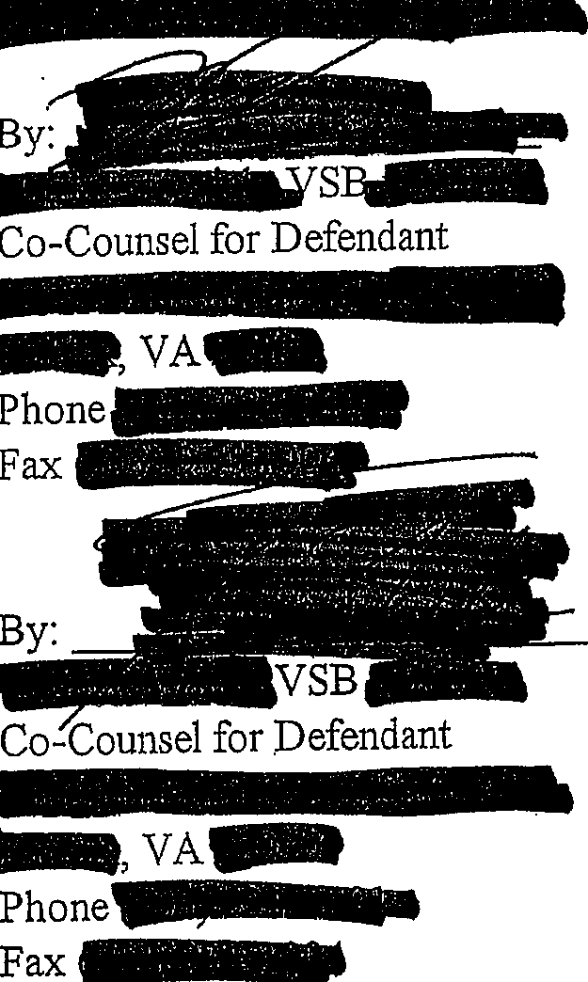Respectfully submitted,
By Coun el

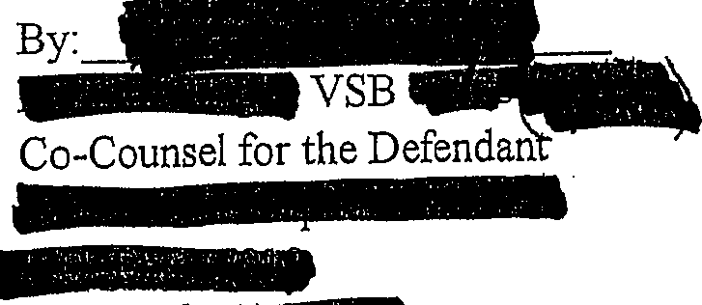
--
...
-
fax

CERTIFICATE OF SERVICE

We/I hereby certify that a true copy of the foregoing l\:fotion/Memorandum was delivered and/or mailed, first class mail to:
squire ommonwealth's Attorney

and the original was foI:Varded for filing to: Hon.
Clerk
On this aday of

12 \
I

i

