,. ,,

"VIRGINIA:

IN THE CIRCUIT COURT OF

FILED
CRli'··11NAL
MIM['·1; ,;r-,
.Hr:t t ,,
-

CLE Rf
-VA

. COMMONWEAL TH OF VIRGINIA,

v.

)
)
). . . CRIMIN.AL No.:
)
)

C.,?z-::;

.-...,..,-,.,,.. fT'! C)
rT!
....
-::=i;!
rr'"r' .

) The Honorable- 71.T ;:-: r"-

) HearingDate:-rVf:'::
-::.:>
1·...J

Defendant. )
l::;j ( n
. en

NOTICE AND MOTION FOR DNA TESTING OF POSSIBLE BLOOD STAIN THAT WAS NOT TESTED FOR DNA FOR THE VIRGINIA DIVISION OF FORENSIC SCIENCES

PLEASE TAKE NOTICE that on -at 10:00 a.m., or as soon thereafter as

this Motion can be heard, the Defendant;

of and
through his attorneys, of the

will move this Honorable Court, pursuant to his rights under the Fifth, Sixth, Eighth and

Fourteenth Amendments to the United States Constitution and Article 1, sections 8, 9 and 11 of the Virginia Constitution, for the entry of an Order compelling the DNA testing of a suspected blood stain recovered from the general crime scene that this Court has already ordered to be tested and that DFS did not test.
In support of this Motion, defense counsel states the following on information and belief:

- On this Court granted the Defendant's previous Motion for Testing of Recovered Evidence that pertained to apparent blood stains observed in the hallway
outside the decedent's apartme t,l:llfi6 f - Jnl.etedent's apartment, and a bathroom at
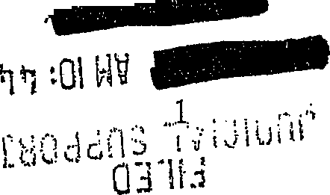

\., .

the bottom of that stairwell. These items were listed as 32 (door knob), 40 (swab from 1st to 2 nd floor baluster), 41 (swab from 2nd floor baluster), 43 (swab from 3rd to 4th floor baluster), 49 (swab from hallway wall), and 50 (swab from ground level men's bathroom). I DPS issued a
Certificate of Analysis on The defense received that Certificate of Analysis on
. .
The Certificate indicated that DFS typed Items 32, 40-43, and 49 for DNA.

- Item 32 matched the DNA profile of the decedent and excluded the defendant.

Similar DNA profiles were developed from each ofltems 40-43, and both the decedent and the defendant were eliminated as the contributor of those items. The contributor of those blood stains is therefore unknown. DFS developed a DNA profile from Item 49, and, again, the decedent and the defendant were both eliminated as the contributor of that item. The contributor ofltem 49 is different than the contributors ofitems 40-43, and, here too, the contributor of that blood stain is unknown. As a result, there are now at least four complete DNA profiles
associated with the crime scene and the blood in the area: the decedent's, the defendant's, that of. the unknown person who is the source of the blood in the stairwell outside the decedent's apartment, and that of the unknown person who is the source of the blood in the decede11-t's hallway.
- The Certificate was ambigyous as to whether DPS attempted to get DNA results from Item 50, the swab from the ground level men's bathroom. As for this item,
DPS reported that "no DNA amplification results were obtained from the swabs." It was unclear from the language of the Certificate whether there was an unsuccessful effort to obtain DNA results from Item 50 or whether DFS stopped its analysis of that sample prior to attempting to
1 A color copy of a crime scene photograph of the stain that was swabbed for Item 50 is attached

2

DNA results.

- The detennination of the source of the stain in Item 50 is highly relevant and material, as it is in a possible path that a perpetrator traveled from the decedent's apartment to outside the building. Indeed, a witness who knows what-looks like has reported seeing someone other than. . exiting the· backdoor of the decedent's wing of the apartment building by the lower-level bathroom with the suspected blood stain at around the time of the murder. Similarly, discovery from the prosecution suggests that its evidence will be that the pe!Petrator- who the prosecution believes to be-.-.exited from that same back door and then may have entered the back door of- wing of the apartment building.
- After a court hearing, the defense received the raw data from
DFS concerning the analyses related to the ertificate. From that raw data, it appears that DFS did not seek to obtain DNA results from Item 50 but rather stopped its analysis of the sample prior to attempting to obtain DNA results.
- Specifically, the notes reflect that DFS first did some serology testing of the sample. The notes reflect the follow:ip_g; "50. One swab w/ c ear microfuge tube, unlabeled, w cotton end. Top~½ of cotton stained lt rib. P O [negative], TMB wk+ [weak positive]--> INC. All of stained area on swab cut for DNA." (This page of the notes is attached as Exhibit B). On information and belief, these notes reflect that DFS concluded that its presumptive blood t sts, read in conjunction with one another, were inconclusive because of the inconsistency in findings between the P negative and the TMB weak positive. Regardless, DFS cut the stain for DNA testing. DFS then attempted to determine the amount of DNA on the cutting, and its quantitation
as :Exhibit A.

3

process detected no DNA. DFS then did not go on to the next step and attempt to amplify the cutting and type it for DNA results.
- Just because the quantitation test fails to detect DNA does not mean that the sample contains no DNA. The quantitation tests are useful tools but imprecise and imperfect. In the experience of def nse couns l and a consulting forensic DNA analyst, laboratories do get· DNA results from samples when the quantitation test failed to detect DNA. Because these tests are not precise, oftentimes there are low quantities of DNA present from which DNA results can
be obta ed. More specifically, DNA typing results can still be obtained after putting in the genetic analyzer, whether, like done at DFS, the PowerPlex 16 system is used for analysis or whether some other analytical system is use.d. Different systems have different optimal quantities of DNA required to obtain the complete, accurate results. The PowerPlex 16 system requires a greater amount of DNA t obtain complete, accurate results than some other systems.
- There is a new technology called Mini-STR testing that requires lesser quantities of DNA to obtain results. Mini-STR testing substantially increases the ability.to obtain DNA results from compromised samples that pi:-eviously may h ve yielded l mited or no genetic data, like the swab from Item 50. Mini-STR testing has been optimized to obtain results from degraded and/or inhibited samples and can obtain results when more traditional DNA testing might not.
- On infonnation and belief, DFS had not yet validated Mini-STR testing and therefore does not do it. That may be part of the reason that DFS did not conduct DNA testing on Item 50. Because DFS does not have the capacity to conduct Mini-STR testing, the defense asks that Item 50 and any sub-items that have been created from Item 50 (such as the cutting and
4

DNA extract) are sent out to a private laboratory for Mini-STR testing to get results to compare to the DNA profiles of the decedent, the defendant, and the two unknown persons whose blood was identified outside the decedent's apartment.
- The defense has investigated options for different laboratories and suggests that

the testing is done at laboratory in
, which is an accredited forensic DNA has gotten DNA results from its

Mini-STR test even when the quantitation test reported a finding of zero. An analyst at
2 I■ J r-aboratories indicated that Mini-STR testing could be completed within 21-28 days of receipt of the evidence, and therefore such testing will take place and be concluded
contemporaneously with the mitochondrial DNA testing conducted by DFS. The cost of the Min-STR testing is $995.00. The defense attaches
:MEMORANDUM IN SUPPORT OF MOTION FOR DNA TESTING

The Court has the authority and responsibility to order the Commonwealth to provide the defense team with access to the above identified collected items to allow the defense to test Item

2 Out of an abundance of caution and to avoid unnecessary delays in the future, is also giving a price quote for testing by the Identifiler process, which like the PowerPlex 16 process, is a more traditional DNA testing process that requires greater amounts of biological material to obtain results.
as gotten DNA results with both the Identifiler process and the MiniFiler process when the quantitation test reported no DNA. If there is only enough biological material to put through one testing process,
will just conduct Minifiler testing. If there is enough material tb put through two testing
processes, the laboratory's standard operating procedure is to test a sample using the Identifiler process first, because Identifiler generally provides more infonnation (more genetic locations) than does Mini-Filer. If the laboratory obtains sufficient Identifiler results, it does not necessarily conduct MiniFiler testing but may stop its testing right there. If the laboratory does not obtain sufficient Identifiler results and has enough material to then do Minifiler testing, it then conducts MiniFiler testing. It should be noted that, based upon the DFS notes and reports,
does not think there is enough material to try Identifiler testing before it conducts MiniFiler. Upon receipt of the cutting and the extract from the cutting,!! 3 would determine
whether it concludes that it should go straight to Minifiler testing or whe er it could first attempt Identifiler testing without compromising the ability to do Minifiler testing. The cost ofidentifiler testing is $850.00 for one sample.
.The defense only notes that possibility there may be a graduated testing process of Identifiler followed by Minifiler,
if••••••••lrecommends
the alternative approach upon seeing the actual evidence.

5

50 and any sub-items (such as cuttings and DNA extracts) that have been generated from it. This authority derives from rights to due process, compulsory process and effective assistance of counsel under the Sixth and Fourteenth .Amendments to the United States Constitution and Article 1, section 8 of the Constitution of Virginia. -s right to be free from cruel and unusual punishment under the Eighth .Amendment to tli.e U. S. Con'stitution and Article 1, section 9 of the Virginia Constitution further justifies and necessitates the Court granting the requested relief The Court should exercise its authority in the circumstances of this case for the following reasons.
First, the United States Constitution requires the disclosure of any evidence tending to

negate a criminal defendant's guilt and/or punishment. Brady v Maryland, 373 U.S. 83 (1963) Because this is a capital prosecution, exacting standards must be met to assure that it is fair. "[T]he penalty of death is qualitatively different from a sentence of imprisonment, however iong Death, in its finality, differs more from life imprisonment than a 100-year prison term differs from one of only a year or two." Woodson v. North Carolina, 428 U.S. 280, 305 (1976).
Because "death is different," the United $tat s C9nstitution requires that "extraordinary measures [are] to insure that"-"isafforded process that will guarantee, as much as is humanly possible, that [a sentence of death not be] imposed out of whim, passion, prejudice, or mistake." Caldwell v. Mississippi, 472 U.S. 320,329 n.2 (1985) (quoting Eddings v. Oklahoma, 455 U.S.
104, 118 (1981) (O'Connor, J., concurring)). Therefore, in order to prevent any miscarriage of

justice, due process requires that the Court exercise its authority and make available for testing the items listed above to remove any unfair and prejudicial obstructions to £ l's defense.
The right to call witnesses and present evidence in one's own defense is a fundamental

6

right of due process protected under both the United States Constitution and the Virginia Constitution. Washington v Texas, 338 U.S. 14, 19 (1967). The Sixth Amendment of the U.S. Constitution proclaims that an accused is guaranteed a "compulsory process for obtaining
witnesses in his favor." U.S. Const. am. VI. Under the Virginia Constitution, an accused has the right to Acall evidence in his favor." Va. Const. art.' I. section 8. Defense counsel must be
afforded the ability to "investigate and evaluate the evidence in preparation for trial." Gilchrist v Commonwealth, 227 Va. 540, 546 (1984). "[A]n accused has the unqualified right to 'call for evide ce in his favor' This includes the right to prepare for trial which, in tum, includes the right to interview material witnesses and ascertain the truth." Warmouth v Commonwealth, 29 Va.
App. 476,485 (1999), (quoting Bobo v Commonwealth, 187 Va. 774, 779, (1948)); Va. Const.

art. I, section 8.

The Court of Appeals ofVirginia observed that a crimina1 defendant's rights to a compulsory process and due process (denominated "right to call for evidence in his favor" under
state constitution) require that a trial court grant a defendant's request to compel defense "access to the raw materi,aj.s :in.tegral to the building of an effective d fense." Id. at 344 (quoting Ake v. Oklahoma, 470U.S. 68, 77 (1985)). The court elaboratedinHenshawv. Commonwealth, 19 Va.
App. 338 (1994):

This ... includes the right to interview material witnesses and to ascertain the truth." Bobo v. Commonwealth, 187 Va. 774, 779, 48 S.E.2d 213,215 (1948)), the right to prepare for trial, and the right to present an adequate defense. Gilchrist v. Commonwealth, 227 Va. 540, 547, 317 S.E.2d 784, 787 (1984). These rights lie at the heart of a fair trial, and when they are abridged, an accused is denied due process.

7

In fact, the Supreme Court of Virginia has established that a defendant is entitled to inspect potential evidence upon a plausible showing that the material might have exculpatory relevance, see Ramdass v Commonwealth, 246 Va. 413,437 (1993), and impeachment value
alonemaymaketheinformation exculpatory. FitezgeraldvBass, 6Va. App. 38, 52-53 (1988). Furthermore, the Court of Appeals has ruled that a failure on the part of the Commonwealth to conduct a particular form of investigative testing, which potentially could provide exculpatory evidence, requires dismissal. Breeden v Commonwealth, 15 Va. App. 148, 150 (1992).
Finally, any barriers imposed on the defense's investigation in this case, if allowed to persist, will render - counsel constitutionally ineffective. The seriousness of a capital murder charge and the defendant's possibility of a sentence of death are circumstances that must
be considered in evaluating whether counsel provides the effective assistance required under the Sixth Amendment. See Virginia Dept. of Corrections v. Clark, 221 Va. 525, 534 (1984).· Counsel must conduct a reasonable pretrial investigation in a capital case. Id. A thorough
defense investigation in a capital case is "vitally important." Powell v. Alabama, 287 U.S. 45, 57 (1932).. _"Cou.psel <1:t fjvery stage have an obligation to conduct thorough and independent investigations relating to the issues of both guilt and penalty." Guideline 10.7, Guidelines for the Appointment and Pe1formance of Defense Counsel in Death Penalty Cases, ABA (2003) (emphasis added).
WHEREFORE, -by counsel, requests that this Court enter an order that requires the Commonwealth to order Mini-STR,. testing ofitem 50 (swab of suspected blood stain) and any sub-items ofltem 50, such as cuttings or DNA extract.
Respectfully submitted,

8

By Counsel

Co-Counsel for Defendant

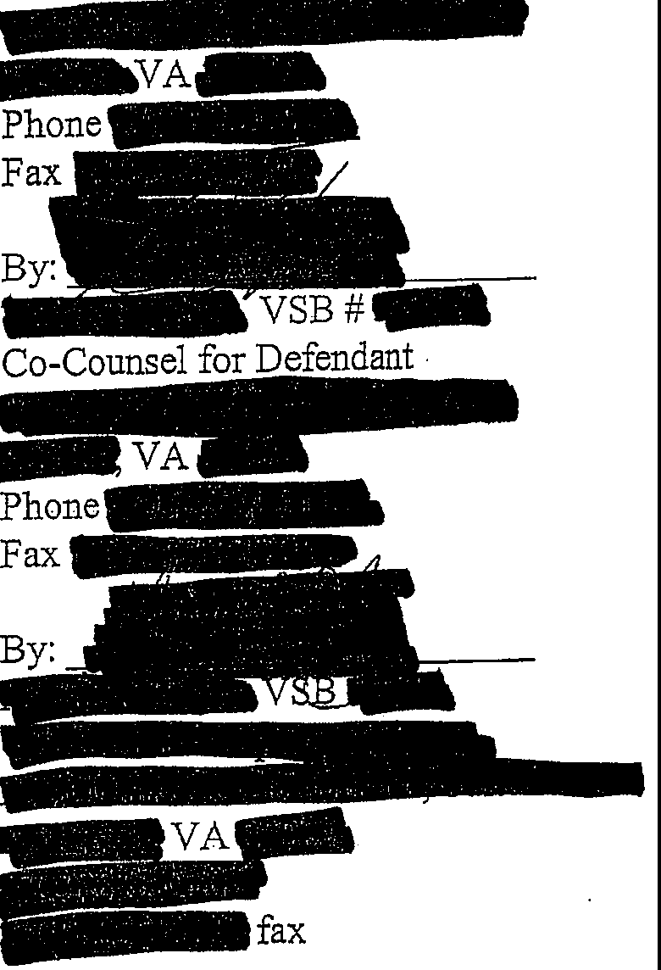
CERTIFICATE OF SERVICE

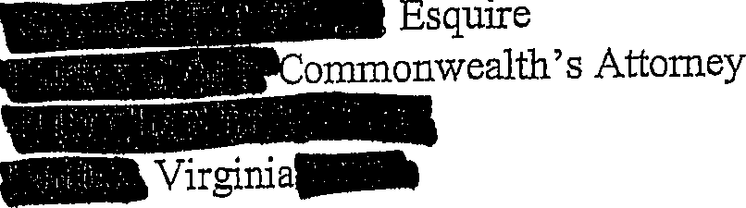
We/I hereby certify that a true copy of the foregoing Motion/Memorandum was delivered and/or mailed, first class mail to:

9

and the original was forwarded for filing to:

Bon.­ Clerk
..
Virginia

Onthis-ayof ...

10

Exhibit A

r'!#Z.
,..
I
I

r. ,
C\I o­
g--
;
-

Cf)
-
w
I
! I
I
l
I\)
I
- •
,
-
--

:r:
-
0z
at -

f-o'....,-"!"'''-;. ,-i-;,·
i
i .
I
....=_,.,,,.-,,,--- -•-..,;.,.,-, .,.·,..m:,...

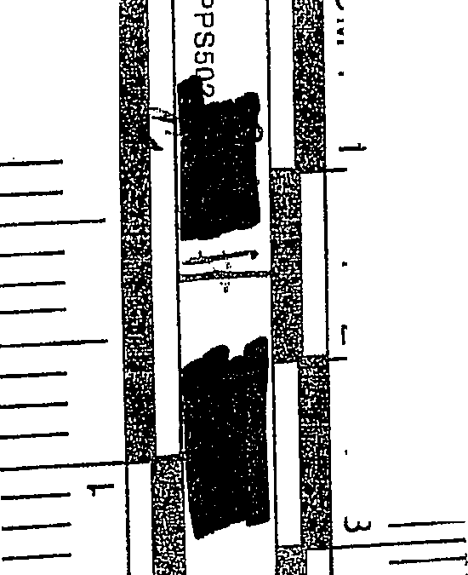

. --·-··· ·-· - - ·····-·--···-··-···-··-·····----·--······· --•··--···..··- ·---·- --·-··-----·---.-

Exhibit B

{ L)/\t, 17
LI\( _{IY1C:} t1v' 5 /-f-1-,
} )
ll·',-,I,.•,1. . , .
,,'.:-> ·-•· I)I
I'='Ci I I I J t-,,_r

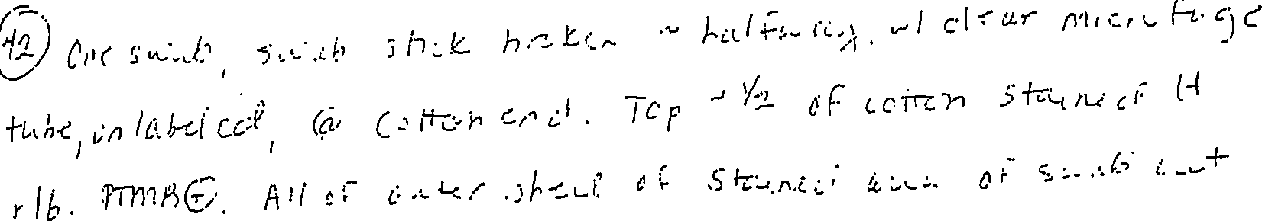
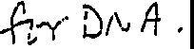

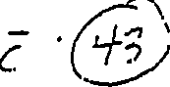

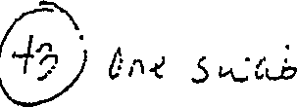
C .-c ,;.,r / ,I\\ c.. , ..,,,C., ,,.:J c:. ht h,·•() [,, _{I]} ·1'C' L I? c I r /'/"rJ ,C:"' l •,'· ·J.c... ..,..., .: r"•c.( •
/ 1
Vuj [+. c((LJ _,; /J.-11;'-:..;..h, -J-='-,..1"'3/,, :,¼;...,, (o-.-w;) .,.\/"3 -:. :;,. ,,.,b
{'1rh{!) 0/<-0. A-Ii o; .:;hcl\,{cf a,1.,ui. 1:·{ ,51,,._•,;,_b C,A hr D11]fl-_

@ 0"-l (YI.:.,) rib ,5u..:i:,,J,_) i,.1/ cka.r- (Hl·u1.J,,·'5c. ·h,k 1 - 11 t¹ ._h --e.(.

._,t .f )

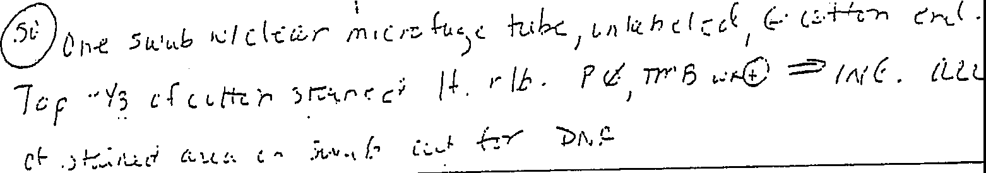(!_ Co -r r:,....) fI !Y'8 f.) ·" 1/3 c: i,: cl ;,;:k./ .;J,,-c I( r { S _{<.,c.,_}b Cu,/- Fi,-,r (.) i·"-.:i A,.

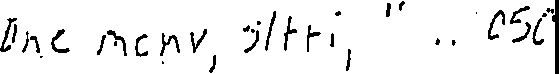
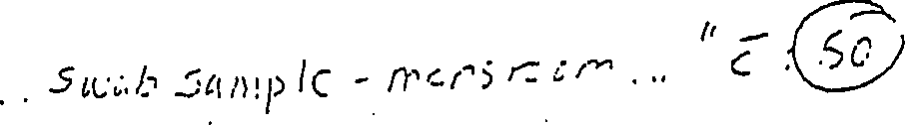
(cl\i _{2_1}

Exhibit C

Date Quote No.

Number/Name | Commonwealth vs.
Summary | Evidence consists of a swab taken from a stain found on the floor of a bathroom. Sample will likely be an extract unless the sample was not previously consumed. Sample was quantified previously with Plexor HY which produced no results.
·
.
·
.
•
- :
, Test_.
Minifiler - Evidence
· .·
·
· · . .· .
. , .·
Standard (21 -28 Days)
$995.00
·
Ex e d d:
$995.00
Total $995.00
This proposal is subject to revision if the actual samples or information submitted are not consistent with the quotation. Pass through travel expenses are priced on advanced booking at the time of proposal and are subject to change based on market price at the time of proposal acceptance.

Evidence that co tains degraded DNA may not yield a suitable DNA prcifile with tier one· testing. Extended testing with MiniFiler often proves useful in generating a DNA profile from samples containing degraded DNA. Contact the lab for more information.
pmt P •ce
. . _. •. ,,
(Business Days) .. Quantt y .
.
TurnAroundTime:

- • • Fax •

- '
'-,,_-
',' '
-
• , • : :-• 'l'I ',:
.J
- .

~-"-!.., ... •11,"•-

Date Quote No.

. ... .,
. | . . •·
 |  | . " | '
._Case:'lnforination:-·

' ·
t
Number/Name
Summary | Evidence consists of a swab taken from a stain found on the floor of a bathroom.  Sample will likely be an extract unless the sample was not previously consumed. Sample was quantified previously with Plexor HY which produced no results.
.
,
-_-
- -. ,es_,·:
T t
- ,
.
_- ·,. {Business'Days).- uan1y
Turn Around Time Q t:-t
U P, .
m_ nee,
-E
·,
This proposal is subject to revision if the·actual samples or information submitted are not consistent with the quotation. Pass through travel expenses are priced on advanced booking at the time of proposal and are subject to change based on market price at the time of proposal acceptance.

Evidence that contains degraded DNA inay not yield a suitable DNA profile with tier one testing. Extended testing with MiniFiler often proves useful in generating a DNA profile from samples containing degraded DNA. Contact the lab for more information.
Total $850.00
$850.00
$850:00
Standard (21 -28 Days)
ldenlifiler - Evidence
t d- d
xen_,e

• •

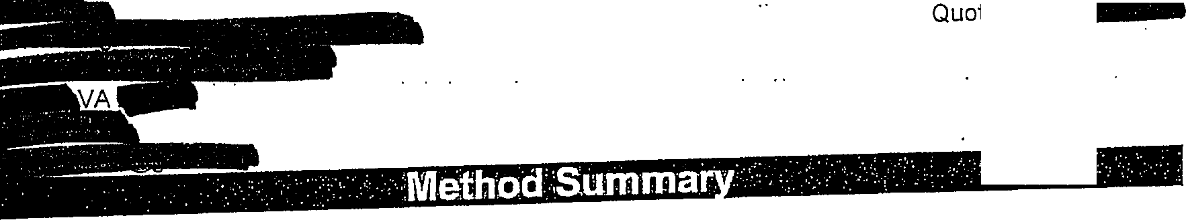
Date Quote No.

Laboratory analyses are performed in accordance with validated standard operating procedures. Samples are processed by one or more of the following techniques, depending on the nature of the evidence and the analysis requested.
y e
Forensic Screening | All samples are screened in Chromosomal's advanced evidence screening laborator prior to analysis. Physical examination is augmented, as necessary, with an alternat light source. Select sub samples are subjected to additional testing with Kastle-Meyer  acid phosphatase, PSA or microscopy, as warranted.
DNA Extraction and  Purification | DNA extractions are performed by one of the following techniques: Prepfiler, EpiCentr QuickExtract, Differex, Promega DNA IQ System, or proteinase K/phenol-chloroform depending on the nature of the sample.
DNA Quantification | Total human DNA and total. human male DNA. is quantified using Quantifiler an Quantifiler Y, respectively, as appropriate.
ldentifiler | Designed for forensics and paternity testing, the ldentifiler kit from Applied Biosystems simultaneously analyzes 15 STR loci as wel.I as the gender determining marker Amelogenin. Included are the 13 CODIS loci as well as two additional markers, 02S1338 and D19S433. The data generated from this profile exceeds the recommendations of CODIS, the European Network of Forensic Science Institutes (ENFSI) and Interpol organizations. This profile can achieve an average probability of  identity of 1.31 x 10-18 to 3.62 x 10-17 in select populations.
Yfiler | The Yfiler assay analyzes 16 Y-chromosome STR regions that are variable in length and are widespread throughout the human genome. The regions analyzed include the core set of nine loci defined as the European Minimal Haplotype and the two loci recommended by the Scientific Working Group on DNA Analysis Methods (SWGDAM). Six additional highly polymorphic loci are also tested, significantly increasing the discrimination capacity of haplotype analysis. Y-Chromosome STRs enables the  analysis of complex male:female DNA mixtures that often yield ambiguous or inconclusive results with autosomal STRs.
Minifiler | The MiniFiler™ Kit substantially increases the ability to obtain DNA results from compromised samples that previously would have yielded limited or no genetic data. The MiniFiler™ Kitis a 9-plex and Includes: D13S317, D78820, Amelogenin, D2S1338, D21S11, D16S539, 018S51, CSF1PO, and FGA. The MiniFiler™ Kit has been optimized to yield results from degraded and/or inhibited samples. Loci that drop out using currently available STR kit technology may be recovered using the MiniFiler™ Kit.
Case Review c F  l | A scientific technical review is performed by a qualified Forensic DNA Analyst for ompliance with the recommendations of The Quality Assurance Standards for orensic DNA Testing Laboratories issued by the Director of the Federal B reau of  nvesti□ation and other industrv best oractice.

,

e
,

d

a • a a.
•• w
3•

Date Quote No.

· · ·.·· .·. ..' .·..
·· · ·..
. ··'. · i
- : .
·- · ·... ·.··. :·

• • 'r,,•, • -. ! .• •••• ,.,, :t:,,.· ·, .. •, ;.y
- · ·:·.· -·.- · .._, ,;.-:.•.;·.:e,,,·,dence··"·1· ·os'"1t·1o·n·:·:·-·: -, ··- ··.-....- ··.... --·:··
.'.J..I.
• •. ·., ,,•• ·•.·•• ·. ! ·, • ·• ,· ._' •
The physical evidence submitted will be returned to the client subsequent to completion of testing.
a
•·
•
Fax
•
The Quality System at Chromosomal Laboratories is modeled after ISO 17025:2005, General Requirements for the Competence of Testing and Calibration Laboratories, the international benchmark for approving the competence of testing and calibration laboratories. The Chromosomal quality program has been engineered to meet the diverse requirements of several accreditation bodies and standards, including AABB, ASCLD and DAB. The laboratory complies with applicable industry guidelines, including the Quality Assurance Standards for Forensic DNA Testing Laboratories and Convicted Offender DNA Databasing Laboratories issued by the FBI Director.
11
·A
·.... ·
·'
··
., .
', ·,· .-
· | ·..· ': ·Q |  | i•a1·,•·' · •ssu·ran·ce··· -
,.-. | : | , .· I | . | : .N: .: |  | ..

l A
Forensic Quality Services International (FQS-1) | Chromosomal Laboratories is accredited by Forensic Quality Services Internationa (FQS-1) to perform biological screening, DNA analysis for forensic casework and DN analysis for CODIS databasing. Through this ISO 17025 accreditation, our forensi department provides validated, court admissible testing to the legal community, la enforcement, and private investigators. The laboratory has validated procedures for  both autosomal STRs and Y-STRs.
State ofTexas- DPS Accreditation | Chromosomal Laboratories, Inc has been granted Full DPS Accreditation by the Director of the Department of Public Safety for the discipline of Biology.
American Association of Blood Banks (AABB) | Chromosomal Laboratories, Inc is an American Association of Blood Banks (AABB) Accrl;)dited .Relationship Testing F cility. AABB is an international association involved in activities related to transfusion and cellular therapies· including transplantation  medicine.
State of New York | Chromosomal Laboratories, Inc is authorized to perform DNA Parentage/Identity  Testing on samples originating in the State of New York by the New York State Department of Health, PFI: 8237.
U.S. Department of Homeland Security Immigration Testing | The U.S. Department of Homeland Security requires that DNA testing must be performed by an American Association of Blood Banks (AABB) accredited laboratory. As an AABB Accredited Testing Facility, Chromosomal meets the requirements for Immigration Testing for the U.S. Department of Homeland Security. Chromosomal Laboratories, Inc works with the State Department and embassies all over the world, In providing relationship services to petitioners and beneficiaries.

c w

Date Quote No.

_: - · ... · ·._ · ,,_._. ·.-,GeneralProvis"ions··_ · ,·.. • · · ·-.
,_

Forensic evidence does not always contain DNA of sufficient quality or quantity to yield a DNA profile. All fees must be paid in full, regardless of whether the sample produces a DNA profile or not. Pricing is valid for six
at••••••• li• or
months. All services shall be performed in accordance with our current terms and conditions which can be
found
■
by calling
The client agrees to pay for all costs incurred, including the time spent by
employees, should £ ]LJ required to respond to legal process related to the services it has
performed for the client or should the client requ!3st file searches, a ditional reporting, or a consultation that is outside the scope typically offered in the normal course of business. ·

Written authorization is required with case submission. An invoice for services rendered will be issued with the final report.•••••·•••·•ermsare net 30 days.

If you have any questions regarding this proposal, please do not hesitate to call or email. Sincerely,

r
,Clie.nf.Acce 'tanceAuthorizatio·n· · · : ·..

/a·:·
.···.:·'. --·_. ·· i_-.· :·

· .· · ·.. · ·

Name

Signature Date

.. • • •

SUBMITTING A FORENSIC CASE

is accredited by Forensic Quality Services International (FQS-1) to perform biological screening, DNA analysis for forensic casework and DNA analysis for CODIS databasing. Through this ISO 17025 accreditation, our forensic oemartment provides validated, court admissible testing to the legal community, law enforcement, and private investigators.
Submitting a case:

To better serve our clients we ask that the enclosed Forensic Case Submission Form and Chain of Custody be filled out when submitting samples. The evidence can be hand delivered or shipped to the address below using a courier service, such as OHL, FedEx, or UPS.
Deliver samples to:

Guidelines:
Email:

- Forensic DNA techniques require sufficient biological material to be extracted in order to generate informative results. When possible, permission shouid be granted to extract samples [n .their entirety for evidence that may contain, or is likely to contain, low amounts of biological material. Before granting consent please review the ASA criminal justice standard 3.4 standards for consumptive testing, shown below.
When possible, a portion of the DNA evidence tested and, when possible, a portion of any extract from the DNA evidence should be preserved for further testing.
  - A laboratory should not undertake testing that entirely consumes DNA evidence or the extract from It without the prior approval of the prosecutor if a law enforcement officer is requesting the testing, or of defense counsel if the testing is requested by defense counsel or defense counsel's agent.
  - Before approving a test that entirely consumes DNA evidence or the extract from it, the prosecutor should provide any defendant against whom an accusatorial instrument has been filed, or any suspect who has requested prior notice, an opportunity to object and move for an appropriate court order.
  - Before approving a test that entirely consumes DNA evidence or the extract from it, the attorney for any defendant against whom an accusatorial instrument has been filed, or for any other person who intends to conduct such a test, should provide the prosecutor an opportunity to object and move for an appropriate court order.
  - If a motion objecting to consumptive testing is filed, the court should consider ordering procedures that would permit an independent evaluation of the analysis, including but not limited to the presence of an expert representing the moving party during evidence preparation and testing, and videotaping or photographing the preparation and testing.
- Evidence should be stored in paper bags or envelopes and should be dried before storage.
- Biological evidence that are moist, such as tissue and organs, should generally be frozen and shipped on dry ice unless otherwise instructed by medical personnel. .
- Dry biological specimens should be stored and shipped at room temperature.
- Samples that are shipped on ice should be in a leak proof container.
- Use personal protective equipment (latex gloves, mask, etc.) when handling samples.
- Each piece of evidence should be packaged independently of one another.
Upon submission of sample evidence, your case will be assigned a DNA Case Manager who will work with you one on one during the analysis of the evidence. For general questions and current pricing please feel free to contact one of our DNA C se Managers at- or by email at

0 :-"'" .••..
':
1
. ..
..... ·,,:. : .
'·,'l.L,..,,.:...,.• , ·, •. 11...:r.a.
Forensic Case Submission Fonn
Check only one: D New Case ··· · 0 Addition to the following case·:
Submitted by: D Government/Law Enforcement Agency D Private Individual/Company

Client Contact Information
Agency Case #:
Initial Contact:
Agency Name:
Address:
City, State, and Zip:

--------- --

Quote#
Court Date: -_-- -_-_J_I!!_I_l!_I_I_I_I_I_II_!!! IL - _-_-
Phone#: -
Fax: Email:
. . .

Billing Information
DSame as Above
(Note: Pre-payment required for non-government agencies)

Agency Name:
Address: City, State, and Zip:
Phone#: Fax: Email:

Reporting Instructions
Send by: 0 Email
Send to: 0 Contact address above

0Fax
D Additional address below
Dus Mail
0 Alternative address below

Agency Name: Address: City, State, and Zip: Phone#: Fax: Email:

Sample Return Address
DClient contact address DAlternative address below

Print Name
Signature
Date
Agency Name: Address: City, State, and Zip:

Authorized personnel allowed to discuss case details (i.e. prosecutors, defenders, detectives, etc... )

Name: Phone#: Email:
I hereby certify that the information provided on the above Forensic Case Submission Form is accurate to the best of my knowledge. Furthermore, I authorize & to perform the requested analysis on the specimens submitted in accordance with
their standard procedures, terms and conditions. I also understand that I will be charged for the services according to the applicable fee schedule.

I herby authorize above.
o conduct testing on the sample(s) listed on this form according to the specifications listed
Print Name
Signature
Date

•·, (I
--
Chain of Custody

This form must be filled out completely and sent along with the evidence

Agency Name: Date:
Check only one: ONewCase D Addition to the following case:
DNA Analysis
- ldentlfller-15 STRs - 13 CODIS + 2 Loci+ AMEL
- Y-Filer - 16 STRs
- MiniFiler - 8 STRs - testing for degraded DNA
Forensic Biology Screening
- Testing for the presence of blood
- Testing for the presence of seminal fluld/spem, cells
- Testing for the presence of saliva
Analytical Test

Lab No. | Description | Permission to Consume  Sample (If necessary) | Type of Testing
 |  |  | Desired (Select  applicable letters from the above list) | Date  Collected
□YES
□NO
□YES
□No
□YES
□No
□YES
ONO
□YES
□No
□YES
ONO
*To rush a case please call - (877) 434,:,0292
Comments:

Received From: n Courier n us Mail I | UPS I I FedEx I I DHL Quote#
Relinquished By | Received By | Date/Time

