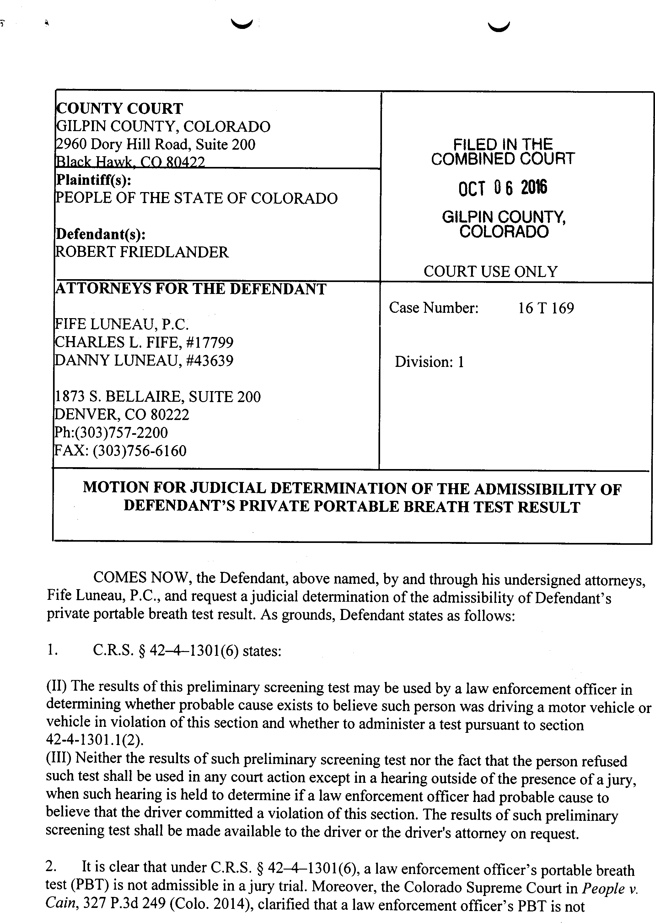

DATE FILED: October 6, 2016 CASE NUMBER: 2016T169

r !

admissible under any circumstances, including impeachment or the "opening the door" exception.

- In this case, Mr. Friedlander owned his own (PBT) that he used prior to arrest in this case. Mr. Friedlander's PBT recorded a blood alchol content (BAC) under .05.

- C.R.S. § 42-4-1301(6)and Cain do not address or prohibit the use of a private PBT. Mr. Friedlander wishes to use this PBT result during his trial.

- A defendant's right to present a defense pursuant to the Due Process Clauses of the Colorado and United States Constitution cannot be unreasonably restricted by a statute or rule. Courts have repeatedly held that where a defendant seeks to introduce reliable exculpatory evidence it is a violation of his Due Process rights for that evidence to be excluded based upon a rule or statute that would othenvise prohibit the admission of such evidence. Holmes v. South Carolina, 126 S.Ct. 1727 (2006)(State rule that prohibited admission of evidence of third party guilt unless it raised a reasonable inference of the defendant's guilt violated defendant's due process rights), Rock v. Arkansas, 483 U.S. 44, 107 S.Ct. 2704 (l 987)(state rule prohibiting admission of hypnotically refreshed testimony violated defendants right to present a defense under the Due Process clause), Crane v. Kentucky, 476 U.S. 683, 106 S.Ct. 2142 (1986)(exclusion of testimony regarding circumstances of defendant's confession on the grounds that the issue of voluntariness was resolved against the defendant at the pretrial hearing denied the defendant his right to Due Process of law and a fair trial ), Chambers v. Mississippi, 410
U.S. 284, 93 S.Ct. 1038 (1973)(exclusion of hearsay statements where third party confessed violated defendant's right to Due Process of law.

- Other states that have evaluated this question have held that even where the results are not admissible by the prosecution, if the results are exculpatory they may be admitted by the defense. Patrick v. State, 750 S.W.2d 391 (1988)(where PBT is admissible for purpose of determining probable cause they should be considered reliable enough to be admitted as exculpatory evidence).

- The probative value of this evidence is very high as it confirms that Mr. Friedlander was not under the influence or driving while ability impaired at the time he was driving. Given that there is minimal chance that the PBT result was falsely lower than actual BrAC, there is no unfair prejudice to the prosecution in admitting this evidence. To the extent that the PBT may have read lower than the actual BrAC, the prosecution can elicit this information either through cross examination or a rebuttal witnesses.

; !

WHEREFORE, Defendant requests a judicial determination as to the admissibility of his PBT during trial.

Respectfully submitted,
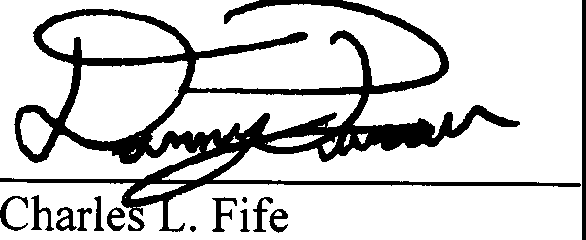
Danny Luneau
ATTORNEYS FOR DEFENDANT

CERTIFICATE OF MAILING

I do hereby state and affirm that a copy of the foregoing MOTION FOR JUDICIAL DETERMINATION OF THE ADMISSIBILITY OF DEFENDANT'S PRIVATE
PORTABLE BREATH TEST RESULT was placed in the U.S. Mail, postage pre-paid, this 4th day of October, 2016:

Office of the District Attorney County of Jefferson
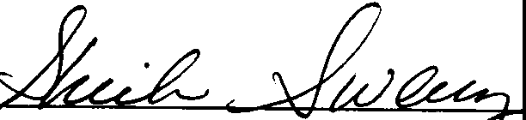
500 Jefferson County Parkway Golden, CO 80465

