VffiGINIA:
.I
I
,; )
,,
I

IN THE CIRCUIT COURT OF I
Amendments to the United States Constitution and Article 1, sections 8, 9 and 11 of the Virginia Constitution, for the entry of an Order compelling microscopic hair comparison and, where deemed to be human byproduct, DNA testin . of certain previously untested ev_idence recovered from the general crime scene and from the decedent.
In sup_port of this Motion, def nse counsel states. the following on information and belief:
1. . This Court has previously granted
s motions for additional DNA
testing.
2. · DNA- testing thus far has resulted in the identification of at least four complete DNA profiles associated with the crime scene and the blood in the area: the decedent's; the

COMMONWEALTH OF VIRGINIA, )
)
- ) CRlMtNAt No.:
)
)
) The Honorable
) Hearing Date:
Defendant. )

NOTICE AND MOTION FOR ADDITIONAL NUCLEAR DNA TESTING OF A BLOOD SAMPLE, AND MICROSCOPIC HAIR COMPARISON AND MITOCHONDRIAL DNA TESTING OF HAIR SAMPLES

PLEASE TAKE NOTICE that on at 10:00 a.m., or as soon thereafter as this Motion·can be heard, the Defenda t, _, through his attorneys, will move this Honorable Court, pursuant to1tls rights under the Fift.h, Sixth, Eighth and Fourteenth

-------·-----------

defendant's; that of an unknown person who is the source of blood in the stairwell outside the

decedent's apartment; and that of another unknown person who is the source of blood in the
,
' ·. ......

decedent's hallway. DNA testing has also resulted in a partial profile inconsistent wit he four
above profiles ip. evidence recovered from the decede"1t's person and apartment. ,. .,.

  - 's counsel has reviewed the DNA testing results and und lying; 4atri
'\

and now moves for additional testing. This testing is necessary to explore evidence of dlerent
.f

or second perpetrator of the offense. groups of evidence.
moves for forensic afialysis of SftVeral separate
t !e

  - . Hairs and Hair Fragments beneath left and right fingernails of the decedent:

.DFS lab reports indicate that DFS observed hair :fragments located under the decedent's
.
I

:fingernails and labeled "Left Fingernail" and:'Right Fingernail:: µnder It m 1, "Decedent PERK."
\ •, ' .

, Both of these items were previously tested for the pre&ence of blood (which was confirmed), and
. .
. . .
. .

for the presence of nuclear DNA (which was matched only to the decedent). Also associated with
both "Left Fingernail" and "Right Fingernail," however, were hairs or hair fragments that did not retain hair roots, and thus were not suitable for nuclear DNA testing.
. (

requests that the hair or hair :fragments associated with Item 1 are tested to determi11e whether they are human hair; if human, requests they be subjected to mitochondrial DNA testing and compared to the mtDNA profiles of-and the
decedent. The mtDNA results can determine wh ther ..,..·and the decedent are excluded as the contributors of any of the hairs and hair fragments. Such results of a different mtDNA profile associated with evidence beneath the decedent's fingernails would be strong evidence of a different or second perpetrator to the offense.

  - Hair observab/e'in cluster in decedent's left hand: Next, si rly moves for the DNA testing of hair located in the decedent's l ft hand, visible in both the crime scene photographs and in the medical examiner's photographs. This hair cluster may be found in Item 25, "bag fro.m left hand of decedent," and·Item 38, ''hair strands collected from decedent's hand at autopsy."
  - Item 38, and any hair located in Item 25, should be tested to determine whether

they contain human hair (it is possible that some of the hairs are animal hairs from the decedent's
cat); if human,■-- ■requeststhat the human hairs be subjected to nuclear DNA testing if possible; if nuclear DNA testing is not possible, requests they be subjected to
mitochondrial DNA testing. As with the hairs and hair fragments beneath the decedent's
.fingernails, the mtDNA results can determine whether ( .lJand the decedent are excluded as the contributors of any human hairs held within the hand of the decedent as she lay on the
ground. Such results of a different mtDNA profile associated with evidence beneath the · deced_ent' s fingernails would be strong evidence of a different or second perpetrator to the offense.
  - The dete nation of the source of these hairs discussed in paragraphs 4-7 is highly relevant and material, as they were all found in or on the decedent's own hands.
  - Blood·Stain on Back Stairwell Dpor: Lastly, - requests the DNA testing ofltem 48, blood found on the stairwell door. -requests that this item undergoes nuclear DNA testing and is compared to the four nuclear DNA profiles that DFS has already identified as present in the general scene.
  - : DNA from blood found on the door handle c;,fthis same door (Item 32) matched

the DNA profile of the decedent and excluded the defendant. The decedent and
were ,-;i

both excluded, however, from DNA profiles from swabs taken from through the door and inside the stairwell: specifically, the stairway itself- 40 (swab from 1st to 2nd floor baluster), 41 (s ab
from 2nd floor baluster), 43 (swab from 3 rd to 41t floor baluster). DFS determined that all of the
blood stains inside the stairwell matched a single, unidentified profile. The decedent and...
£ I were·also excluded from DNA profile taken from swab from the decedent's hallway -
Item 49 (swab from hallway wall). This swab resulted in a fourth unique, unknown DNA profile. Accordingly, Item 48 could contain a DNA profile matching either the decedent, the defendant, either of two previously identified (yet unknown) DNA profiles, or a new profile entirely.
  - The determination of the source of the stain in Item 48 is highly relevant and

.. , material, as it is in a possible path that a perpetrat9r traveled fro.m _t4e d cedent' s apartment to
••I

outside the building.. Indeed, a witness who knows what■

looks like has reported

seeing someone other than••••exiting the backdoor of the decedent's wing of the apartment building by the lower-level bathroom with the suspected blood stain at around the time of the murder. Similarly, disc\'.,very from the prosecution suggests that its evidence will be that the perpetrator - who the prosecution believes to be--exited from that same back door and. then may have entered the back door of-swing 0f the apartment building.
  - Accordingly, -requests that Item 48 be examined for nuclear DNA results and compared the nuclear DNA profiles of the decedent; the defendant, the unknown profile from the hallway, and the unknown profile from inside the stairwell on the balusters.
  - This forensic analysis is necessary to afford-due process and his other constitutional rights. Although the defense maintains its request that the testing is done at a

private laboratory,· the defense understands from prior court rulings that the testing would be done at DFS. If ordered at the otions hearing, based on DFS' previous efficiency in processing testing requests in this case, the test results will come back well before the­ llltrial date in this matter, thereby not risking any interference with the current trial date.
MEMORANDUM IN SUPPORT OF MOTION FOR DNA TESTING

The Court has the authority and responsibility t order the Commonwealth to conduct testing of the above mentioned items and, if necessary, to provide the defense team with access to the evidence items and any sub-items (such as cuttings and DNA extracts) that have been generated from them. This authority derives from 's rights to due process, compulsory process and effective assistance of counsel und·er the Sixth and Fourteenth Amendments to the nited States Constitution and Article 1, section. 8 of the Constitution of Virginia. -'s
right to be free from cruel and unusual punishment under the Eighth Amendment to the U. S.

Constitution and Article 1, section 9 of the Virginia Constitution further justifies and necessitates the Court granting the requested relief The Court should exercise its authority in the circumstances of this case for the following reasons.
First, the United States Constitution requires the disclosure of any evidence tending to negate a criminal defendant's guilt and/or punishment. Brady v Maryland, 373 U.S. 83 (1963). Because this_ is a capital prosecution, exacting standards must be met to assure that it is fair. "[T]he penalty of death is qualitatively different from a sentence of imprisonment, however long. Death, in its finality, differs.more from life imprisonment than a 100-year prison term differs from one of only a year or two." Woodso v. North Carolina, 428 U.S. 280, 305 (1976). Because "death is different," the United States Constitution requires that "extraordinary measures [are] to

,.

insure that"- "is afforded process that will guarantee, as much as is humanly possible, that [a sentence of death not be] imposed out of whim, passion, prejudice, or mistake." Caldwell
v. Mississippi, 472 U.S. 320, 329 n.2 (1985) (quoting Eddings v. Oklahoma, 455 U.S. 104, 118 (1981) (O'Connor, J., concurring)). Therefore, in ord r tQ prevent any miscarria e of justice, due process requires that the Court exercise its authority and make available for testing the items listed above to remove any unfair and prejudicial obstructions to defense.
Additionally, the right to call wit11;esses and present evidence in one's own defonse is a fundamental right of due process protected under both the United States Constitution and the Virginia Constitution. Washington v Texas, 338 U.S. 14, 19 (1967). The Sixth Amendment of
the U.S. Constitution proclaims that an accused is guaranteed a "compulsory process for obtaining witnesses in his favor." US. Const. amend. YL Under the Virginia Constitution, an accused has the right to call evidence in his favor." Va. Const. art. I. section 8. :pefense counsel
. . .
must be afforded the ability to "investigate and evaluate the evidence in preparation for trial.'' Gilchrist v Commonwealth, 227 Va. 540, 546 (1984). "[A]n accused has the unqualified right to 'call for evidence in his favor' This includes the right to prepare for trial which, in tum, includes the right to interview material witnesses and ascertain the truth." 'f?"armouth v Commonwealth, 29 Va. App. 476, 48_5 (1999), (quoting Bobo v Commonwealth, 187 Va. 774, 779, (1948)); Va.
Const. art. I, section 8.

The Court of Appeals of Virginia observed that a criminal defendant's rights to a compulsory process and due process (denominated "right to call for evidence in his favor" under state constitution) require that a trial court grant a defendant's request to compel defense "access to the raw materials integral to the building_ f an effective defense." Id at 344 (quoting Ake v..

Oklahoma, 470 U.S. 68, 77 (1985)). The court elaborated in Henshaw v. Commonwealth, 19 Va.

App. 338 (1994):

This ... includes the right to interview material witnesses and to ascertain the truth." Bobo v. Commonwealth, 187 Va. 774, 779, 48 S.E.2d 213,215 (1948)), the right to prepare for trial, and the right to present an adequate defense. Gilchrist v. Commonwealth, 227 Va. 540, 547, 317 S.E.2d 784, 787 (1984). These rights lie at the heart of a fair trial, and when they are abridged, an accused is denied due process.

In fact, the Supreme Court of Virginia has established that a defendant is entitled to inspect potential evidence upon a plausible showing that the material might have exculpatory relevance, see Ramdass v Commonwealth, 246 Va. 413,437 (1993), and impeachment value alone may make the information exculpatory. Fitzgeraldv Bass, 6 Va. App. 38, 52-53 (1988).
Furthermore, the Court of Appeals has ruled that a failure on the part of the Commonwealth to conduct a particular form of investigative testing, which potentially could: provide exculpatory evidence, requires dismissal. Breeden v. Commonwealth, 15 Va. App. 148, 150 (1992).
Finally, any barriers imposed on the defense's investigation in this case, if allowed to

persist, will render- 1s counsel constitutionally ineffective. The seriousness of a capital murder charge arid the defendant's possibility of a sentence of death are circumstances that must be considered in evaluating whether counsel provides the effective assistance required under the
. Sixth Amendment. See Virginia.Dept. of Corrections v. Clark, 227 Va. 525, 534 (1984).
Counsel must conduct a reasonable pretrial investigation in a capital case. Id. A thorough defense investigation in a capital case is "vitally importa11:t." Powell v. Alabama, 287 U.S. 45, 57 (1932). "Counsel at every stage have an obligation to conduct thorough and independent investigations relating to the issues of both guilt and penalty." Guideline 10.7, Guidelines for the

7

..

Appointment and Performance of Defense Counsel in Death Penalty Cases, ABA (2003)

(emphasis added).

WHEREFORE, by Y ,unsel, requests that this Court enter an order that requires the Commonwealth to order .microscopic hair comparison evidence of hairs and hair fragments recovered from/on the decedent's hands, DNA testing, including mitochondrial DNA testing of any such hairs determined to be hu an in origin, and DNA testing of blood ·stain on stairwell door.
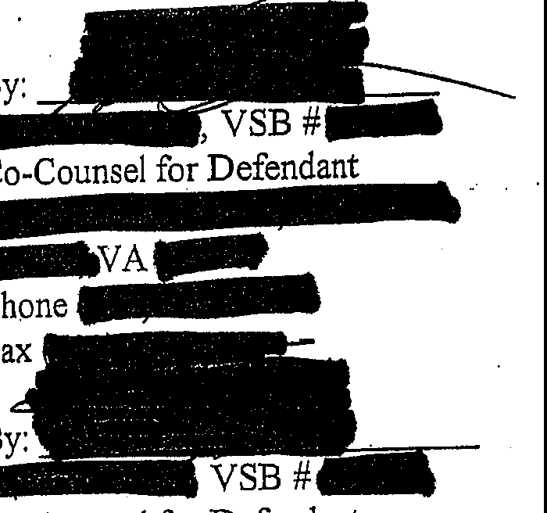
-ted, By Counsel

Co-Counsel for Defendant

- £VAW
Phone

Fax--
*Application to proceed pro hac vice pending.

CERTIFICATE OF SERVICE

We/I hereby certify that a true copy of the foregoing Motion/Memorandum was delivered and/or mailed; fi,rst class mail_ to:
Esquire
Esquire Commonwealth's Attorney

Virginia
and the original was forwarded for filing to:· Hon.-
Clerk .
ircuit Court
=::II'

On this.dayo ·

