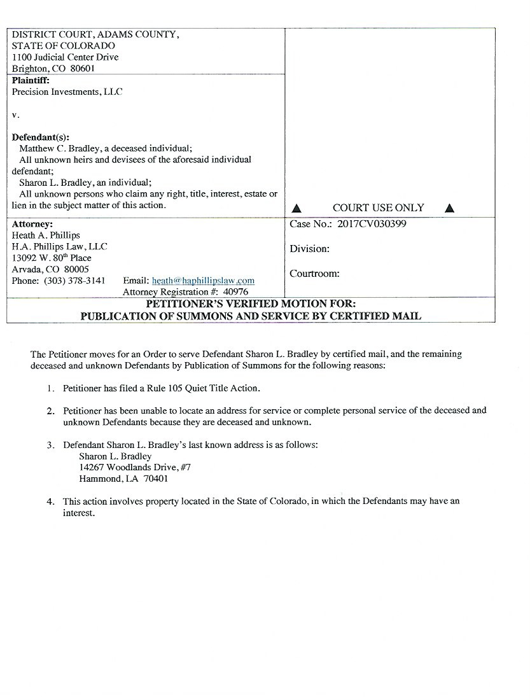

DATE FILED: March 24, 2017 1:28 PM FILING ID: 715BAD3BCAEE9
CASE NUMBER: 2017CV30399

VERIFICATION AND ACKNOWLEDGEMENT

I swear/affirm under oath that l have read the fo regoing Motion and that thestatements set forth therein are trueand correct to the best of my knowledge.

Petitioner. Precision Investments, LLC

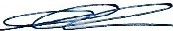Date: _3_-_2_.'.(_ · 1.,1 _
By: Gary Clark Member

S ubscribed and affirmed, or sworn to before me by e:100), 0 in . the County of , Scate of Colora d ,this dayofMarch,2017.
\ICO>lf
Mycommsisionexpires on: @4)<\\.al\% tJ LD6(:,1, ,,_Q&l/\./L
Notary Public

M
8
MB.ANIEoattm<>
NOTARY PllBUC S1'A1EOFCQlORADO NOTARY to20024005615
. Y COWISStON EXPIRES FEBRUARY 19,201

