District Court, Jefferson County, Colorado 100 Jefferson County Parkway  Golden, CO 80401 DA  FIL  CA  PEOPLE OF THE STATE OF COLORADO  v.  GARY LEE NICKAL  Defendant  Peter A. Weir, District Attorney  Eva Wilson, Senior Chief Deputy District Attorney Christian Gardner-Wood, Deputy District Attorney 500 Jefferson County Parkway  Golden, CO 80401-6002  Phone Number: (303) 271-6831  Fax Number: (303) 271-6888 E-mail: cgardner@jeffco.us Atty. Reg. #: 38889 | TE FILED: July 21, 2017 3:24 PM ING ID: E627427B8678A  SE NUMBER: 2016CR1463  COURT USE ONLY  Case Number:  16CR1463  Div.: 12 Ctrm: 5D
MOTION FOR VICTIM’S FAMILY TO BE EXEMPTED FROM SEQUESTRATION (P-6)

PETER A. WEIR, District Attorney in and for the First Judicial District, County of Jefferson, State of Colorado, respectfully submits this motion to exempt the family of the victim, Molly Nickal, from any sequestration order issued by the Court. As grounds therefore the People state:

1. The victim in this matter, Molly Nickal, was murdered by the defendant, who was her husband. Molly Nickal is survived by her children, her mother, her father and step- mother, her maternal aunts, and her three sisters and two brothers-in-law, among others. Most of the above listed individuals have been present at the majority of court appearances in this matter.

- Pursuant to Artile II, § 16a of the Colorado Constitution,

“Any person who is a victim of a criminal act, or such person’s designee, legal guardian, or surviving immediate family members if such person is deceased, shall have a right to be heard when relevant, informed, and present at all critical stages of the criminal justice process. All terminology, including the term “critical stages”, shall be defined by the general assembly.”

- As required by the Colorado Constitution, the General Assembly passed legislation implementing the constitutional amendment. See C.R.S. § 24-4.1-301, et. seq.

- Initially, it is important to note that the charge in this case, Murder in the First Degree, falls under the scope of the Victims Rights Act. C.R.S. § 24-4.1-302(1)(a).

- Further, the trial in this matter is a critical stage giving rise to the constitutional and statutory right to be present. C.R.S. § 24-4.1-302(2)(g) and § 24-4.1-302.5(1)(b).

- As Molly Nickal is deceased, her immediate family members share in the rights afforded by the Colorado Constitution and Revised Statutes. As defined in C.R.S. § 24-4.1-302(5):

“’Victim’ means any natural person against whom any crime has been perpetrated or attempted…or, if such person is deceased or incapacitated, the person’s spouse, parent, child, sibling, grandparent, grandchild, significant other, or other lawful representative.”

Further, as defined in C.R.S. § 24-4.1-302(6):

“’Victim’s immediate family’ means the spouse, any child by birth of adoption, any stepchild, the parent, stepparent, a sibling, a legal guardian, significant other, or a lawful representative of the victim.”

- C.R.S. § 24-4.1-303(6)(a) provides that a victim or an individual designated by the victim may be present at all critical stages unless the court or the district attorney determines that exclusion of the victim is necessary to protect the defendant’s right to a fair trial.

- It is unclear at this time which, if any, of Molly Nickal’s family members will be required as witnesses at the trial in this matter. However, should they be required to testify, the fact of their need to testify for very discrete topics, should not impair their ability to watch the entire trial should they wish to do so.

- Pursuant to C.R.S. § 24-4.1-303(6)(a) the District Attorney’s Office does not believe that the presence of Molly Nickal’s family will impact the defendant’s right to a fair trial.

- Should it be suggested that the right to sequestration is a matter of due process and therefore should trump the right to be present under the Victims Right Amendment and Victims Rights Act, as a matter of legal interpretation, any conflict between
C.R.E. 615 and the Victims Rights Amendment must yield to the Victims Rights Amendment as a constitutional provision. Further, if C.R.E. 615 was always a matter of constitutional due process, the provision in C.R.S. § 24-4.1-303(6)(a) that allows for a decision of the court or the district attorney to exclude a victim if the defendant’s right to a fair trial would be impacted would be needless. Thereby clarifying that sequestration is not always a matter of constitutional import.

- Significantly, the Court of Appeals has confirmed the point that a victim’s right to be present at all critical stages under the Colorado Constitution takes precedence over a party’s right to sequester witnesses under C.R.E. 615. People v. Coney, 98 P.3d 930 (Colo. App. 2004). In Coney, the Court of Appeals disapproved of the trial court’s order excluding the father of a deceased victim from the trial after he testified. The victim’s father was the first witness in the case and testified briefly and on minimal issues. “CRE 615 does not provide authority for departing from the constitution and statute.” Id. at 935.

- As in Coney, any testimony from Molly Nickal’s family members is expected to be brief and deal with minimal issues. However, while Coney provides clear authority to allow a victim/victim’s representative to be present after they testify, the Coney court did not have occasion to address the issue of a victim being present before she testifies. Should Molly Nickal’s family members not be the first witnesses to testify, as was the father in Coney, the People believe both the Constitution and statutes, as outlines above, provide Molly Nickal’s family the right to be present throughout the trial, regardless of when they may testify during the course of the trial. Such a ruling will not impact the defendant’s right to a fair trial and any possible impact such presence would have on testimony could be fully explored by defense counsel during cross-examination.

WHEREFORE, the People respectfully request this Honorable Court allow the family of the victim to be present throughout the trial in this matter and therefore exempt them from any order of sequestration.

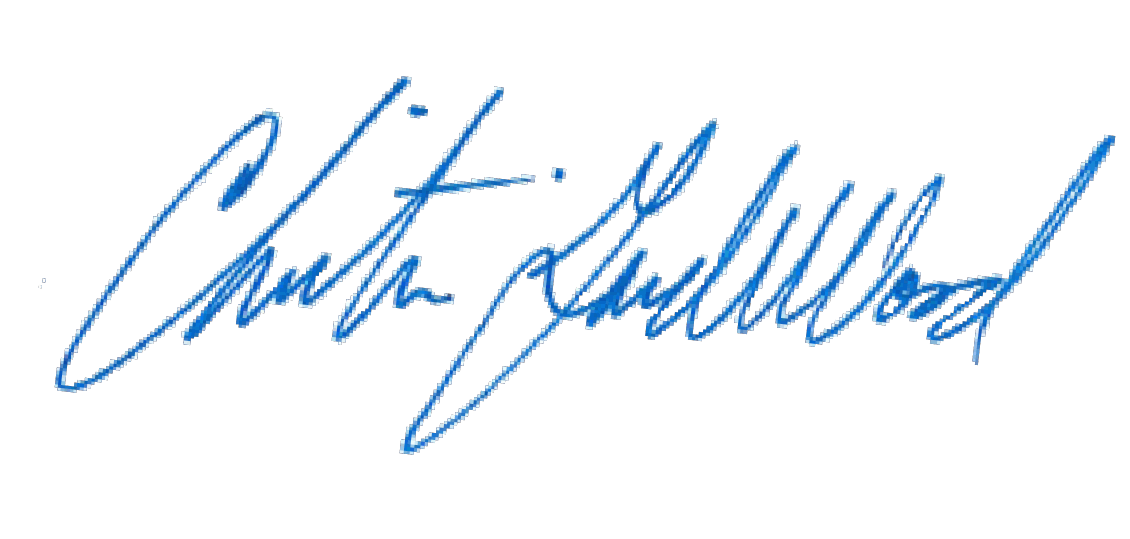
Respectfully submitted, PETER A. WEIR
District Attorney

By: Christian Gardner-Wood
Deputy District Attorney Reg. No. 38889

CERTIFICATE OF MAILING

I hereby certify that a true and correct copy of the foregoing MOTION FOR VICTIM’S FAMILY TO BE EXEMPTED FROM SEQUESTRATION (P-6) was
electronically served via Colorado Courts E-Filing on July 21, 2017, properly addressed to the following:

Patrick J. Mulligan Mulligan Breit, LLC

Jennifer E. Longtin
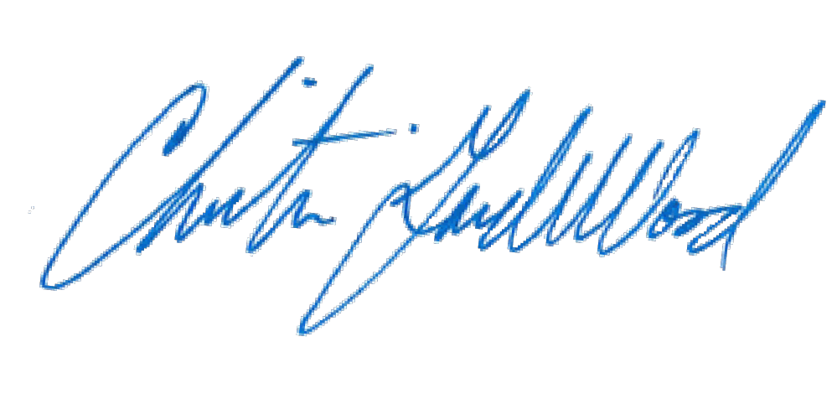The Law Office of Jennifer E. Longtin, LLC

