District Court, Jefferson County, Colorado 100 Jefferson County Parkway  Golden, CO 80401 | DA FIL CA | TE FILED: July 21, 2017 3:24 PM ING ID: E627427B8678A  SE NUMBER: 2016CR1463
PEOPLE OF THE STATE OF COLORADO
v.
GARY LEE NICKAL
Defendant
Peter A. Weir, District Attorney  Eva Wilson, Senior Chief Deputy District Attorney Christian Gardner-Wood, Deputy District Attorney 500 Jefferson County Parkway  Golden, CO 80401-6002  Phone Number: (303) 271-6831  Fax Number: (303) 271-6888 E-mail: cgardner@jeffco.us Atty. Reg. #: 38889 |  | COURT USE ONLY  Case Number:  16CR1463  Div.: 12 Ctrm: 5D
NOTICE PURSUANT TO C.R.E. RULE 902(11) (P-7)

PETER A. WEIR, District Attorney in and for the First Judicial District, County of Jefferson, State of Colorado, hereby gives notice:

The People may introduce self-authenticating certified domestic records of regularly conducted activity pursuant to Rule 902(11), C.R.E.

Specifically, the People may introduce bank records from the following financial institutions:

Wells Fargo Bank, N.A. Valley Bank and Trust Centennial Bank and Trust American Express
Bank of America Trademark Title Services
Synchrony Bank Capitol One
Chase Bank USA N.A. Citibank N.A.
Discover Visa

Wherefore, the People give notice pursuant to C.R.E. Rule 902(11).

Respectfully submitted,

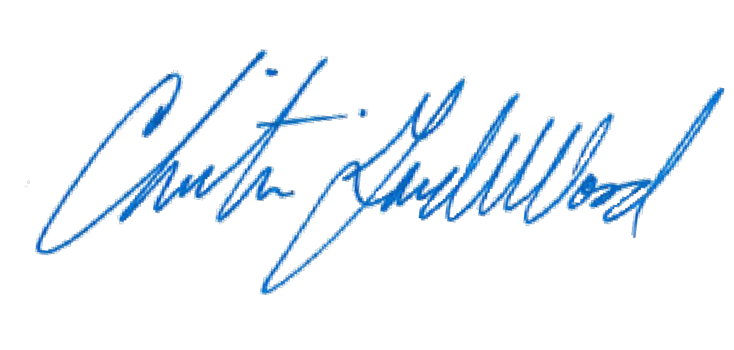
PETER A. WEIR
District Attorney

By: Christian Gardner-Wood
Deputy District Attorney Reg. No. 38889

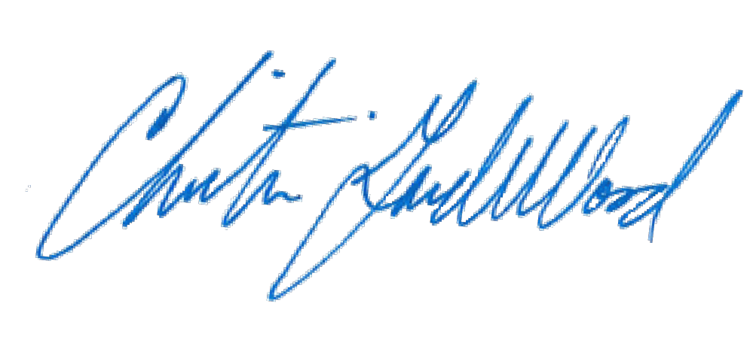
CERTIFICATE OF MAILING

I hereby certify that a true and correct copy of the foregoing NOTICE PURSUANT TO C.R.E. RULE 902(11) (P-7) was electronically served through Colorado Courts E-Filing on July 21, 2017, properly addressed to the following:

Patrick J. Mulligan Mulligan Breit, LLC

Jennifer E. Longtin
The Law Office of Jennifer E. Longtin, LLC

