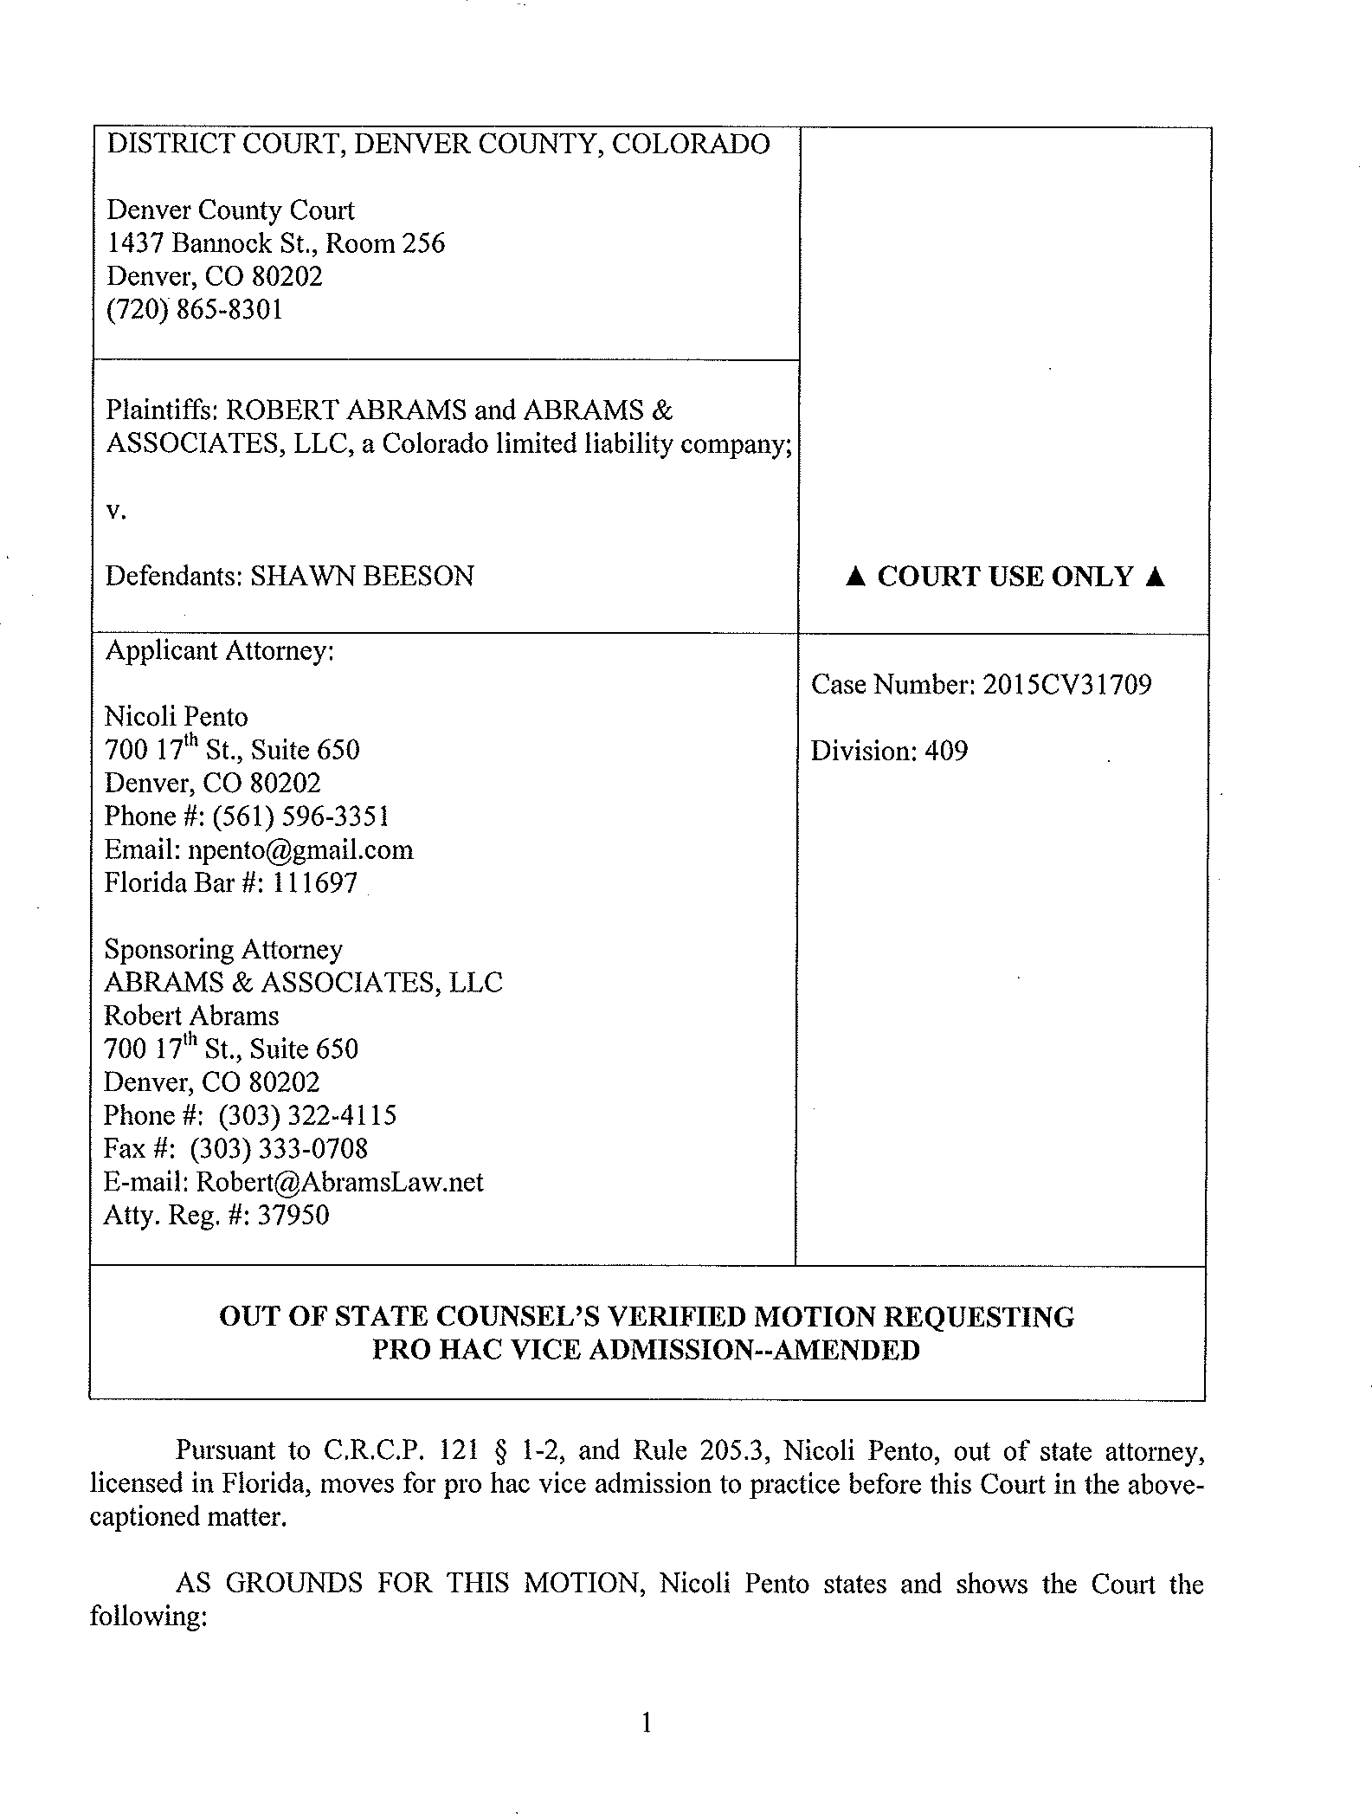

DATE FILED: April 26, 2016 5:22 PM FILING ID: F178C3FCDC51A
CASE NUMBER: 2015CV31709

I. Under Rule 205.3, an attorney and counselor at law in good standing from any other jurisdiction in the United States may, in the discretion of a Colorado court of record, be permitted to participate before the Court in a trial, argument and other proceeding in the particular case in which the attorney is employed, provided that a member in good standing of the Bar of the State of Colorado is associated in such cause at all stages of the case.

- Nicoli Penta is a member in good standing of the Bar in the State of Florida. Nicoli Penta is assigned bar admission number 111697 in the State of Florida.

- Nicoli Penta is in good standing in all Bars wherever admitted and has not been subject to any order of discipline or disability by any Bar, or had any request for pro hoc vice admission denied or revoked.

- Nicoli Penta has not previously sought pro hoc vice admission in Colorado.

- Nicoli Penta acknowledges that he is subject to all applicable provisions of the Colorado Rules of Professional Conduct, the Colorado Rules of Civil Procedure and other court rules, and that he has read such rules and will follow such rules.

- Robert Abrams, is a member in good standing of the Bar of the State of Colorado.

- Robert Abrams will present and paiiicipate in a meaningful and substantial manner through the proceedings and trial of this matter.

- The following are parties to the proceedings and have been notified of this Verified Motion requesting pro hac vice admission:

  - Plaintiffs: Robe1i Abrains and Abrams & Associates, LLC
  - Defendant: Shawn Beeson

- Nicoli Penta filed a copy of this motion with the Clerk of the Supreme Cami at the Office of Attorney Registration, 1300 Broadway, Suite 510, Denver, Colorado 80203 and paid the required fee.

- An affidavit setting forth Nicoli Pento's qualifications and compliance is attached.

- By execution of the attached verification, the Colorado licensed Sponsoring Attorney verifies his association on this matter.

WHEREFORE, Out of State Counsel respectfully requests the Court admit Nicoli Penta pro hoc vice, to practice before this Cami in this case.

RESPECTFULLY SUBMITTED this 26°" d,y / ..t"-----
£cog:
Florida Bar #: 111697 700 17th St. Suite 650
Denver, Colorado 80202
(561) 596-3351

and
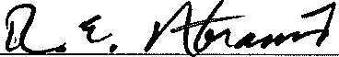
Robe1t Abrams Atty. Reg.#: 37950
700 1ih St. Suite 650
Denver, Colorado 80202
(303) 322-4115

VERIFICATION

I declare under penalty of perjury under the laws of the State of Colorado that the foregoing OUT OF STATE COUNSEL'S VERIFIED MOTION REQUESTING PRO
HAC VICE--AMENDED is true and correct to the best of my knowledge, information, and belief

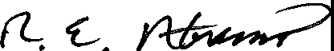April 26, 2016
Robert Abrams, Attoney Reg, # 37950

STATE OF COLORADO )
) ss: COUNTY OF DENVER )

The foregoing OUT OF STATE COUNSEL'S VERIFIED MOTION REQUESTING
PRO HAC VICE--AMENDED was sworn to or affirmed and signed by Robe11 Abrams before me this 26th day of April, 2016.

Witness my hand and official seal,
.--::"

SEAL

[Not511' !Pub ic

JOSIAH SILVERSTEIN NOTARY PUBLIC STATE OF COLORADO
NOTARY lO 11 20094024232
MY COMMISSION EXPIRES JULY 28, 2017

My commission expires:

VERIFICATION

I declare under penalty of perjury under the laws of the State of Colorado that the foregoing OUT OF STATE COUNSEL'S VERIFIED MOTION REQUESTING PRO
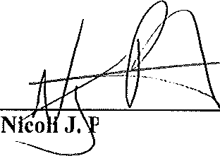RAC VICE--AMENDED is true and correct to the best of my knowledge, information, and belief

April 26, 2016

ento, Florida Bar# 111697

STATE OF COLORADO )
) ss: COUNTY OF DENVER )

The foregoing OUT OF STATE COUNSEL'S VERIFIED MOTION REQUESTING
PRO HAC VICE--AMENDED was sworn to or affirmed and signed by Nicoli Pento, Florida Bar#: 111697 before me this 26th day of April, 2016.

Witness my hand and official seal, SEAL
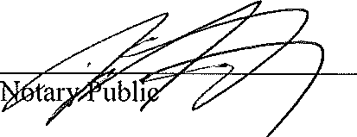

JOSIAH SILVERSTEIN NOTARY PUBLIC STATE Of COLORADO
NOTARY 10 # 20094024232
MY COMMISSION EXPIRES JULY 28. 2017
My commission expi es:

CERTIFICATE OF SERVICE

I HEREBY CERTIFY on this 26th day of April, 2016, a true and correct and correct copy of the foregoing OUT OF STATE COUNSEL'S VERIFIED MOTION REQUESTING PRO HAC VICE ADMISSION OF NICOLI PENTO---AMENDED was served via ICCES and/or
United States Mail, upon:

Michael Boyce
Law Office of Michael P. Boyce, PC
3773 Cherry Creek Drive North, Suite 575 Denver, CO 80209 mike@boycelawoffice.com
Attorney for Defendant

Isl Josiah Silverstein
Josiah Silverstein, Paralegal

(Original signature on file at Abrams & Assoc., LLC pursuant to C.RC.P. 121§ 1-26)

