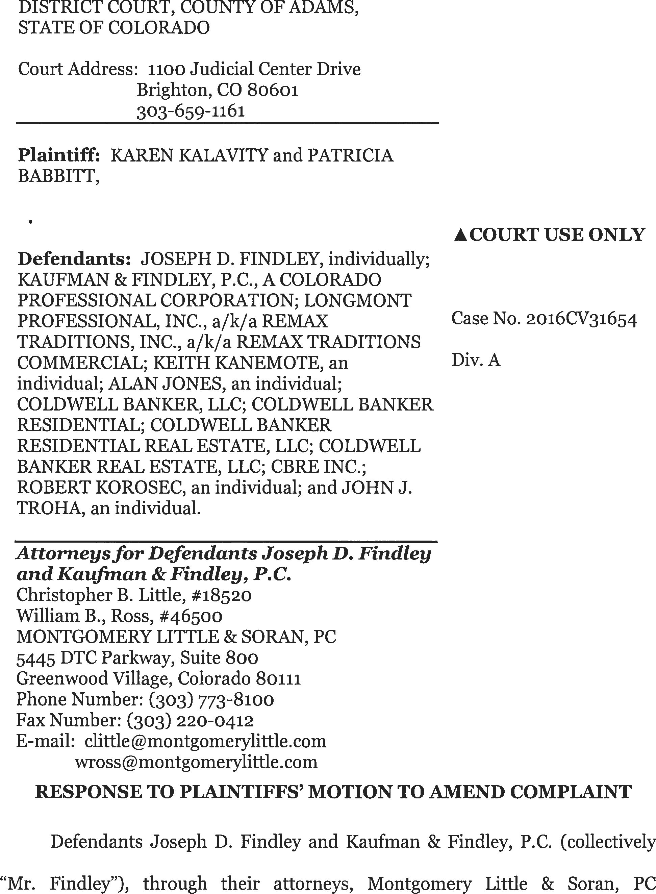

DATE FILED: March 20, 2017 2:41 PM FILING ID: F34B419908539
CASE NUMBER: 2016CV31654

respectfully submit this objection and Response to the Plaintiffs' Motion for Leave to Amend. 1
The court should deny the Plaintiffs' request for permission to file another amended complaint for the following reasons:
INTRODUCTION & SUMMARY

The Plaintiffs did not prepare or serve a proposed amended complaint. Their Motion to Amend is void of facts. Responding to the unknown is difficult but the failure to assert any factual support renders the Plaintiffs' Motion to Amend futile.
Plaintiffs' current claims against Mr. Findley, and the other named Defendants, arise out of a closed probate action entitled the Estate of Jerry F. Kalavity (deceased), in Adams County, Colorado Probate Action, 2014 PR.30341 ("Probate Action"). The Probate Action was opened on June 12, 2014. The Probate Action closed on June 3, 2015. The Plaintiffs did not appeal any order issued in the Probate Action by the Honorable Patrick T. Murphy ("Judge Murphy") who presided over the Probate Action. Mr. Findley was the personal representative in the probate action. He was appointed by the court.
According to the docket in the Probate Action, the Plaintiffs' current attorneys, The Law Offices of Randy B. Corporon, P.C. ("Corporon Attorneys"),

1 The Plaintiffs' motion had two requests. A motion for expedited briefing and to amend the complaint. The court has granted, in part, the expedited briefing process. This response will address the motion to amend.

began representing the Plaintiff Karen Kalavity ("Ms. Kalavity"), on July 5, 2016. In the Motion to Amend, these attroneys do assert that "prior to" some recent event, they were "chiefly advisory" counsel. See ,I 4 of the Motion filed March 13, 2017. In that Motion, they argue they did not file the original complaint in this action. Despite their involvement in the underlying case and representation of Ms. Kalavity since July 5, 2016, their argument for another amended complaint is now predicated on a unique attempt to place blame for the admittedly groundless and deficient Amended Complaint at the feet of another attorney, John B. Dougherty and his law firm. ("Dougherty Attorneys").2
In the Motion to Amend, the Plaintiffs assert and confirm that the currently filed amended complaint is deficient. See Motion ,i,i 4 and 11 where Plaintiffs allege or admit that the Amended Complaint was somehow filed without their current counsel's approval and that the Amended Complaint is "deficient." This acknowledgement in spite of the fact that the Corporon Attorneys appear to have

2 Blaming Mr. Dougherty for filing a groundless complaint suggests a gross dereliction of professional responsibility. See People v Maynard, 238, P.3d 672 (Colo. 2009); see also Brooks v. Bank of Boulder, 891 F.Supp. 1469, 1477 CD.Colo. 1995) ("Irresponsible or inadequately considered allegations should be met with severe sanctions pursuant to Rule 11, F.R.Civ.P. In filing such serious allegations one may not shoot first and aim later.") If the court is to consider the effort to blame Mr. Dougherty for filing a groundless complaint, it might want to consider hearing from him. It should also review all communications between Mr. Dougherty and the Corporon Attorneys. The court could also consider communications between the Plaintiffs and their lawyers as well. The fact that these communications were not tendered with the motion suggests another reason for denying the Motion to Amend.

served the Amended Complaint.3 See Docket in this instant action where all the return of services appear to be signed by the Corporon Attorneys. The representations about the factually deficient complaint were also made in communications by the Corporon Attorneys. See Exhibit I discussed below at entry February 13, 2017 and fn #7.
In addition, the claims against Mr. Findley, are barred by C.R.S. §15-12- 1005, titled, "Limitations on proceedings against personal representative." This statute bars claims. The Plaintiffs do not address this statute in their Motion to Amend. The statute mandates that claims against a personal representative "are barred unless a proceeding to assert the same is commenced within six months after the filing of the closing statement." The underlying estate was closed on June 3, 2015. This lawsuit against Mr. Findley, as the personal representative, was not filed until October 16, 2016. This is more than six months after the closing statement. The statute bars the claims. Therefore, there is no plausible claim that can be asserted against Mr. Findley.

3 C.R.C.P. Rule 11 states the "signature of an attorney constitutes a certificate by him that he has read the pleading; that to the best of his knowledge, information, and belief formed after reasonable inquiry, it is well grounded in fact and is warranted by existing law or a good faith argument for the extension, modification, or reversal of existing law, and that it is not interposed for any improper purpose, such as to harass or to cause unnecessary delay or needless increase in the cost of litigation."

HISTORY OF CLAIM-TAKEN FROM JUDICIAL RECORDS4

The following timeline demonstrates why the Plaintiffs' request to file another amended complaint is illusory and not worthy of court consideration.
- June 12, 2014: Plaintiffs' brother, Steven D. Kalavity, commenced the Probate Action by filing a Petition for Probate along with the renunciations of appointment for himself and his three siblings. Two of his siblings, Karen Kalavity and Patricia Babbitt, are the Plaintiffs in this action. The two brothers are not involved in the case. The principal issue in the Probate Action involved the sale of a parcel of property near ₁₃ ₂ nd Ave. and Colorado Boulevard in Adams County. The property was encumbered by a reverse mortgage and the heirs of Jerry F. Kalavity could not agree how the property should be marketed and sold.
- June 27, 2014: Judge Murphy appointed Mr. Findley to act as the personal representative for the estate of Jerry F. Kalavity. See Docket in the Original Action.
- October _{16,} _{2014:} Following a few months of dispute between the heirs over the Adams County property, Judge Murphy held an evidentiary hearing and determined that Mr. Findley's actions for marketing and selling the property were appropriate. Judge Murphy certified that order as final pursuant to C.R.C.P. Rule 54(b). Plaintiffs did not appeal that ruling.s See also Docket in the Original Action. Plaintiffs had private counsel representing them at the hearing.
- April 24, 2015: Mr. Findley filed a Petition for Final Settlement and Final Accounting in the Probate Action. See Docket in the Original Action.

4 These facts are all taken from the Register of Actions in the Probate Action. These facts are not subject to any dispute.

s The Transcript of that proceeding is attached as Exhibit A. In that proceeding, Ms. Kalavity and Ms. Babbitt were represented by a different set of lawyers, Michael Graetz and Wayne Stewart. Of note, these lawyers were sued by Ms. Kalavity and Ms. Babbitt in another action but that action was voluntarily dismissed. See entry of October 9, ₂₀₁₆ below.

- May 11, 2015: Judge Murphy granted Mr. Findley's Proposed Order for Final Settlement in the Probate Action. See Docket in the Original Action.
- June 1, 2015: Mr. Findley filed Receipts and Releases for all of Jerry F. Kalavity's heirs, including Plaintiffs Karen Kalavity and Patricia Babbitt in the Probate Action. These releases provided complete and absolute releases of any claim that any heir had against Mr. Findley. Exhibit B.6
- June 3, 2015: Judge Murphy entered a Decree of Final Discharge in the Probate Action releasing Mr. Findley from every potential claim. See Docket in the Original Action.
- July 5, 2016: Corporon Attorneys entered their appearance on behalf of Plaintiff Karen Kalavity in the Probate Action (hereinafter "Corporon Attorneys"). See Docket in the Original Action. As they entered their appearance, they had access to all filings in the Probate Action.
- July 7, 2016: The Corporon Attorneys requested transcripts from the Probate Action. See Docket in the Original Action. (A transcript for the October 16, 2016 hearing is attached below.)
- September 6, 2016: The Dougherty Attorneys entered their appearance on behalf of Ms. Kalavity in the Probate Action. See Docket in the Original Action.
- September 26, 29, & October 6: The Corporon Attorneys, acting for Ms. Kalavity, demanded receipt of Mr. Findley's files. The files were delivered to the Corporon Attorneys on October 21, 2016. See Exhibit C, an email thread from the Corporon Attorneys to Mr. Findley and his counsel.
- October 9, 2016: The Dougherty Attorneys filed a complaint against Defendants, including the attorneys who represented the Plaintiffs at the

6 The claims, no matter how stated or amended, are also barred by a variety of judicial doctrines res judicata, issue preclusion and release because Ms. Kalavity and Ms. Babbitt signed releases providing:

I [i.e. Ms. Kalavity and Ms. Babbitt] grant a full and final release and satisfaction to the estate and to the fiduciary [i.e., Mr. Findley] and his or her successors for any liability in connection with my interest in the estate.

October 16, 2014 hearing and including Mr. Findley, in Adams County District Court, Case No. 2016CV031601, on behalf of Plaintiffs ("Original Action"). The complaint asserted a claim against Mr. Findley for breach of fiduciary duty. Exhibit D.
- October _{12,} _{2016:} The Dougherty Attorneys filed a first amended complaint in the Original Action against Defendants, including Mr. Findley, the other defendants and the other attorneys. Exhibit E.
- October _{15,} _{2016:} The Dougherty Attorneys voluntarily dismissed Plaintiffs' claims in the Original Action without prejudice. See court record in the Original Action, Case No. 2016CV031601.
- October _{16,} _{2016:} Plaintiffs, through the Dougherty Attorneys, commenced a second lawsuit against Defendants, including Mr. Findley, in Adams County District Court in Case No. 2016CV031654 ("Present Action"). This present lawsuit does not include claims against the lawyers who represented Ms. Kalavity and Ms. Babbitt in the Probate Action.
- January _{25,} _{2017:} The Corporon Attorneys entered their appearance on behalf of Plaintiff Karen Kalavity in the Present Action. (We assume they now represent Ms. Babbitt.)
- January _{27,} _{2017:} The Corporon Attorneys signed the summons and eventually served the Amended Complaint.7 On February 1, 2017, thereturn of service for all defendants was filed by the Corporon Attorneys.
- February 3, _{2017:} Counsel for Mr. Findley delivered a safe harbor letter to the Corporon and Dougherty Attorneys pursuant to C.R.C.P. 121 §1-15,
C.R.C.P. 11 and Colo. R.P.C. 3.1 ("Safe Harbor Letter"). Exhibit F.
- February _{7,} _{2017:} The Corporon Attorneys reply that they are in receipt of the Safe Harbor Letter. They request time to evaluate the letter so that they can review the allegations and discuss the matter with co-counsel and their clients. Exhibit G.

7 Query, if the Amended Complaint is as deficient as the Corporon Attorneys now argue, why did they serve it?

- February 13, 2017, 3:20 p.m.: The Corporon Attorneys respond that "Plaintiffs are unwilling to dismiss." The Corporon Attorneys do not explain why they will not dismiss the claims against Mr. Findley. Exhibit H.8
- February 13, 2017, 4:10 p.m.: Mr. Findley filed the Motion to Dismiss.
- February 14, 2017: Defendants Longmont Professionals, Inc. and Keith Kanemote filed their Answer.
- February 27, 2017: Defendants Coldwell Banker, LLC and Coldwell Banker Residential filed a Motion to Dismiss and a Motion to Quash Summons and to Dismiss for Lack of Personal Jurisdiction. 9
- March 1, 2017: Corporon Attorneys requested seven additional days to respond to Mr. Findley's Motion to Dismiss. Mr. Findley does not oppose Plaintiff's request.
- March 7, 2017: Defendants CBRE, Inc. and Robert Korosec filed a Motion to Dismiss.
- March 10, 2017, 11:40 a.m.: The Corporon Attorneys request permission to file a second amended complaint in this action. Every Defendant asked for more detail and information. None is given. Every Defendant states it will therefore oppose the request.
- March 13, 2017: Plaintiffs filed the instant motion for leave to amend their Amended Complaint. Plaintiffs also requested a stay of the deadline to respond to Findley's motion to dismiss and the other motions. By orders dated March 17, 2017, this court has set forth the timelines that will apply for further briefing on the myriad of Plaintiffs' requests.

8 An observation, on March 13, 2017, the Corporon Attorneys stated, "I misspoke when I said that the amended complaint had been produced without our input; we were consulted in its drafting." Exhibit I.
9 See Exhibit J ("I gave [the Corporon Attorneys] a complete roadmap to address the pleading issues that involve my clients before we filed the motion to dismiss. I gave you an opportunity to correct the issues and time to do so. I told you that if they were not addressed, we would file a motion to dismiss.")

RESPONSE AND CITATION TO LEGAL AUTHORITY

Plaintiffs have not filed a proposed amended complaint. This should be considered a proposal to file the fifth iteration of the complaint initially filed by Plaintiffs' Kalavity and Babbitt against an ever-changing group of defendants. See prior complaints in Case No. 2016 CV 031601, Adams County District Court. The Motion to Amend does not contain one factual or legal suggestion of what the new version would be. An amended complaint should have been filed with the request.10 "The movant carries the burden of demonstrating lack of knowledge, mistake, inadvertence, or other reason for failing to raise the amended claim earlier." Ajay Sports, Inc. v. Casazza, 1 P.3d 267, 273 (Colo. App. 2000) (citing Polk v. Denver District Court, 849 P.2d 23 (Colo. 1993).

10 The party seeking to amend its pleadings bears the burden to demonstrate that the amendment sought should be granted. A court can deny leave to amend because of the resulting delay, undue expense, or other prejudice to the opposing party. Varner v. District Court, 618 P.2d 1388, 1391 (Colo. 1980); Henderson v. Romer, 910 P.2d 48 (Colo. App. 1995). There has been substantial expense responding to the Plaintiffs' actions. The expense is undue and unnecessary as the claims are absolutely barred. The Court can also deny a motion to amend which is futile. Conrad v. Imatni, 724 P.2d 89, 94 (Colo. App. 1986). An amendment is futile if, for example, it merely restates the same facts as the original complaint in different terms, reasserts a claim on which the court previously ruled, fails to state a legal theory, or could not withstand a motion to dismiss. CJ Akin v. Four Corners
Encampment, 179 P.3d 139,146 (Colo App. Div. s 2007); Sterenbuch v. Goss, 266
P.3d 428, 440 (Colo.App. Div. 1 2011). (Among other reasons, failure to proffer additional facts is a reason to deny a motion to amend.) This court has nothing to consider. The plaintiffs have filed four complaints and, as acknowledged by their attorneys, plaintiffs' prior complaints are all deficient because they are simply cut and pasted with different captions. Arguing that an unknown fifth version which has not been prepared is not grounds for allowing another amended pleading.

The Plaintiffs have not credibly argued lack of knowledge, mistake, inadvertence, or any other reason to justify another amended complaint.
As there is nothing for the court to consider. This court will be justified in denying plaintiffs' motion to amend. See Conrad v. Imatni, supra, 724 P.2d at 94; see also Foman v. Davis, 371 U.S. 178, 182 (1962) (Years of precedent tell us that proposed amendments that are dilatory, delayed, prejudicial, futile, or sought in bad faith are not permitted.); Frank v. U.S. West, Inc., 3 F.3d 1357, 1365 (10th Cir. 1993). In accord with federal rules and practices, it is widely recognized that the Rule 8 pleading standard "does not unlock the doors of discovery for a plaintiff armed with nothing more than conclusions." See Ashcroft v. Iqbal, 556 U.S. 662, 678-79 (2009).
It was incumbent upon the Plaintiffs to file a proposed amended complaint
or articulate even one fact so the court could properly evaluate the facts, not the conclusions advanced by counsel. See Warne v. Hall, 373 P.3d 588, 596 ,I27 (Colo. 2016) (The court explaining why the complaint should be dismissed because the allegations of the complaint "were insufficient to state a claim because a number of them were conclusory and therefore not at all entitled to an assumption that they were true "). Id.
Arguing that something might be cured with the filing of another frivolous complaint is not procedurally appropriate. The Plaintiffs should have filed an amended complaint or, at least facts to support their conclusions so the court could

consider how any proposed amendment would cure the current amended complaint's admitted deficiencies.
Plaintiffs' Motion, like the four prior versions of the complaint, are replete with legal conclusions, but completely devoid of any facts to support any conclusion in the motion. Pursuant to C.R.C.P. ₁₂₁ _{§1-15,} counsel for Findley, and upon information and belief, counsel for the other Defendants, identified numerous legal, factual, and procedural deficiencies in Plaintiffs' Amended Complaint on February 3, _{2017.} See Exhibit H. In spite of these good faith conferrals, Plaintiffs refused to provide any information to support their Amended Complaint, or dismiss their claims against any of the Defendants. Instead, Plaintiffs simply wrote they were "unwilling" to make any change and continued to pursue their baseless claims.
CONCLUSION
As a result of these acknowledged deficient pursuits, Defendants, including Mr. Findley, were required to expend considerable attorney's fees in defending against these claims, including the filing of several motions to dismiss. And, of course, responding to the Motion to Amend, that is deficient. Now, Plaintiffs, without any offer of proof, request that they be permitted to amend their Amended Complaint to allegedly address the defects that were identified during Defendant's conferral with Plaintiffs' counsel.11

11 There is no indication what the Plaintiffs will do because they only argue that they may "amend the statements of fact so as to provide greater assurance that

Plaintiffs' requested amendment should be denied because there is no factual support for it and hence, fut ile.12 Alternatively, to the extent this Court considers granting Plaintiffs' amendment, Findley and the other Defendants should be awarded the attorney's fees they incurred in defending against the case from its inception until the court rules on these issues.
Dated: March 20, 2017.
Respectfully submitted,
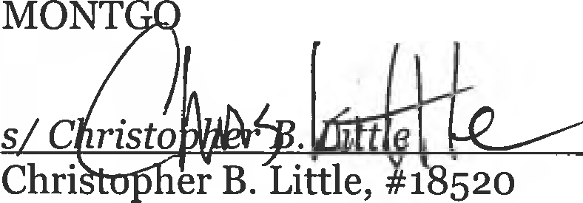
MERY LITTLE & SORAN, PC

their pleading burden has been met." This is not a legal standard. It is an alternative argument by counsel attempting to satisfy a factual burden.

12 An amendment is futile, warranting denial of leave to amend, if it merely restates the same facts as the original complaint in different terms, reasserts a claim on which the court previously rules, fails to state a legal theory, or could not withstand a motion to dismiss. Benton v. Adams, 56 P.3d 81, 86-87 (Colo. 2002). Here, Plaintiffs fail to attach a copy of their proposed Second Amended Complaint even though they admit "doing so is clearly the best practice." Mot. ,r7. While Mr. Findley will not comment on the rationale for this failure, the Court must acknowledge the strategic advantage it confers upon Plaintiffs in that Defendants are limited in their ability to challenge the amendment's ultimate futility. Nonetheless, Findley is confident that any proposed amendment would be futile because every claim against him is barred by the statute. C.R.S. §15-12-1005.

CERTIFICATE OF SERVICE
I hereby certify that on March 20, 2017, a true and correct copy of the foregoing was filed with the Court and duly served to the following via Colorado Courts E-Filing:

Randy B. Corporon Brian E. Lewis Kevin J. Farrell
Law Offices of Randy B. Corporon, P.C.
2821 S. Parker Road, Suite 555
Aurora, CO 80014

John B. Dougherty
357 S. Mccaslin Blvd., Suite 200
Louisville, CO 80027
Attorneys for Plaintiffs

Bernadette J. Wasilik Charami B. Costigan Levinson Costigan Kenneth L. Levinson
Balaban Levinson et al., P.C.
1745 Lafayette St.
Denver, 0 80218

Attorneys for Longmont Professionals, Inc., Keith Kanemote
Colin A. Walker
Fairfield and Woods, P.C.
1801 California St., Ste. 2600
Denver, CO 80202

Attorney for Robert Korosec, John J. Troha, and CBRE, Inc.

Curtis W. Shortridge Ronald Scott
Shortridge Fitzke and Hulquist, P.C.
4 Inverness Court East, Ste. 100
Englewood, CO 80112

Attorneys fo1· Alan Jones, Coldwell Banker, LLC, Coldwell Banker Real Estate, LLC, Coldwell Banker Residential, and Coldwell Banker Residential Real Estate

s/ Kathryn Dixon
In accordance with C.R.C.P. 121 § 1-26(9) a printed copy of this document with original signatures is being maintained by the filing party and will be made available for inspection by other parties or the court upon request.

