District Court, Jefferson County, Colorado 100 Jefferson County Parkway  Golden, CO 80401 DATE FI  FILING I CASE N | ED: February 6, 2017 11:42 PM D: 2CB11304DCDC9  MBER: 2016CR1463
PEOPLE OF THE STATE OF COLORADO
v.
GARY LEE NICKAL
Defendant
Peter A. Weir, District Attorney  Eva Wilson, Senior Chief Deputy District Attorney Christian Gardner-Wood, Deputy District Attorney 500 Jefferson County Parkway  Golden, CO 80401-6002  Phone Number: (303) 271-6831  Fax Number: (303) 271-6888 E-mail: cgardner@jeffco.us  Atty. Reg. #: 38889 | COURT USE ONLY  Case Number:  16CR1463  Div.: 12 Ctrm: 5D
FORTHWITH MOTION TO VIDEOTAPE SANITY EXAMINATION (P-2)

U

PETER A. WEIR, District Attorney in and for the First Judicial District, State of Colorado respectfully requests this Honorable Court order the Colorado Mental Health Institute in Pueblo (CMHIP), to videotape the sanity examination of the defendant. As grounds, the People state:

- The defendant has been charged with Murder in the First Degree. On September 6, 2016, the defendant pled not guilty by reason of insanity (NGRI). Since September 6th, the defendant has been in the Jefferson County Jail awaiting transport to the CMHIP. On February 1, 2017, the Court Services Department at the CMHIP notified the Court and parties that the defendant would be transported to the CMHIP on February 9, 2017 with an evaluation and report to be completed by March 31, 2017.

- The People had sent a letter to the CMHIP to request preservation of notes and reminding the staff of the requirement after January 1, 2017 that evaluations be videotaped. This letter was sent out of an abundance of caution because the People anticipated that the CMHIP would automatically begin complying with the new requirement for any evaluations after January 1, 2017.

- On February 3, 2017, the People’s paralegal received an email from Lori Carter, Evaluations/Admissions Coordinator at the CMHIP indicating that there was no order for videotaping and without an order they would not be videotaping the evaluation of the defendant.

- As the Court is aware, the law regarding sanity evaluations was amended effective January 1, 2017 to include the following language:

“A interview conducted in any case that includes a class 1 or class 2 felony charge or a felony sex offense charge described in section 18-3-402, 18-3-404, 18-3-405, or 18-3-405.5, C.R.S., pursuant to
this section must be video and audio recorded and preserved. The court shall advise the defendant that any examination with a psychiatrist or forensic psychologist may be video and audio recorded.”

C.R.S. 16-8-106(1)(b).

- Apparently, in reviewing the new statute the CMHIP understands the amendment to 16-8-106(1)(b) to only apply to evaluations ordered after January 1, 2017. However, this view taken by the CMHIP does not consider the language of the signed Act of the Colorado General Assembly.

“SECTION 4. Effective date - applicability. This act takes effect January 1, 2017, and applies to court-ordered mental condition examinations conducted on or after said date.”

S.B. 16-019. (Emphasis Added) See Attached.

- Pursuant to S.B. 16-019, and anticipating the defendant’s evaluation would not take place until after January 1, 2017, the People requested during the NGRI plea advisement on September 6, 2016, and this Court agreed, that the defendant should be advised that his evaluation would be video and audio recorded.

- Due to the language of C.R.S. 16-8-106(1)(b) and S.B. 16-019 it is clear the sanity evaluation of the defendant should be required to be audio and video recorded.

- The undersigned has been in contact with counsel for the defendant, Patrick Mulligan. Mr. Mulligan indicates that he objects to this request.

  - It should be noted that Mr. Mulligan, in his conversations with the undersigned about the filing of this motion, noted that pursuant to C.R.S. 16-8-106(1)(c) the psychiatrist or forensic psychologist should assess whether the recording of the examination is likely to cause or is causing mental or physical harm to the defendant or others or will make the examination not useful to the expert forensic opinion.

  - The People are not in disagreement with the applicability of subsection (1)(c); however, this does not change that pursuant to subsection (1)(b)

that the evaluation shall be ordered to be audio and video recorded unless there is a specific finding pursuant to subsection (1)(c), with the required report submitted to the Court documenting the rationale for the finding.

WHEREFORE, the People respectfully request this Honorable Court issue an order directing the CMHIP to audio and video record the court-ordered evaluation of the defendant pursuant to the defendant’s decision to enter a plea of NGRI.
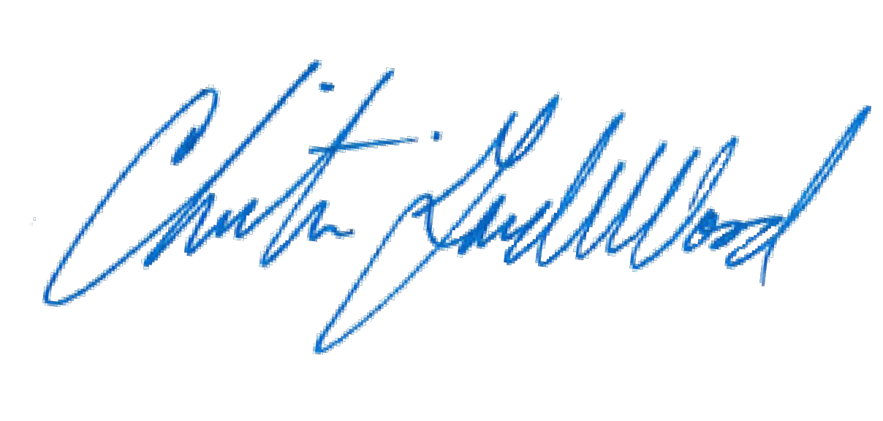
Respectfully submitted, PETER A. WEIR
District Attorney

By: Christian Gardner-Wood
Deputy District Attorney Reg. No. 38889

CERTIFICATE OF MAILING

I hereby certify that a true and correct copy of the foregoing FORTHWITH MOTION TO VIDEOTAPE SANITY EXAMINATION (P-2) was served on February 6, 2017 via the Colorado Courts E-Filing System, properly addressed to the following:

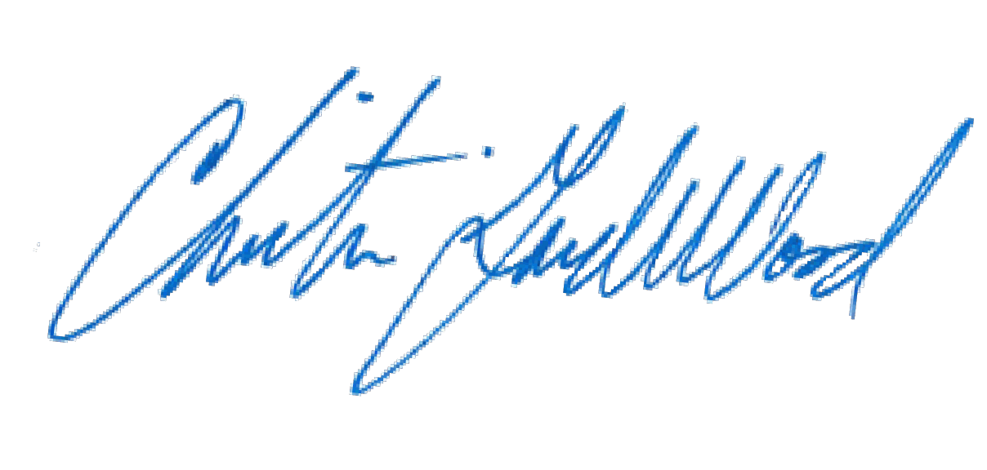Patrick J. Mulligan Mulligan Breit, LLC

