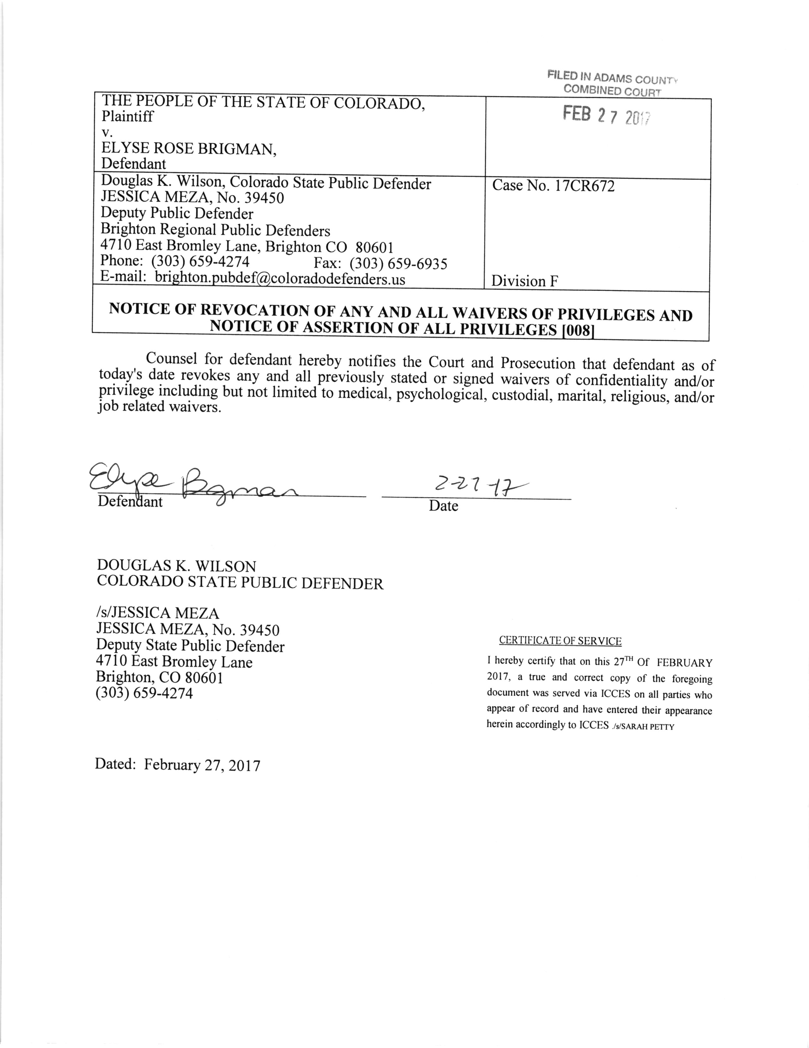

DATE FILED: February 27, 2017 CASE NUMBER: 2017CR672

